Compulsory schools teacher logs
Innholdsfortegnelse

Figurer

Tabeller

4. Teacher logs in compulsory schools

4.1 Which grade level was the lesson for?
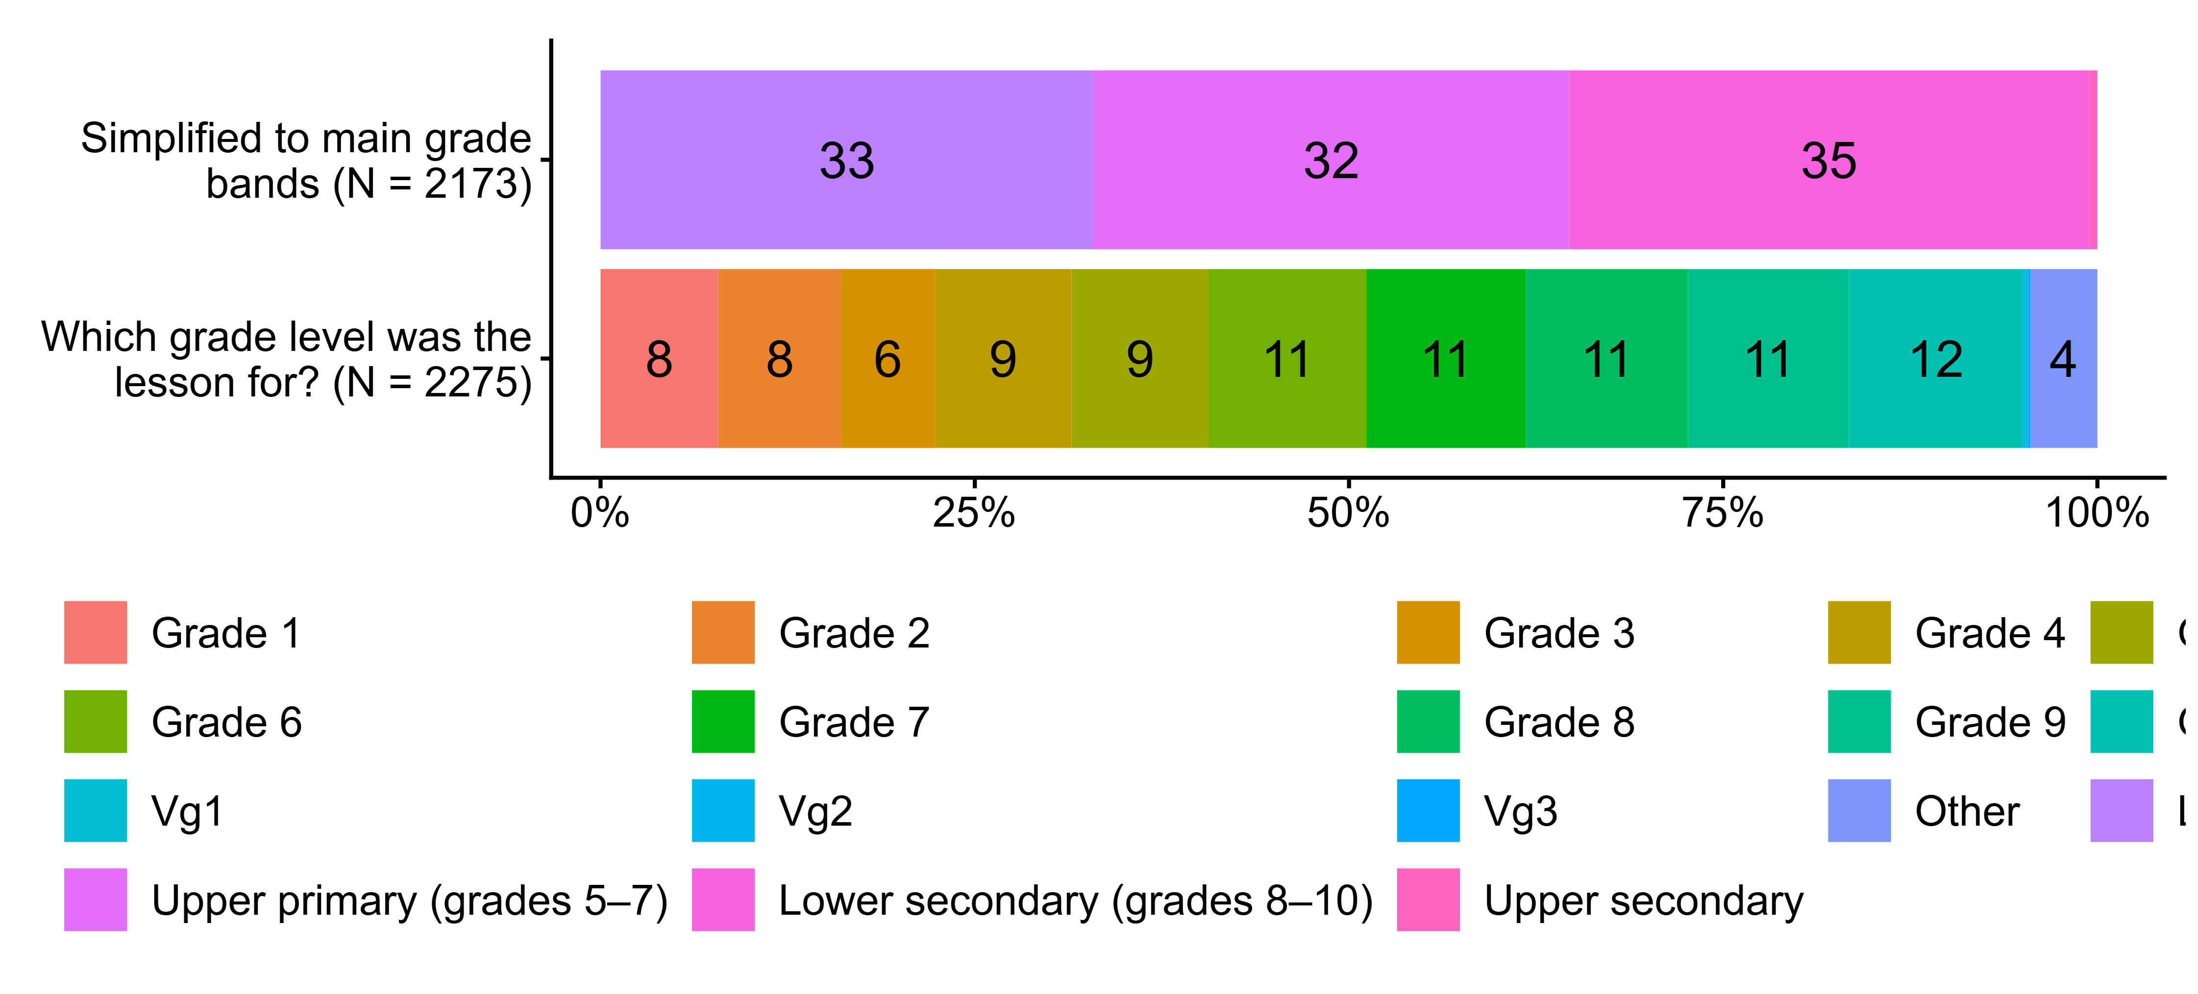
Figur 4.1. Which grade level was the lesson for?. N = [2173–2275], Figurdata (XLSX), PNG. (Q_LG7,Q_LG7_DERIVED)

4.2 Do you have formal qualifications in this subject?
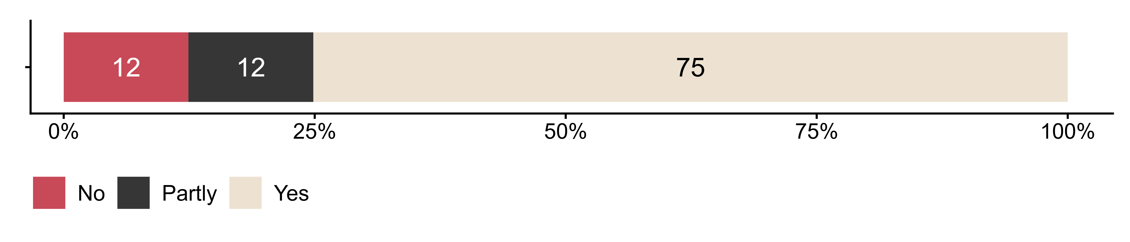
Figur 4.2. Do you have formal qualifications in this subject?. N = 2216, Figurdata (XLSX), PNG. (Q_LG12)

4.3 Did you include any of the following public health and life skills topics in this lesson?
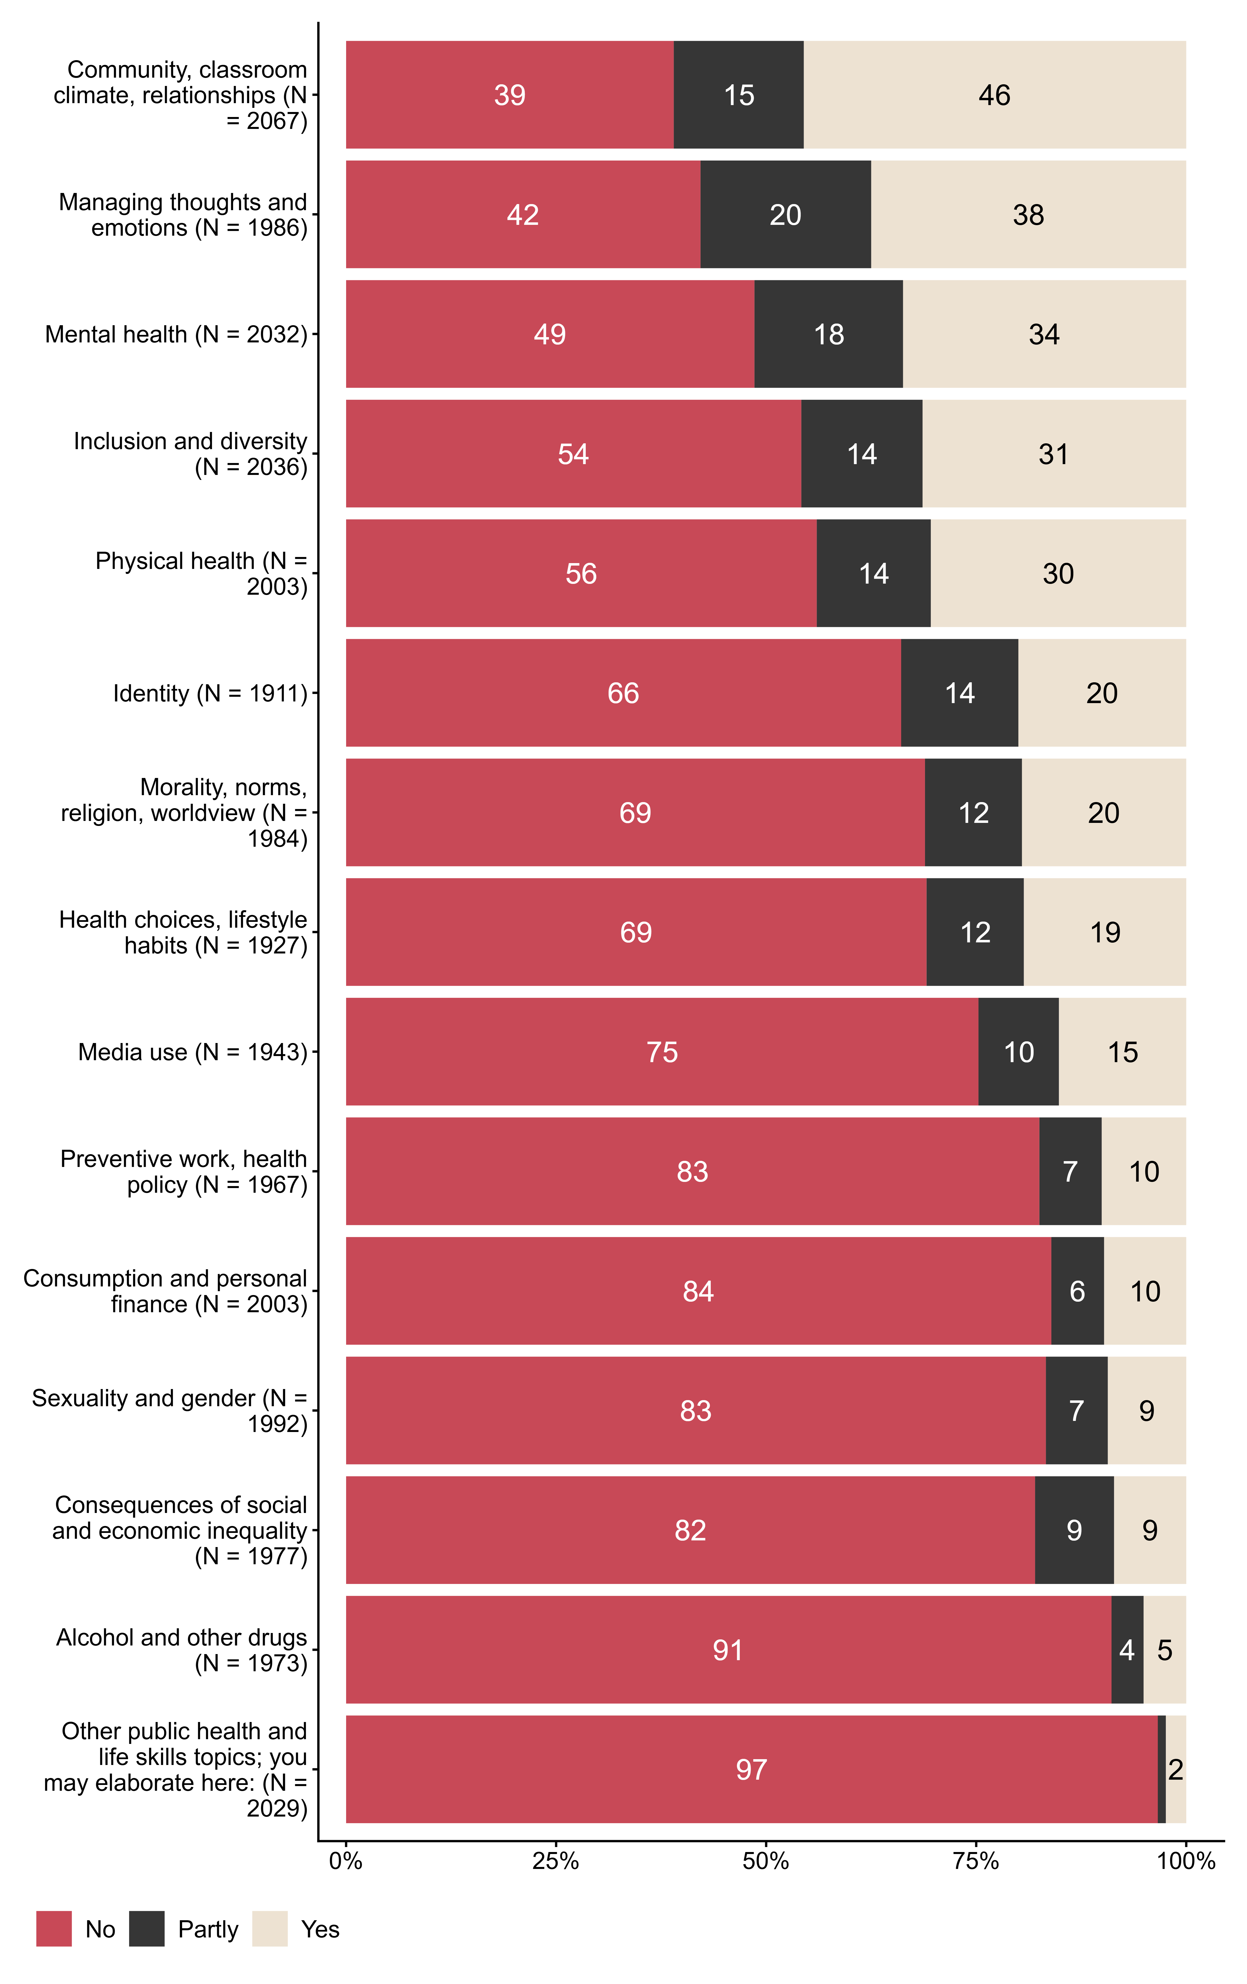
Figur 4.3. Did you include any of the following public health and life skills topics in this lesson?. N = [1911–2067], Figurdata (XLSX), PNG. (Q_LG14_1,Q_LG14_2,Q_LG14_3,Q_LG14_4,Q_LG14_5,Q_LG14_6,Q_LG14_7,Q_LG14_8,Q_LG14_9,Q_LG14_10,Q_LG14_11,Q_LG14_12,Q_LG14_13,Q_LG14_14,Q_LG14_15)

4.4 How did you facilitate public health and life skills in this lesson?
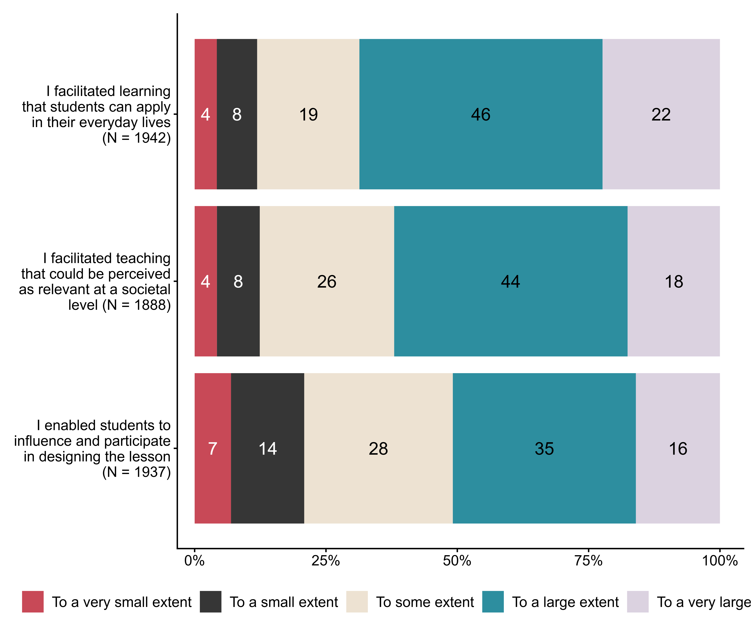
Figur 4.4. How did you facilitate public health and life skills in this lesson?. N = [1888–1942], Figurdata (XLSX), PNG. (Q_LG15_1,Q_LG15_2,Q_LG15_3)

4.5 Did you involve other people when you included public health and life skills (FoL) in the lesson?
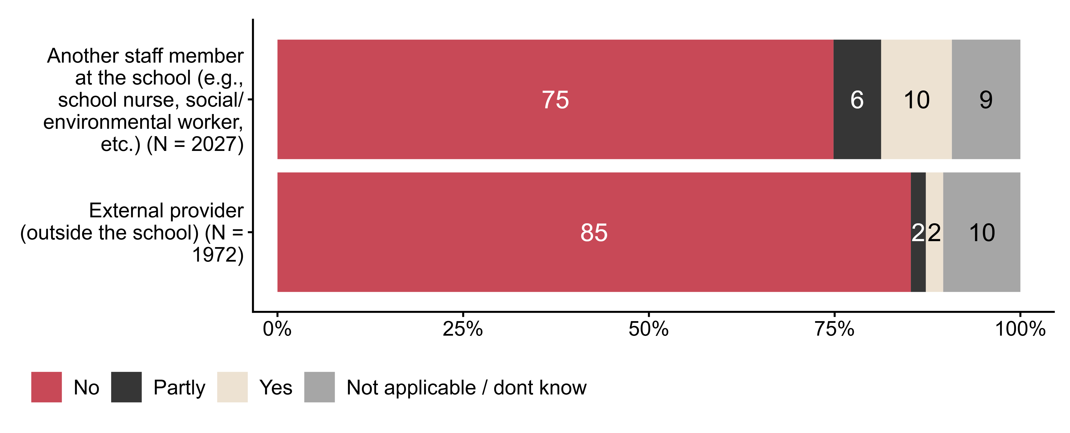
Figur 4.5. Did you involve other people when you included public health and life skills (FoL) in the lesson?. N = [1972–2027], Figurdata (XLSX), PNG. (Q_LG16_1,Q_LG16_2)

4.6 To what extent was public health and life skills included spontaneously in the lesson due to situations that arose just before or during the teaching?
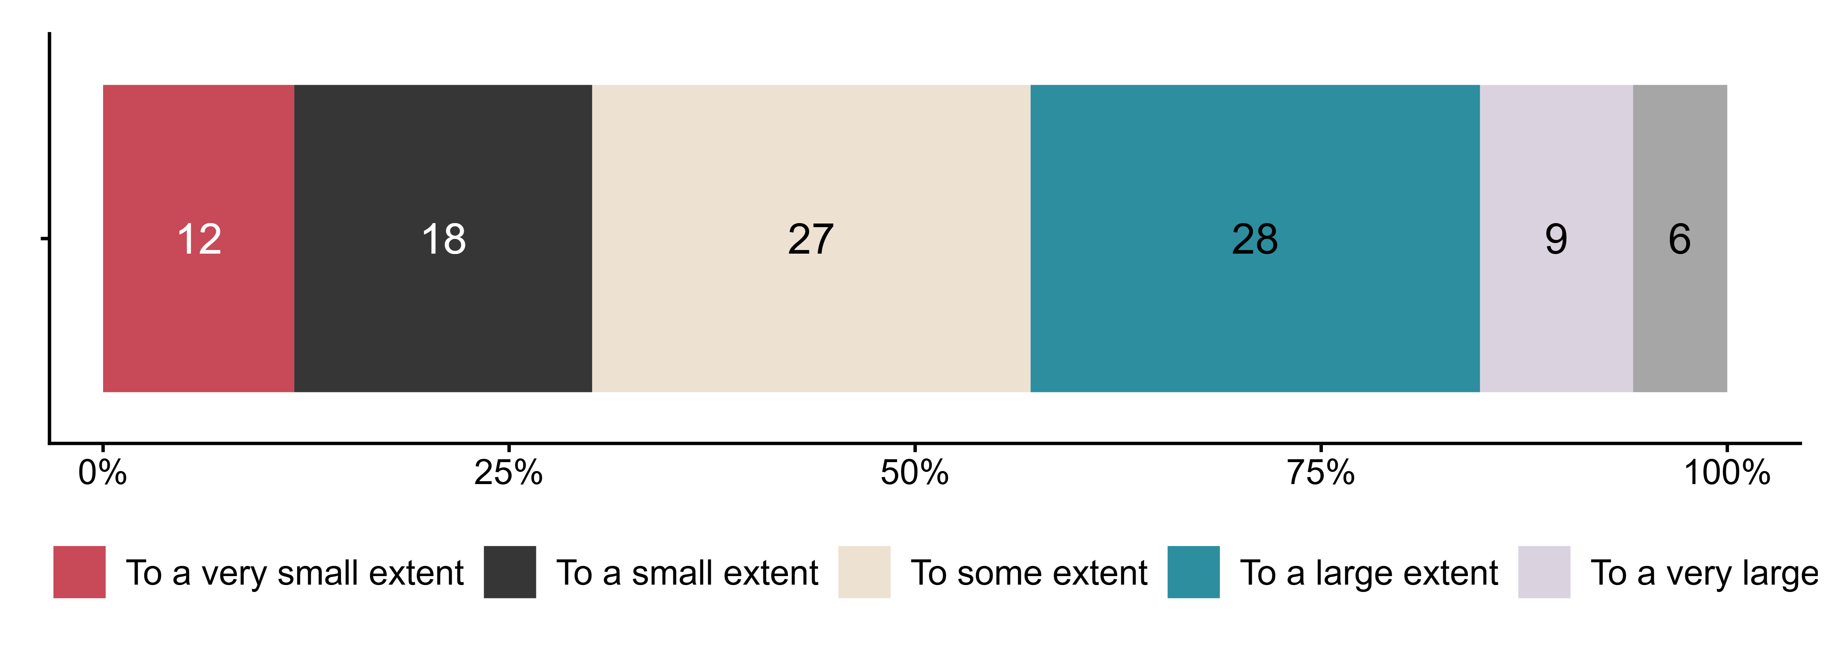
Figur 4.6. To what extent was public health and life skills included spontaneously in the lesson due to situations that arose just before or during the teaching?. N = 2049, Figurdata (XLSX), PNG. (Q_LG17)

4.7 Which of the following categories describe the situation(s) that may have led to spontaneous inclusion of public health and life skills in the lesson?
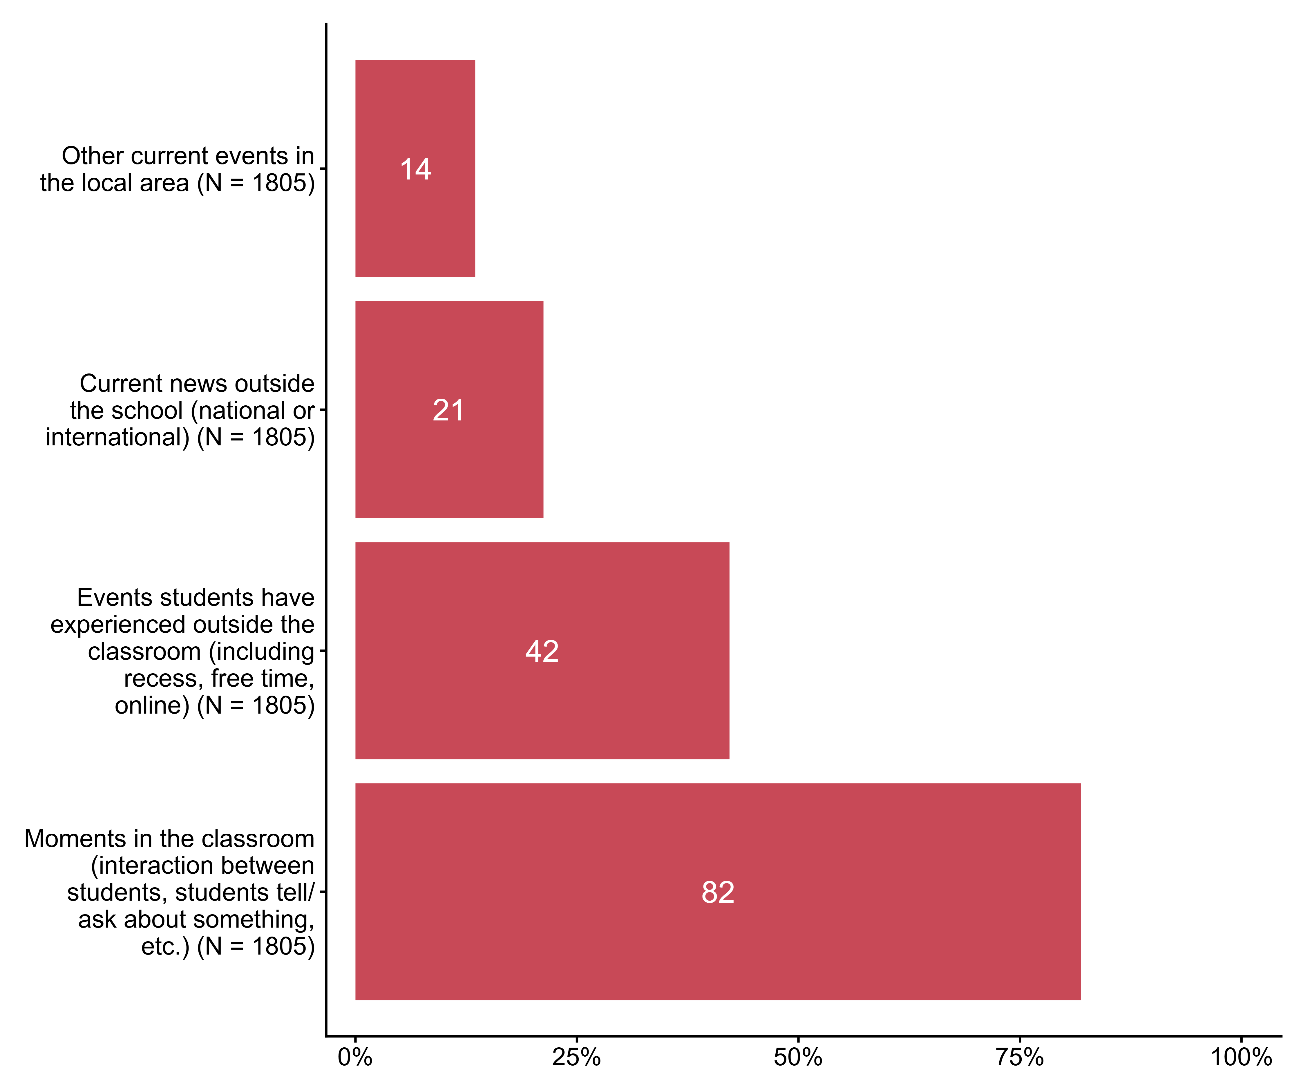
Figur 4.7. Which of the following categories describe the situation(s) that may have led to spontaneous inclusion of public health and life skills in the lesson?. N = 1805, Figurdata (XLSX), PNG. (Q_LG18_1,Q_LG18_2,Q_LG18_3,Q_LG18_4)

4.8 Did you use the following learning activities when you worked with public health and life skills in the lesson?
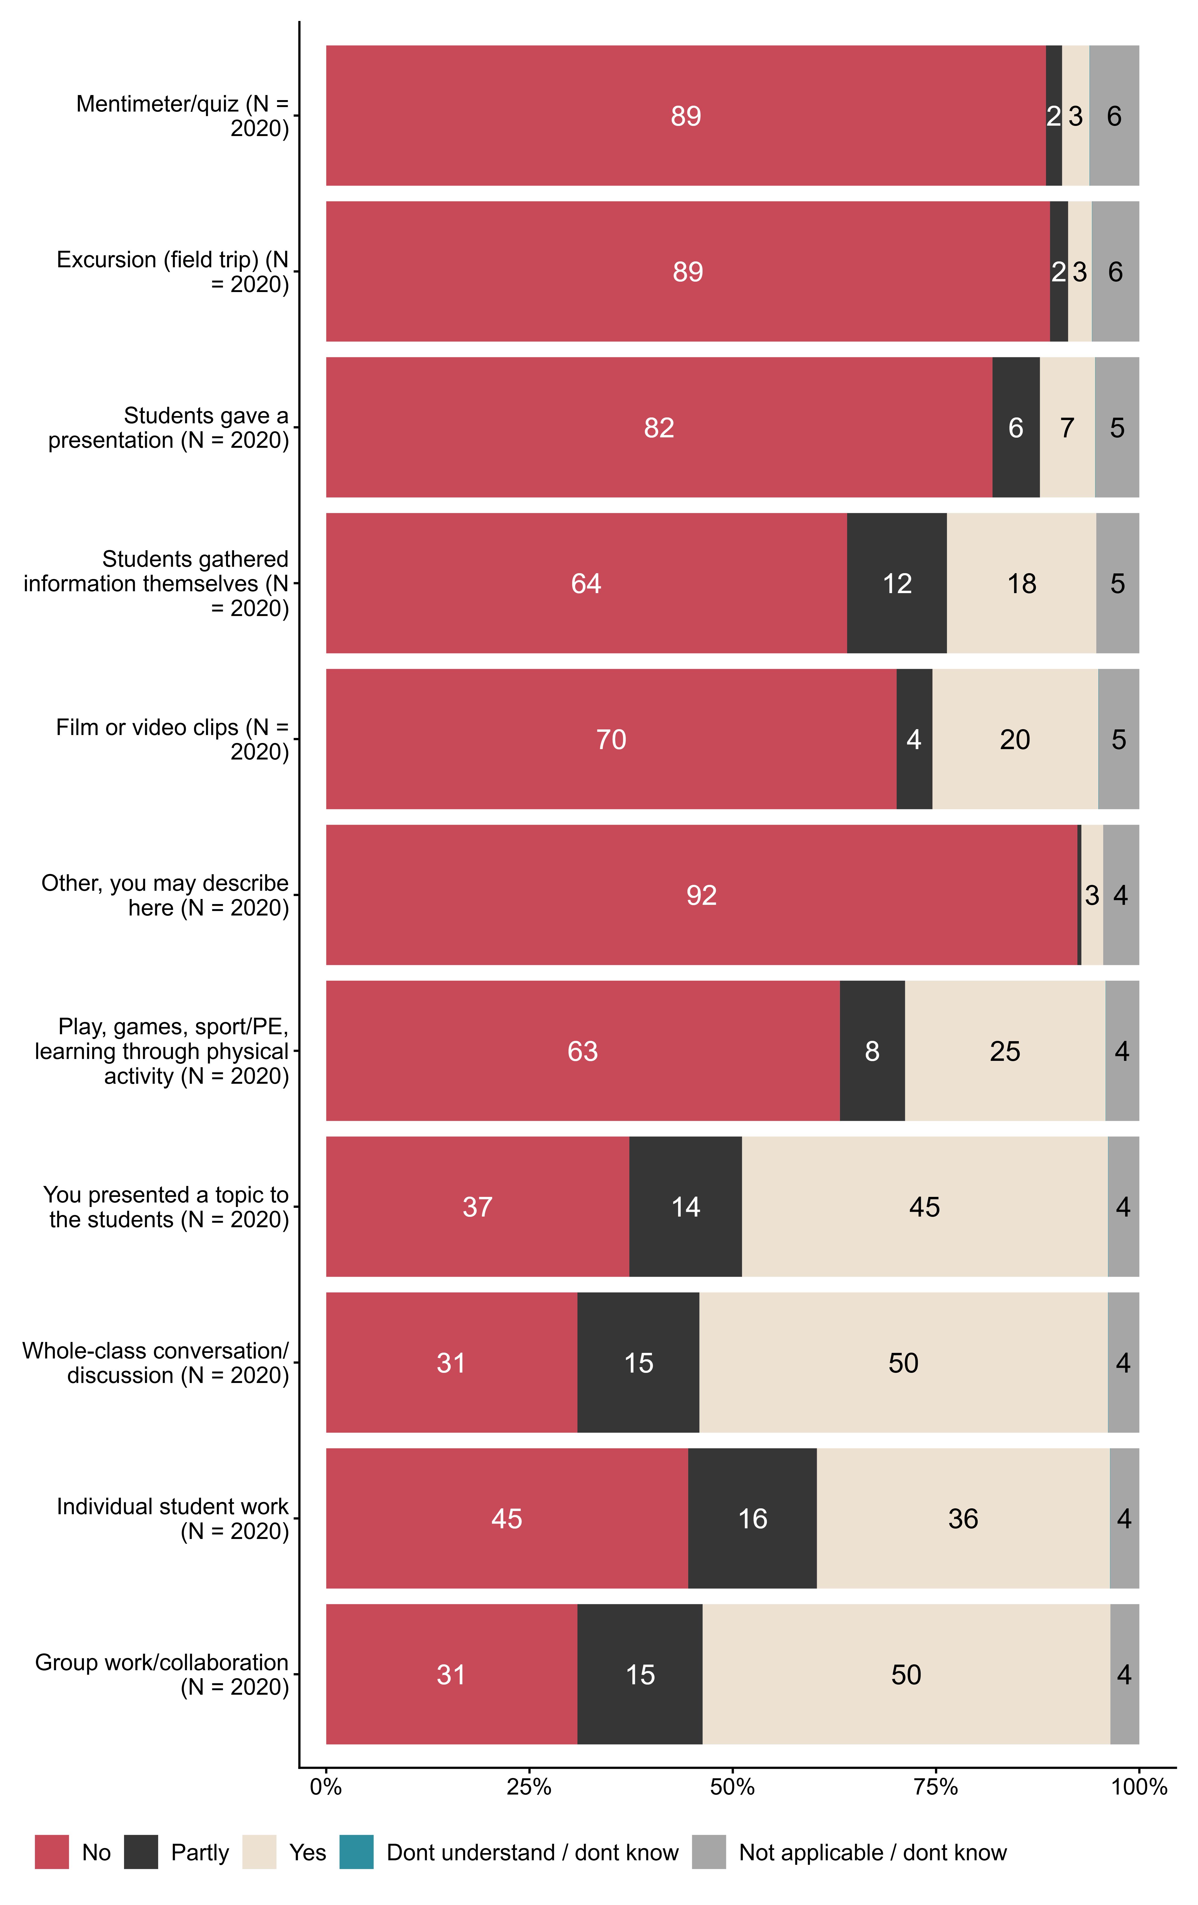
Figur 4.8. Did you use the following learning activities when you worked with public health and life skills in the lesson?. N = 2020, Figurdata (XLSX), PNG. (Q_LG19_1,Q_LG19_2,Q_LG19_3,Q_LG19_4,Q_LG19_5,Q_LG19_6,Q_LG19_7,Q_LG19_8,Q_LG19_9,Q_LG19_10,Q_LG19_11)

4.9 How actively and engaged would you say students participated in this lesson? Drag the slider between 0 (passive/not engaged) and 10 (very active/very engaged).
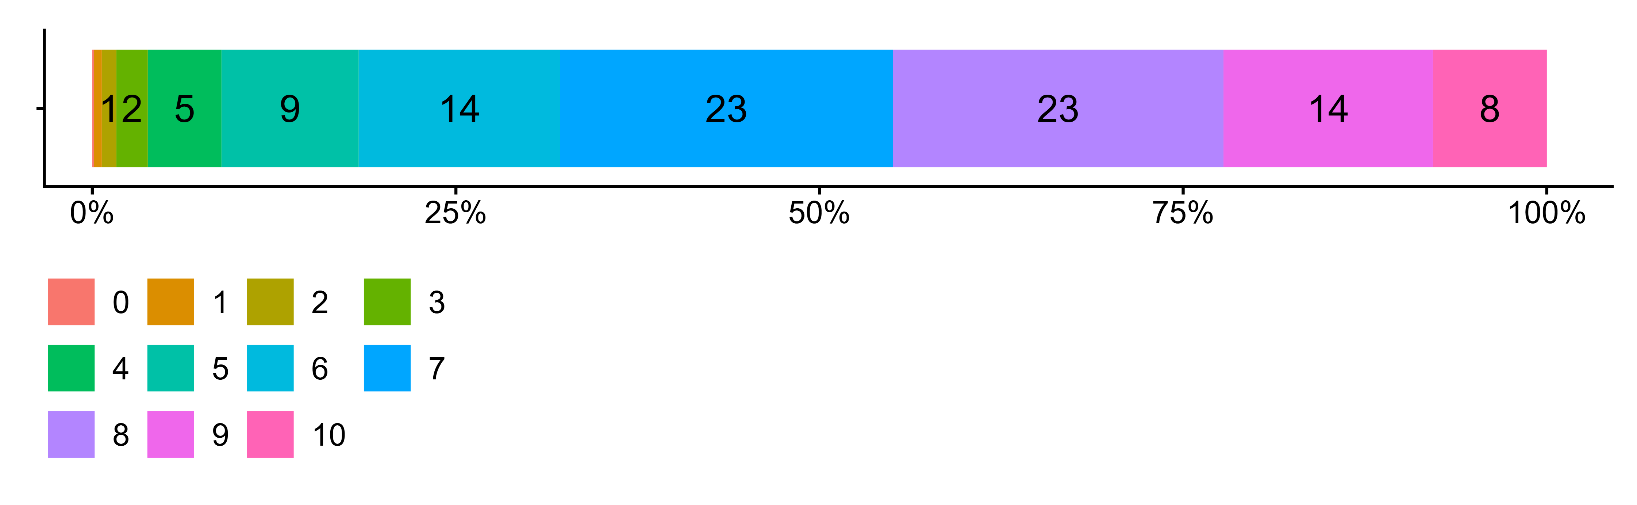
Figur 4.9. How actively and engaged would you say students participated in this lesson? Drag the slider between 0 (passive/not engaged) and 10 (very active/very engaged).. N = 1993, Figurdata (XLSX), PNG. (Q_LG20_3)

4.10 Was the teaching carried out as you had planned?
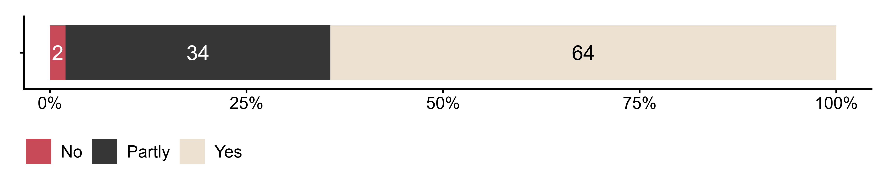
Figur 4.10. Was the teaching carried out as you had planned?. N = 2016, Figurdata (XLSX), PNG. (Q_LG21)

4.11 Why did it not go as planned?
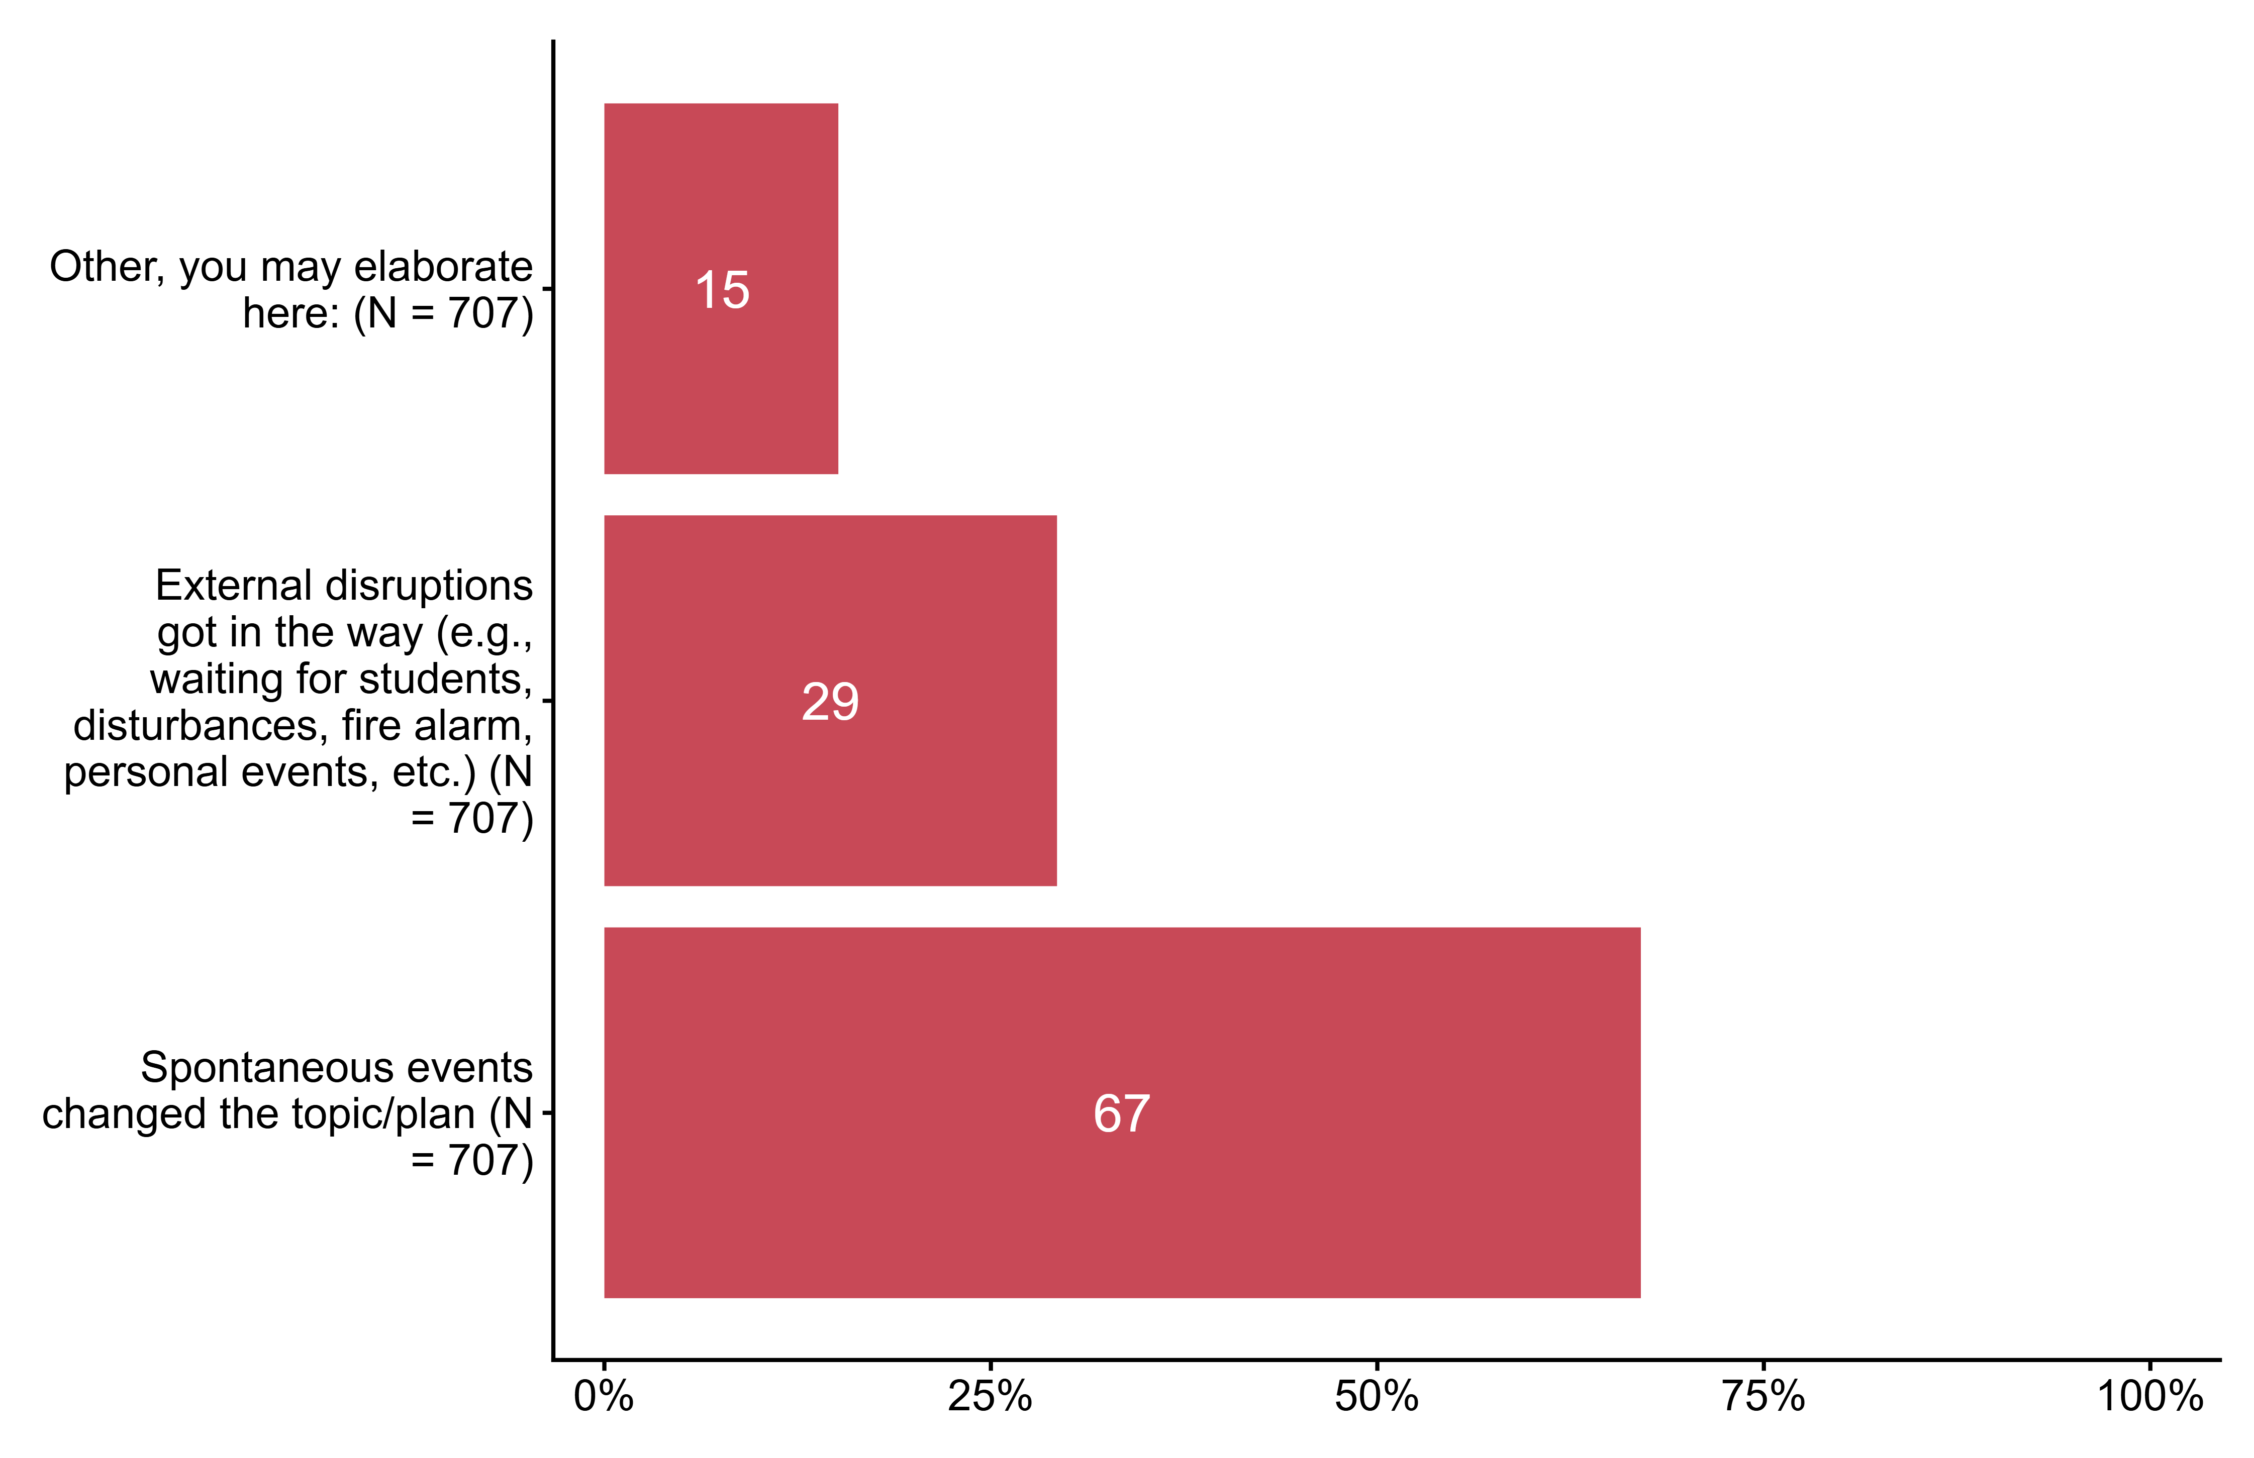
Figur 4.11. Why did it not go as planned?. N = 707, Figurdata (XLSX), PNG. (Q_LG22_1,Q_LG22_2,Q_LG22_7)

4.12 Which subject did you teach?
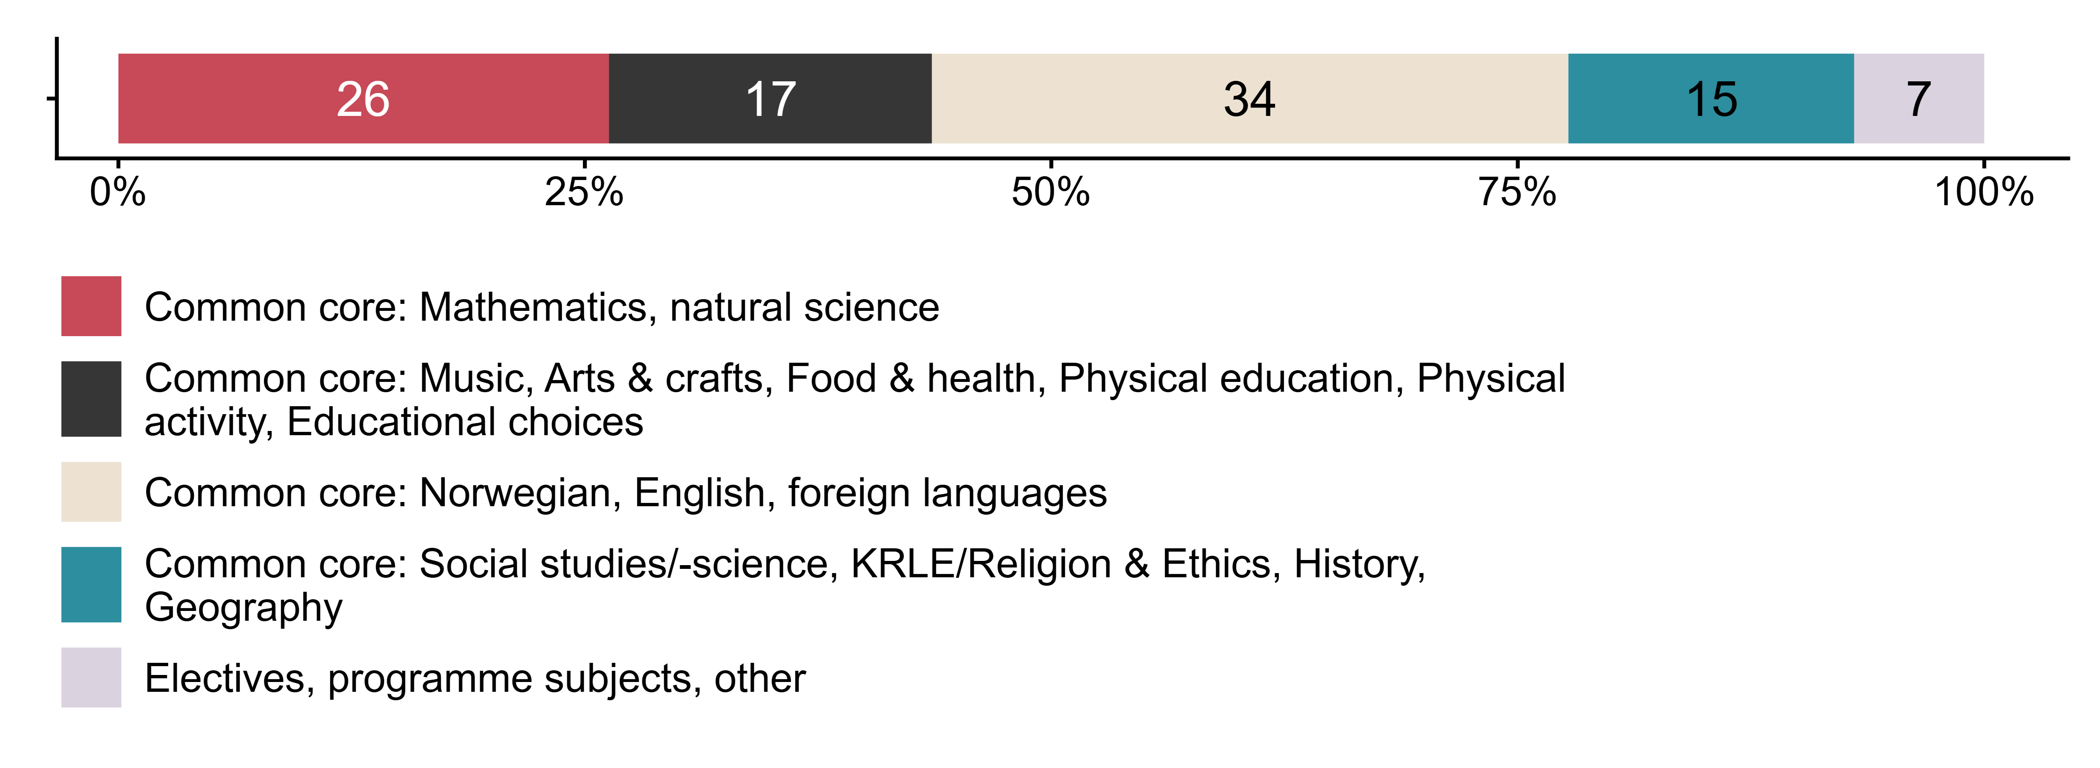
Figur 4.12. Which subject did you teach?. N = 2108, Figurdata (XLSX), PNG. (Q_LG8_DERIVED)

