Compulsory school teacher questionnaires
Innholdsfortegnelse

Figurer

Tabeller

3. Teacher questionnaires in compulsory schools

3.1 Which grade levels do you teach?
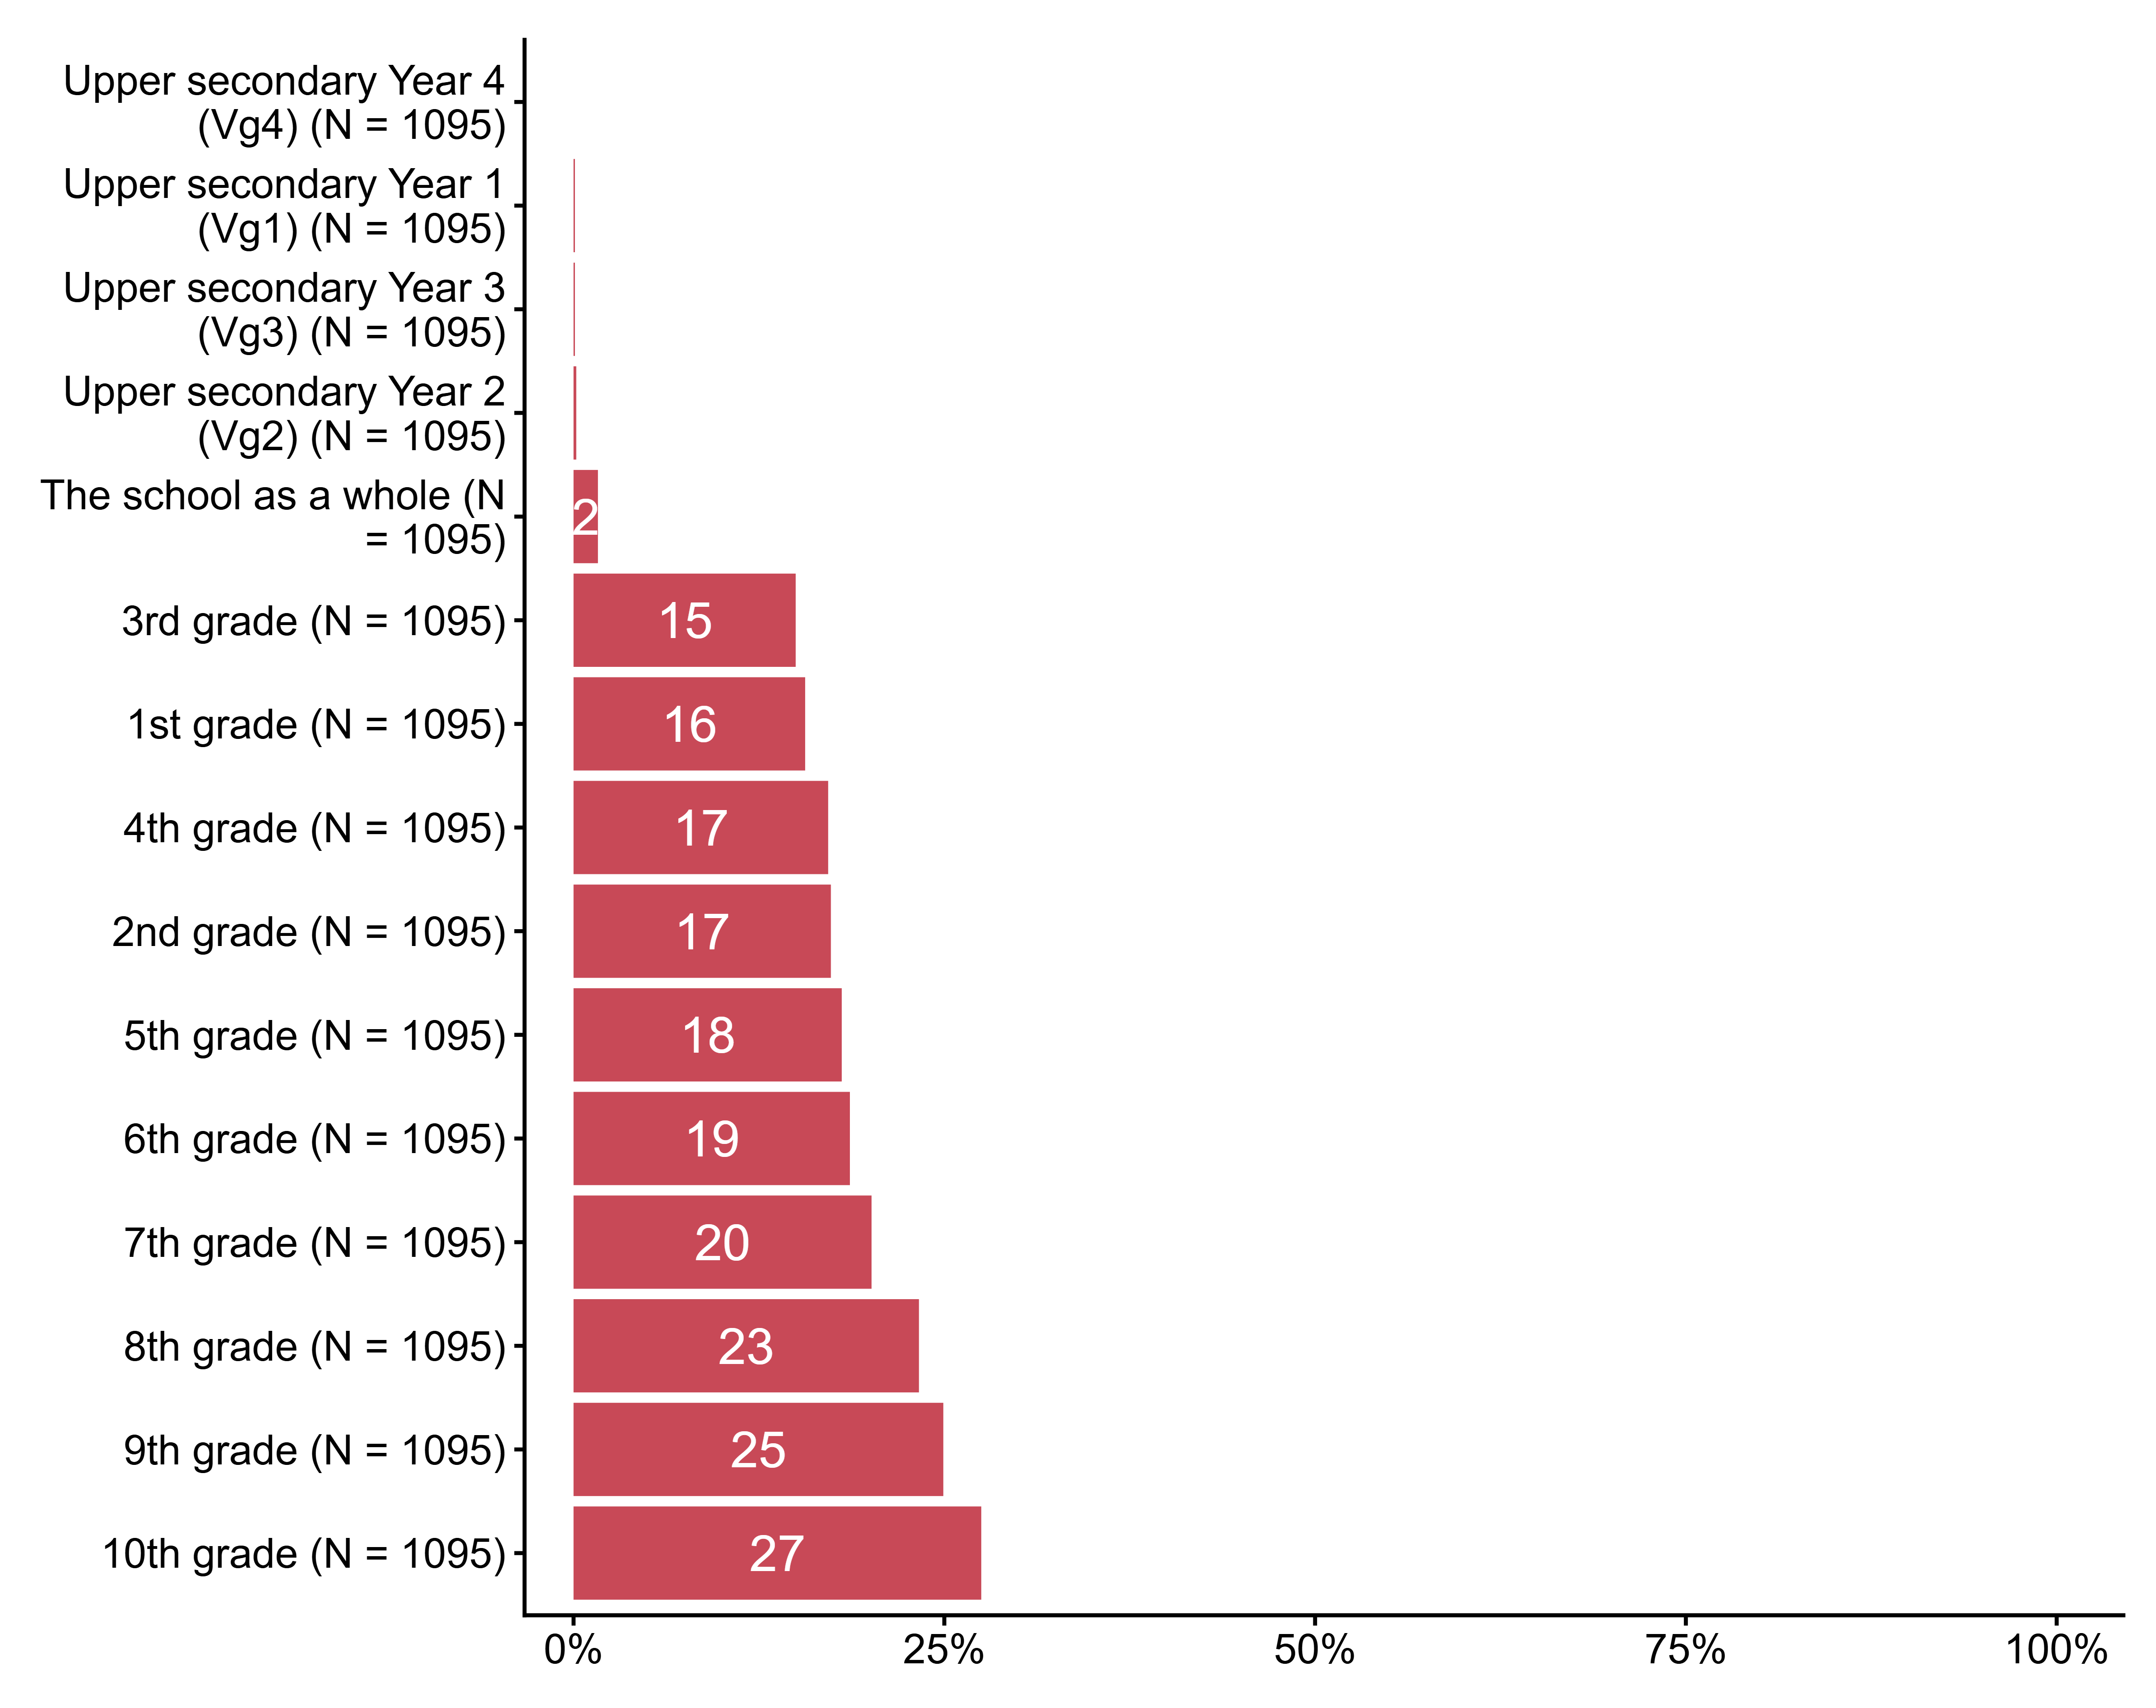
Figur 3.1. Which grade levels do you teach?. N = 1095, Figurdata (XLSX), PNG. (Q_LS7_1,Q_LS7_2,Q_LS7_3,Q_LS7_4,Q_LS7_5,Q_LS7_6,Q_LS7_7,Q_LS7_8,Q_LS7_9,Q_LS7_10,Q_LS7_11,Q_LS7_12,Q_LS7_13,Q_LS7_14,Q_LS7_15)

3.2 In some of the questions and statements we will take as our starting point a specific subject. Choose the subject you most recently taught.
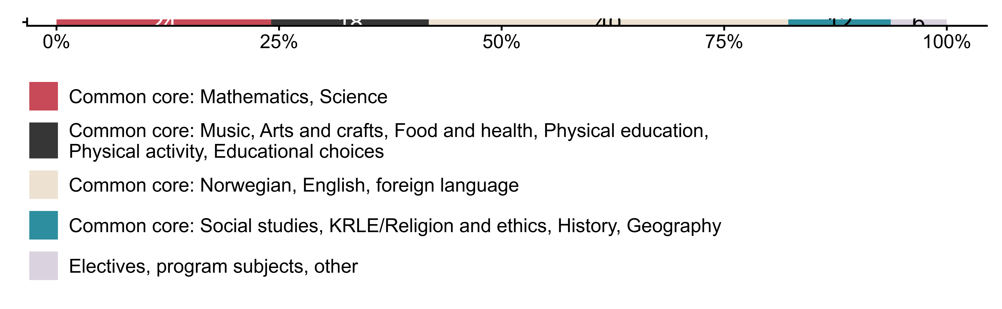
Figur 3.2. In some of the questions and statements we will take as our starting point a specific subject. Choose the subject you most recently taught.. N = 1112, Figurdata (XLSX), PNG. (Q_LS12_DERIVED)

3.3 How familiar are you with what is written about public health and life skills (FoL) in LK20?
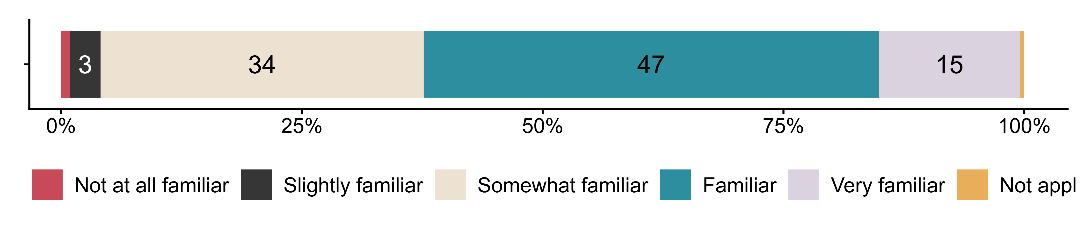
Figur 3.3. How familiar are you with what is written about public health and life skills (FoL) in LK20?. N = 1100, Figurdata (XLSX), PNG. (Q_LS14)

3.4 How do you view your work with public health and life skills (FoL)?
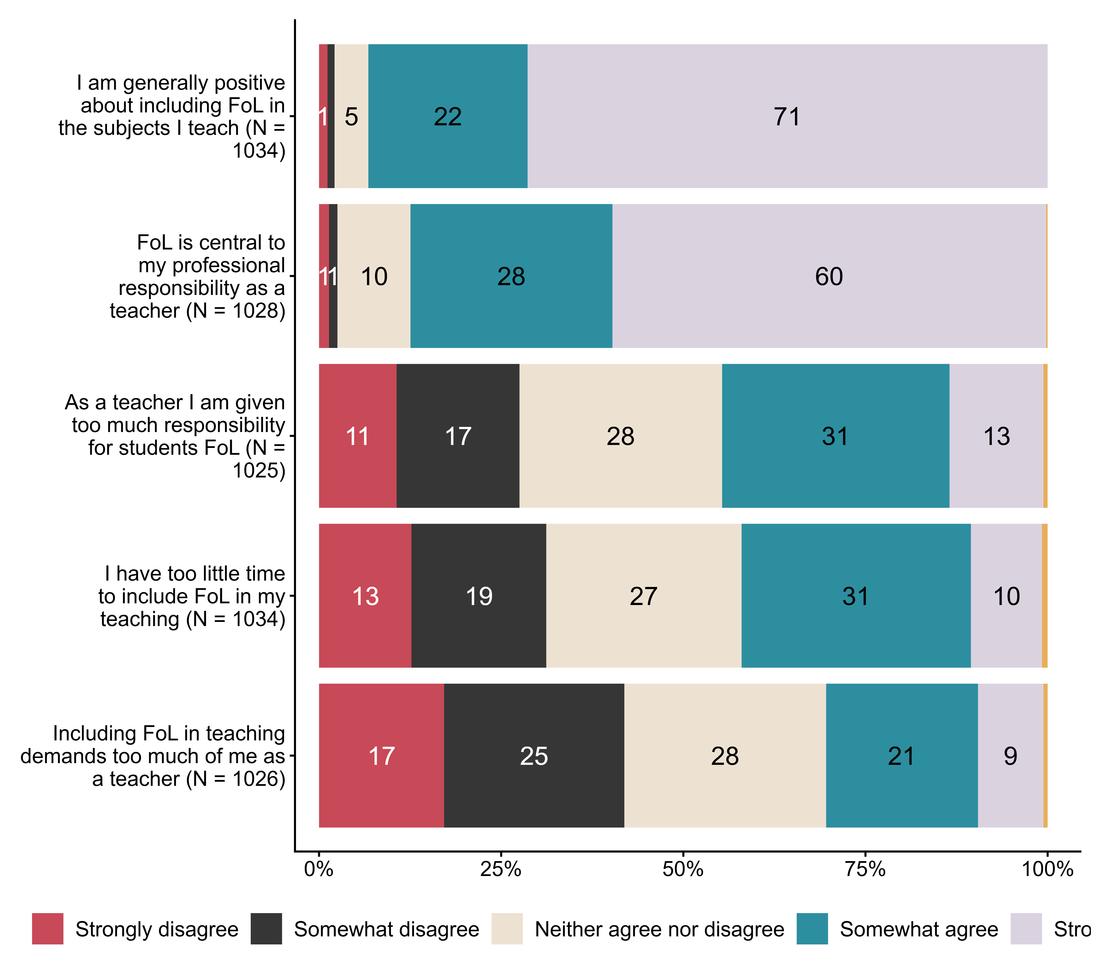
Figur 3.4. How do you view your work with public health and life skills (FoL)?. N = [1025–1034], Figurdata (XLSX), PNG. (Q_LS15_1,Q_LS15_2,Q_LS15_3,Q_LS15_4,Q_LS15_5)

3.5 To what extent do you agree that the introduction of public health and life skills (FoL) in LK20
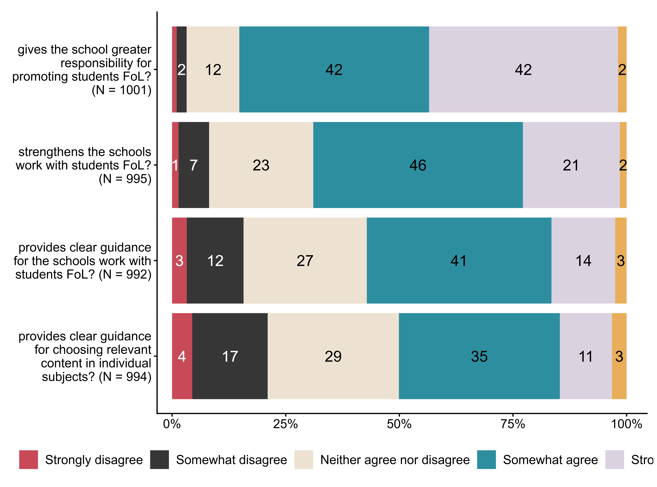
Figur 3.5. To what extent do you agree that the introduction of public health and life skills (FoL) in LK20. N = [992–1001], Figurdata (XLSX), PNG. (Q_LS17_1,Q_LS17_2,Q_LS17_3,Q_LS17_4)

3.6 To what extent do you agree that your school’s work with the theme public health and life skills
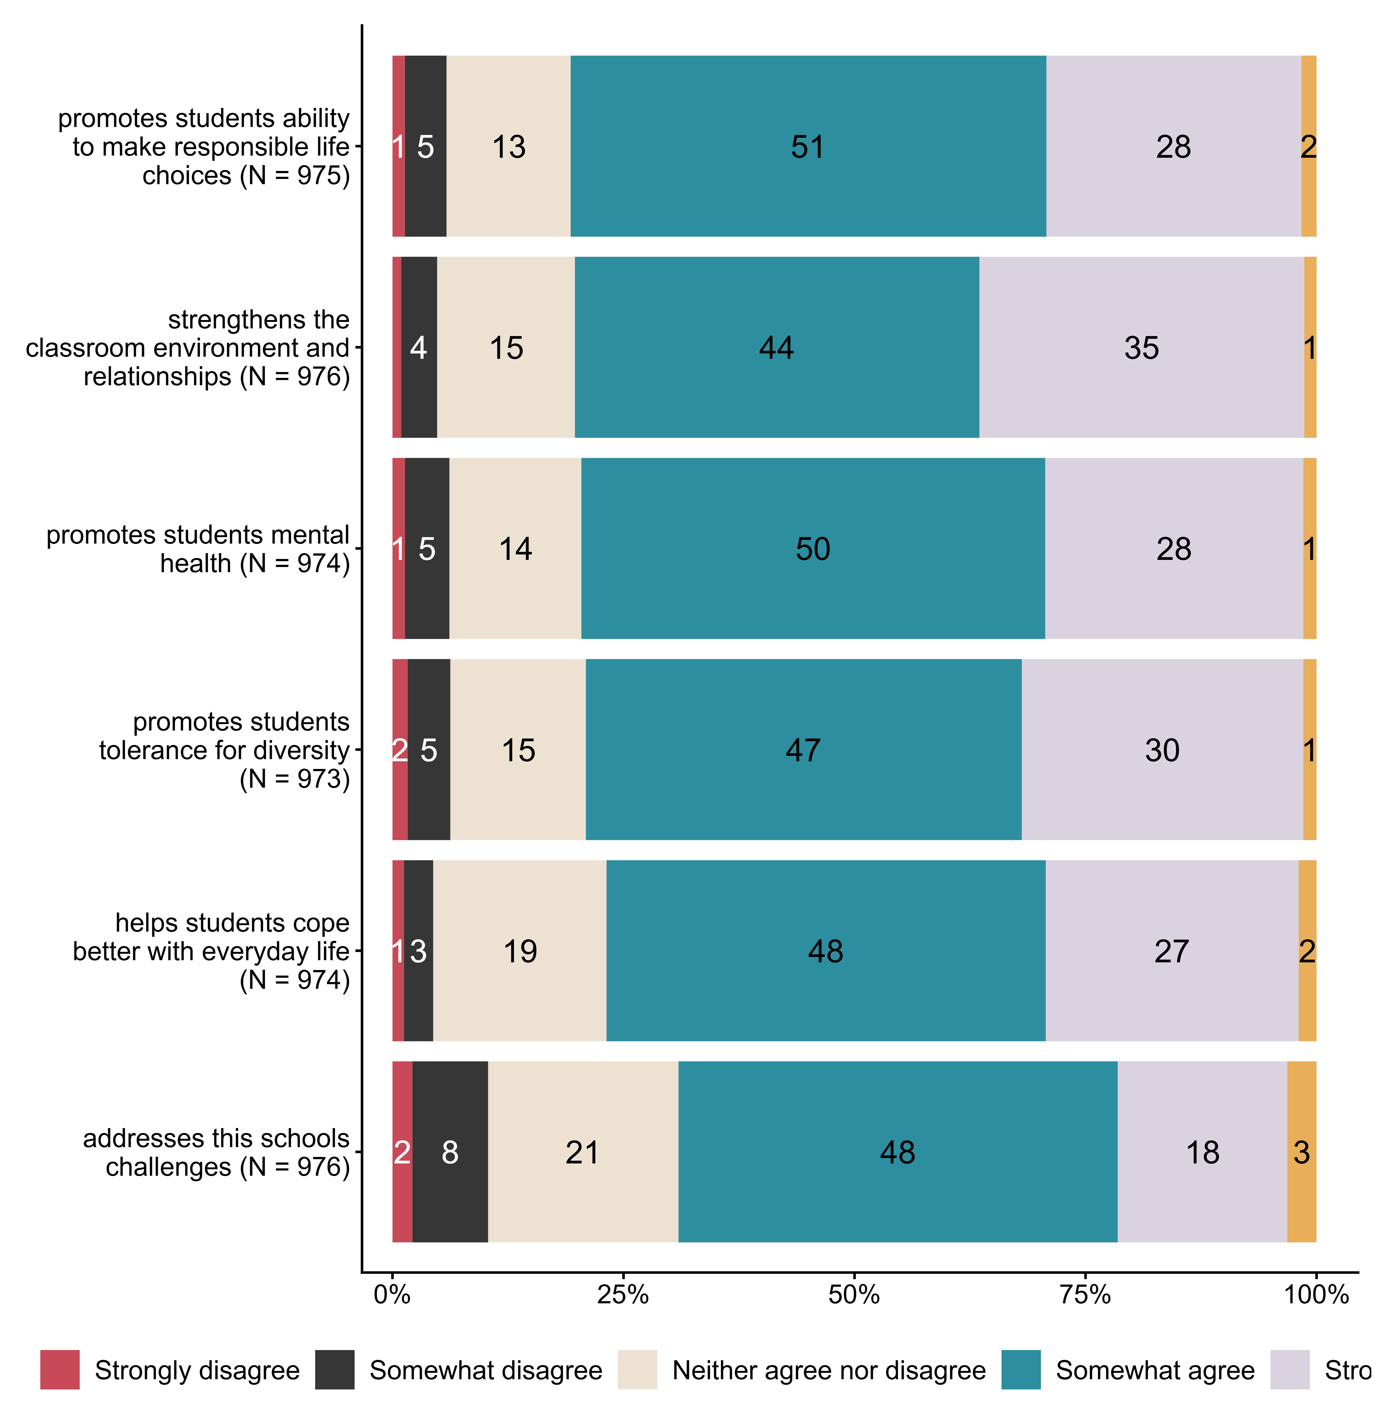
Figur 3.6. To what extent do you agree that your school’s work with the theme public health and life skills. N = [973–976], Figurdata (XLSX), PNG. (Q_LS18_1,Q_LS18_2,Q_LS18_3,Q_LS18_4,Q_LS18_5,Q_LS18_6)

3.7 How much do you disagree/agree with the following statements about work with public health and life skills (FoL) in THE SUBJECT?
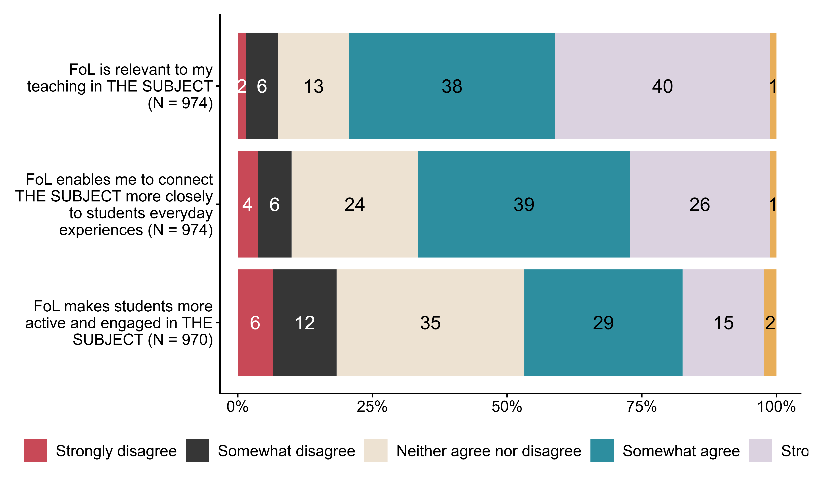
Figur 3.7. How much do you disagree/agree with the following statements about work with public health and life skills (FoL) in THE SUBJECT?. N = [970–974], Figurdata (XLSX), PNG. (Q_LS19_1,Q_LS19_2,Q_LS19_3)

3.8 How do you work with public health and life skills (FoL) at your school?
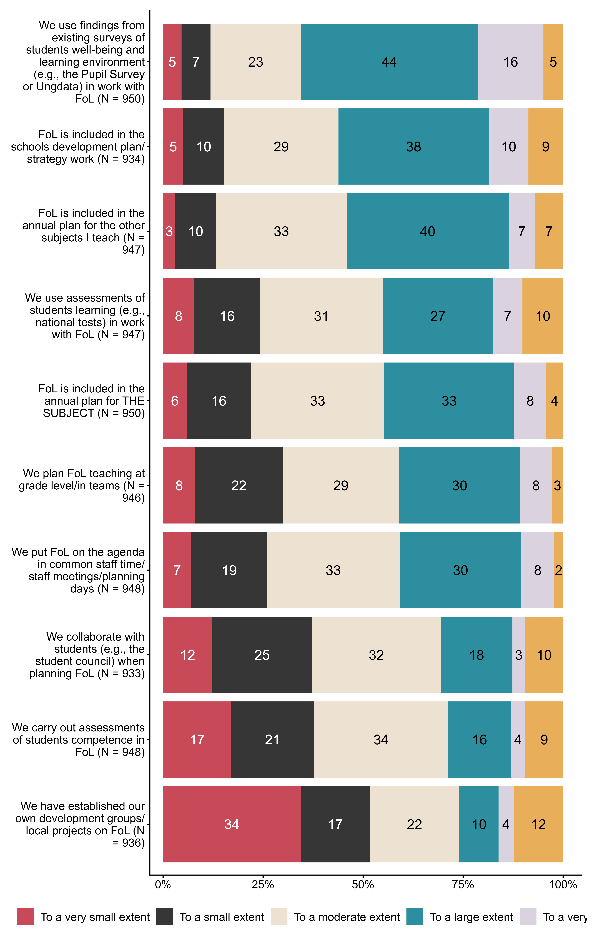
Figur 3.8. How do you work with public health and life skills (FoL) at your school?. N = [933–950], Figurdata (XLSX), PNG. (Q_LS21_1,Q_LS21_2,Q_LS21_3,Q_LS21_4,Q_LS21_5,Q_LS21_6,Q_LS22_1,Q_LS22_2,Q_LS22_3,Q_LS22_4)

3.9 How do you organize work with public health and life skills?
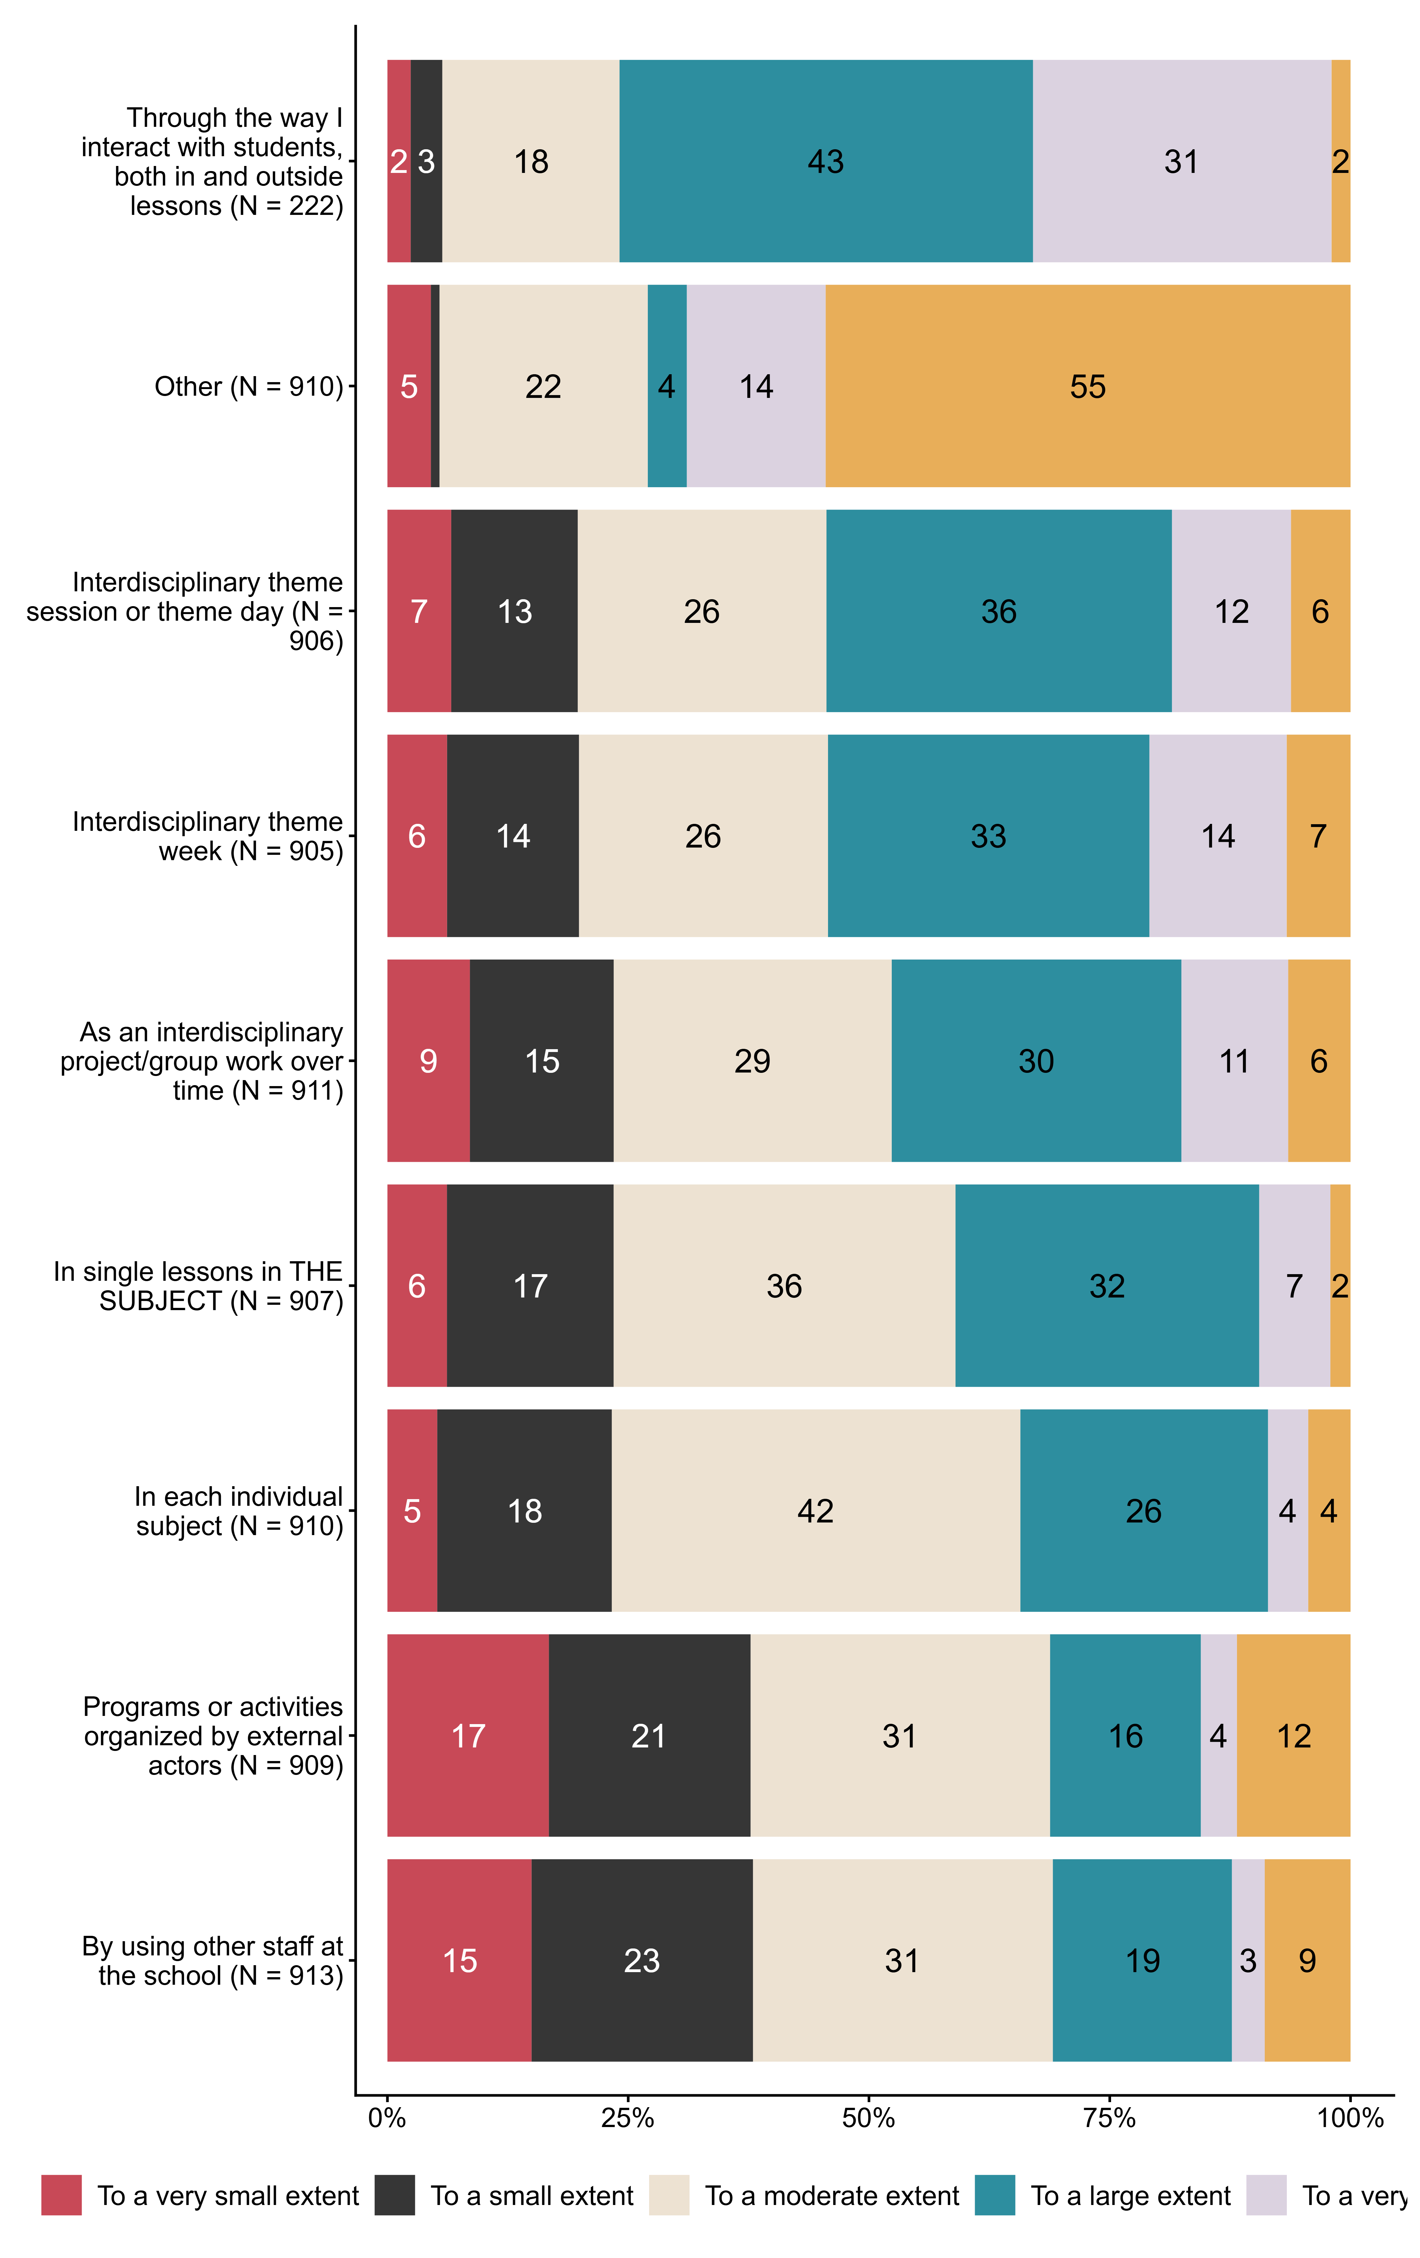
Figur 3.9. How do you organize work with public health and life skills?. N = [222–913], Figurdata (XLSX), PNG. (Q_LS23_1,Q_LS23_2,Q_LS23_3,Q_LS23_4,Q_LS23_5,Q_LS23_6,Q_LS23_7,Q_LS23_8,Q_LS23_9)

3.10 Which sources do you usually use to teach public health and life skills (FoL) in THE SUBJECT?
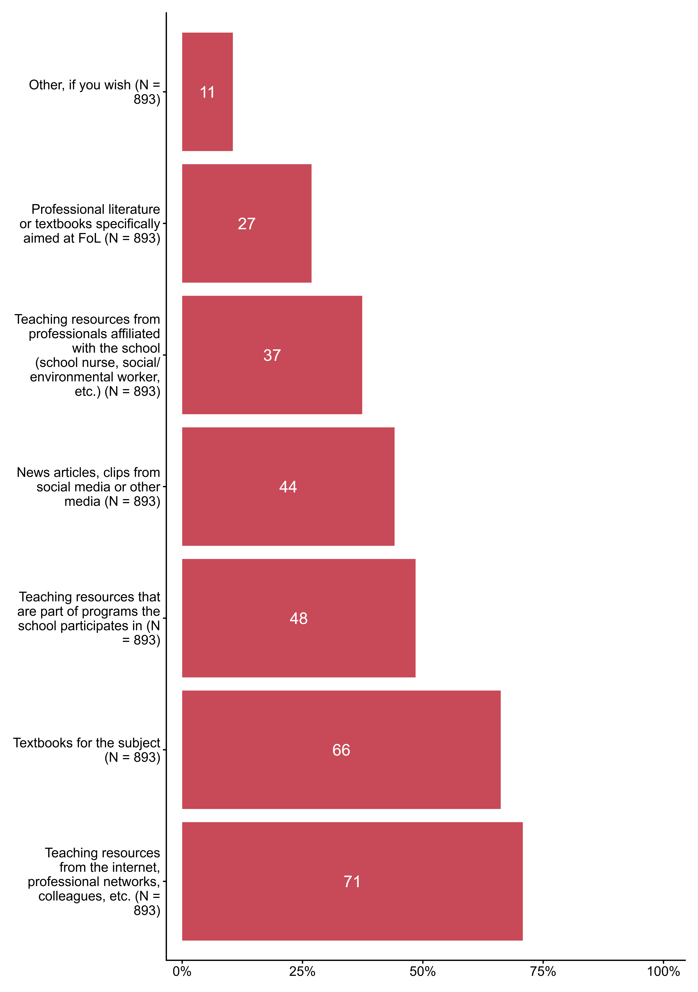
Figur 3.10. Which sources do you usually use to teach public health and life skills (FoL) in THE SUBJECT?. N = 893, Figurdata (XLSX), PNG. (Q_LS24_1,Q_LS24_28,Q_LS24_29,Q_LS24_30,Q_LS24_31,Q_LS24_32,Q_LS24_33)

3.11 Work with FoL can be planned, but can also occur spontaneously, often called ‘learning moments’. To what extent do you facilitate learning about public health and life skills in the following learning moments?
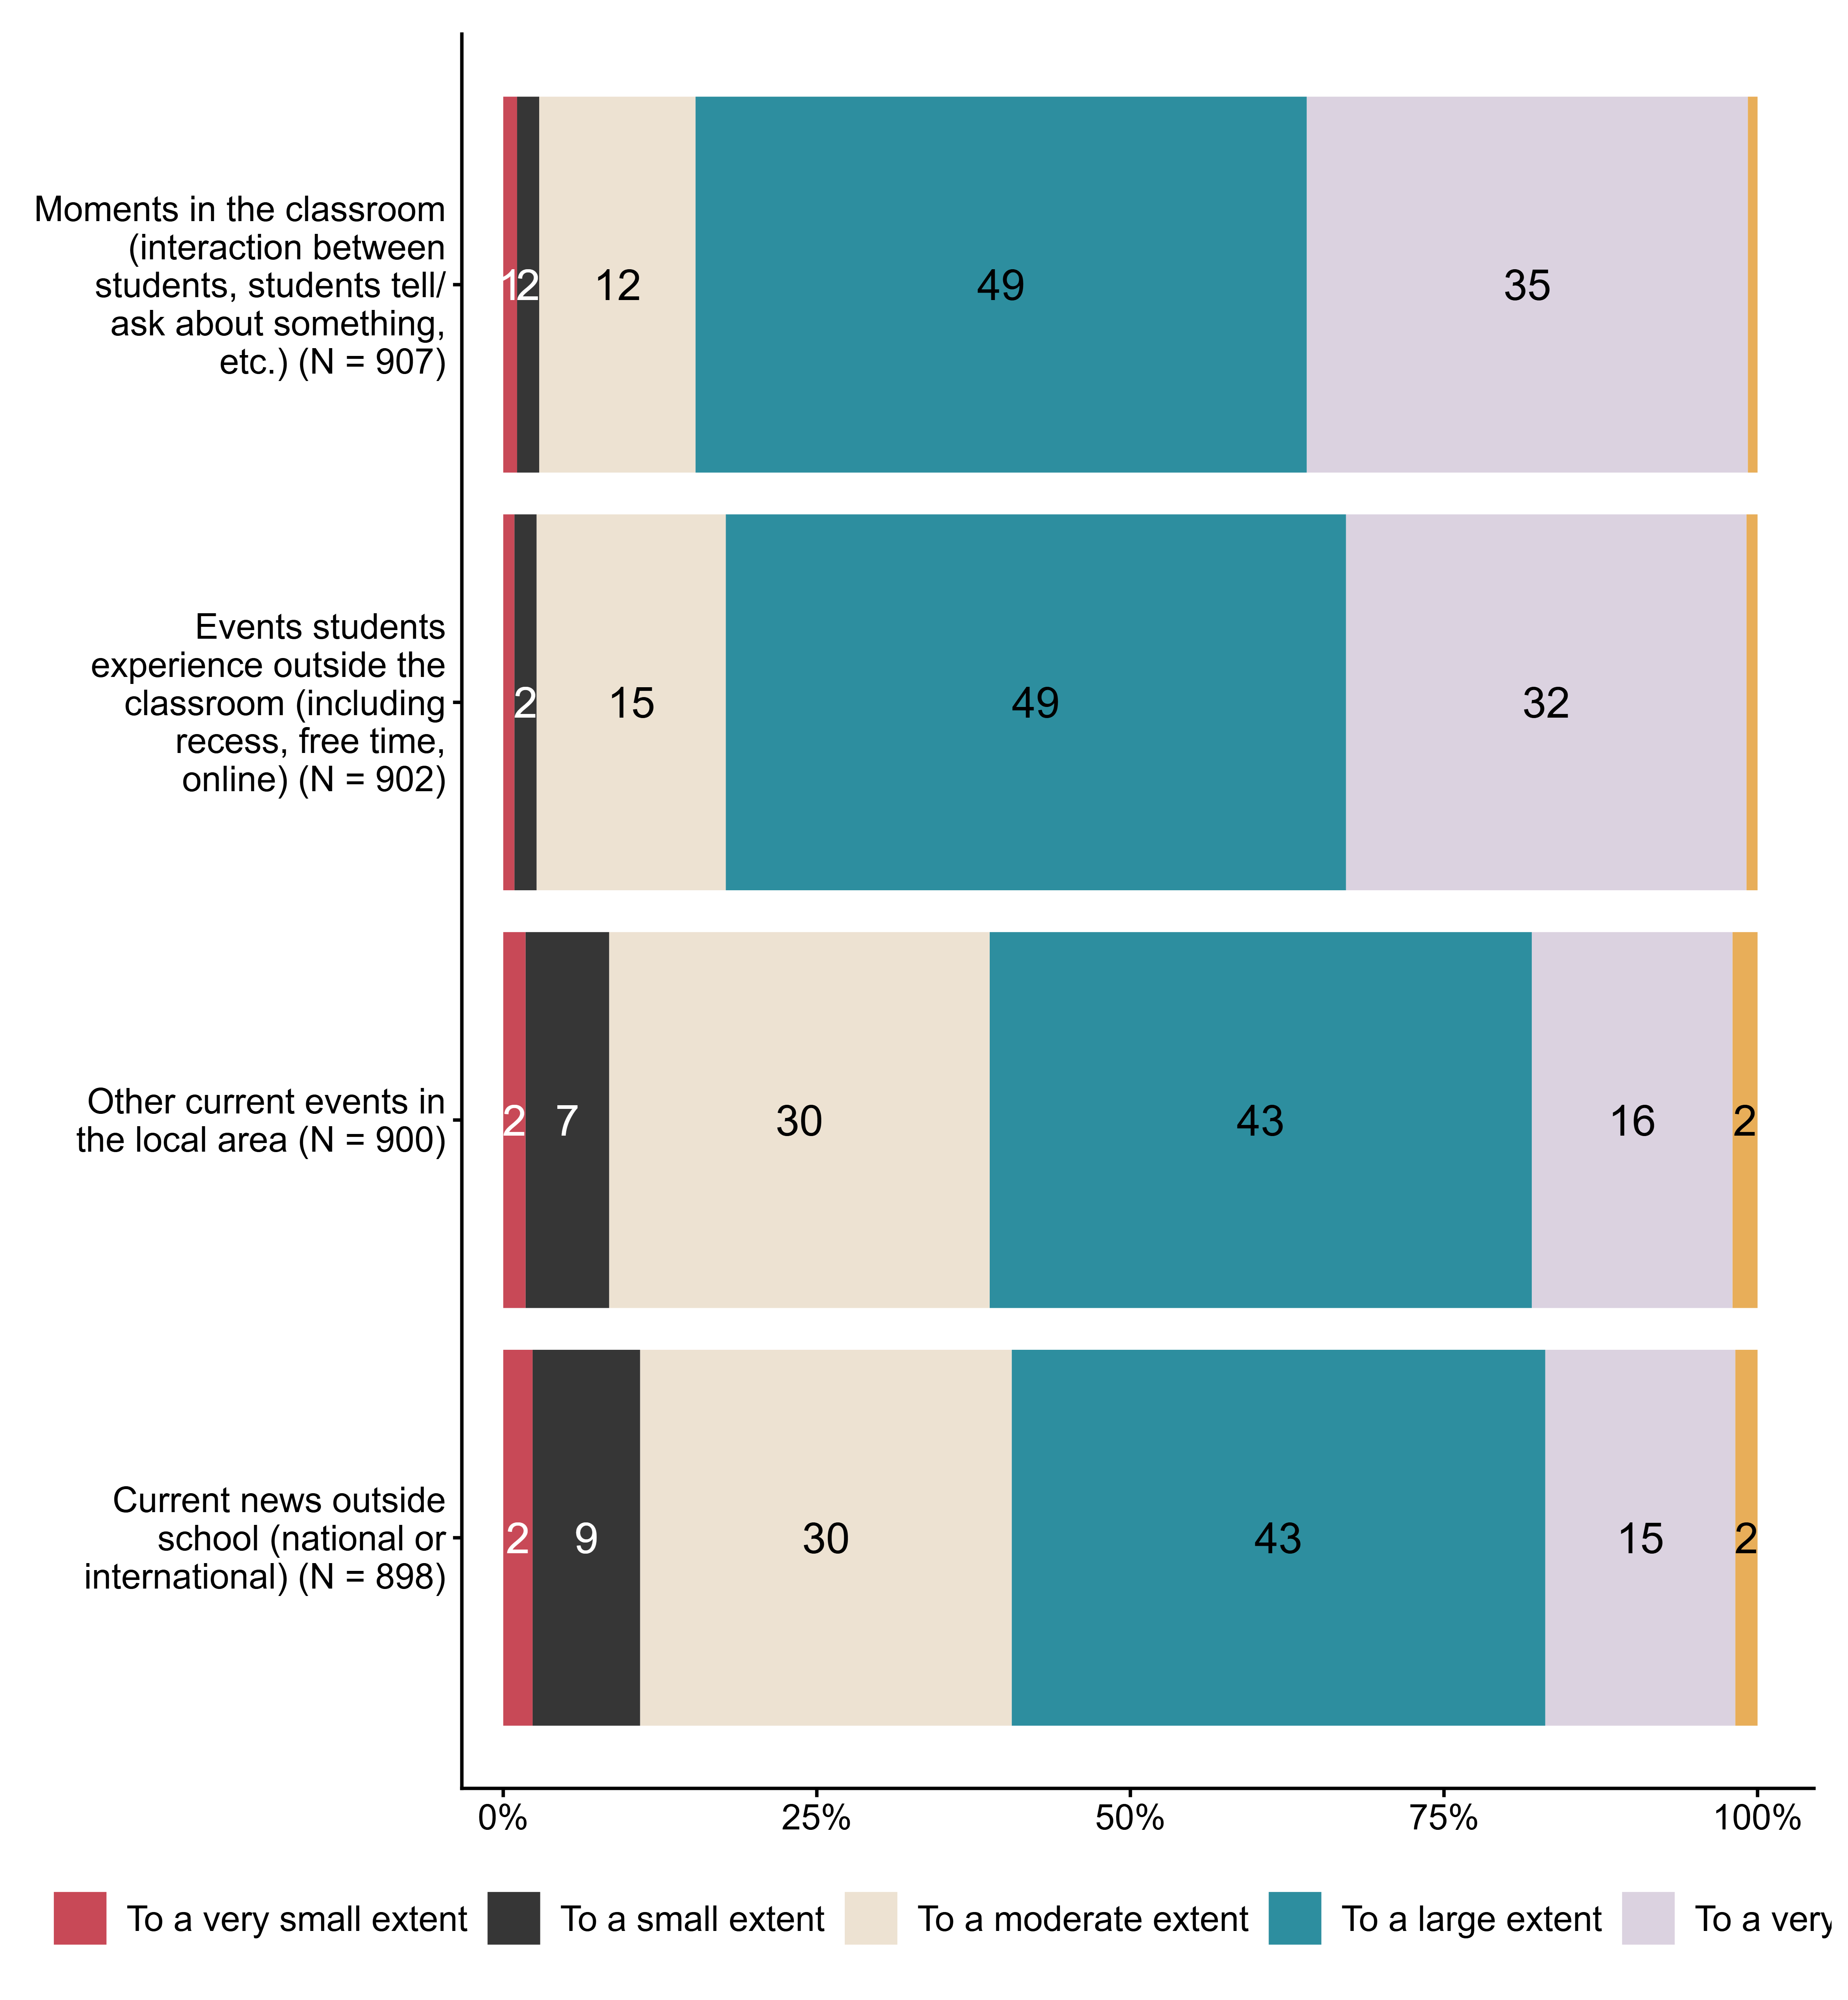
Figur 3.11. Work with FoL can be planned, but can also occur spontaneously, often called ‘learning moments’. To what extent do you facilitate learning about public health and life skills in the following learning moments?. N = [898–907], Figurdata (XLSX), PNG. (Q_LS25_1,Q_LS25_2,Q_LS25_3,Q_LS25_4)

3.12 To what extent do you agree with the following statements about your competence in public health and life skills (FoL)?
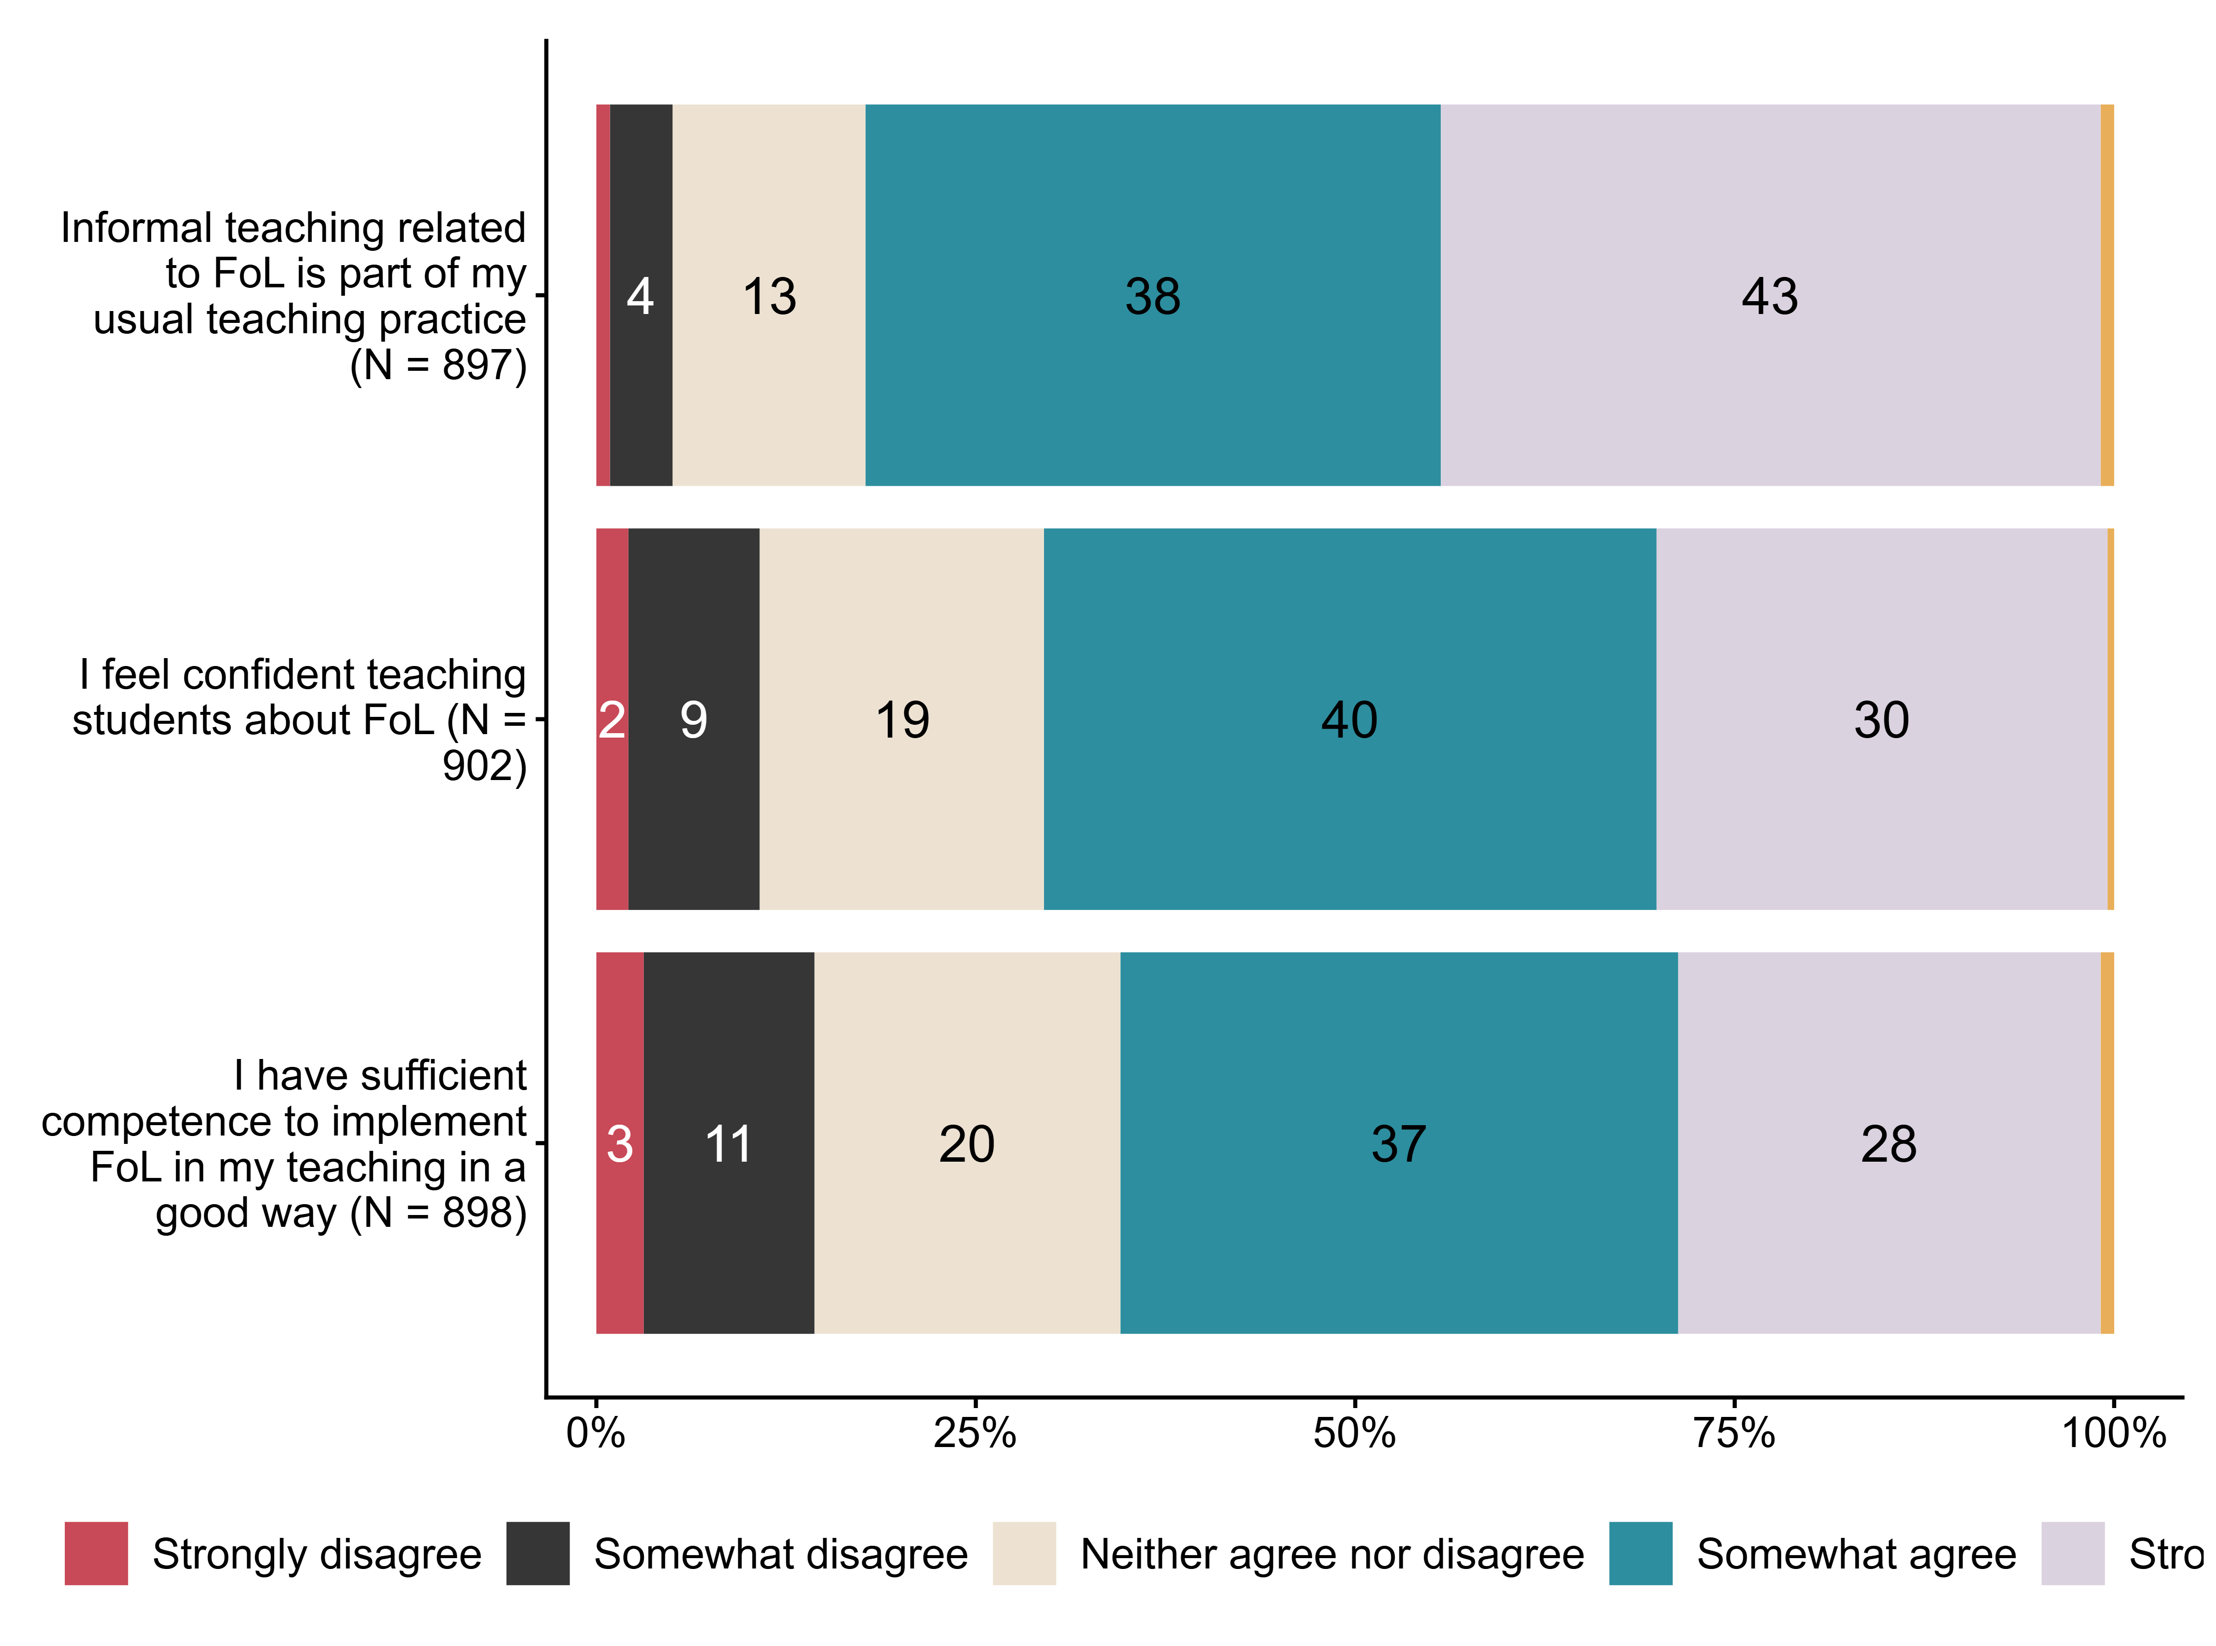
Figur 3.12. To what extent do you agree with the following statements about your competence in public health and life skills (FoL)?. N = [897–902], Figurdata (XLSX), PNG. (Q_LS27_1,Q_LS27_2,Q_LS27_3)

3.13 To what extent do you experience challenges connected to work with public health and life skills (FoL)?
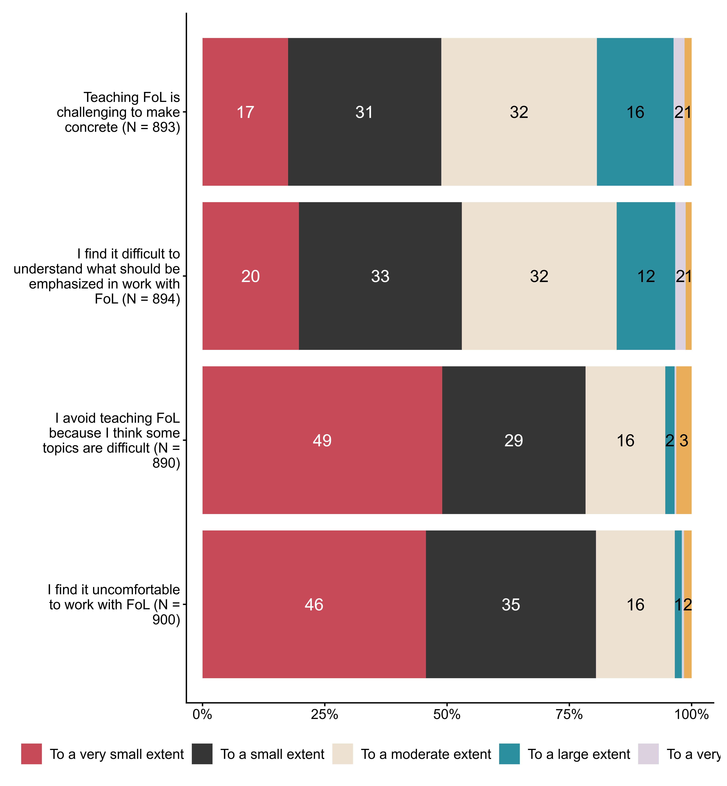
Figur 3.13. To what extent do you experience challenges connected to work with public health and life skills (FoL)?. N = [890–900], Figurdata (XLSX), PNG. (Q_LS28_1,Q_LS28_2,Q_LS28_3,Q_LS28_4)

3.14 To what extent do you agree with the following statements about competence-enhancing measures within public health and life skills (FoL)?
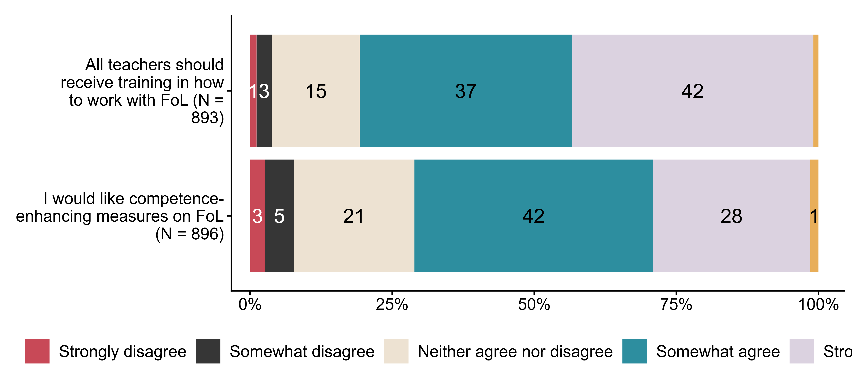
Figur 3.14. To what extent do you agree with the following statements about competence-enhancing measures within public health and life skills (FoL)?. N = [893–896], Figurdata (XLSX), PNG. (Q_LS29_1,Q_LS29_2)

3.15 To what extent do you use the following competence-enhancing measures related to public health and life skills?
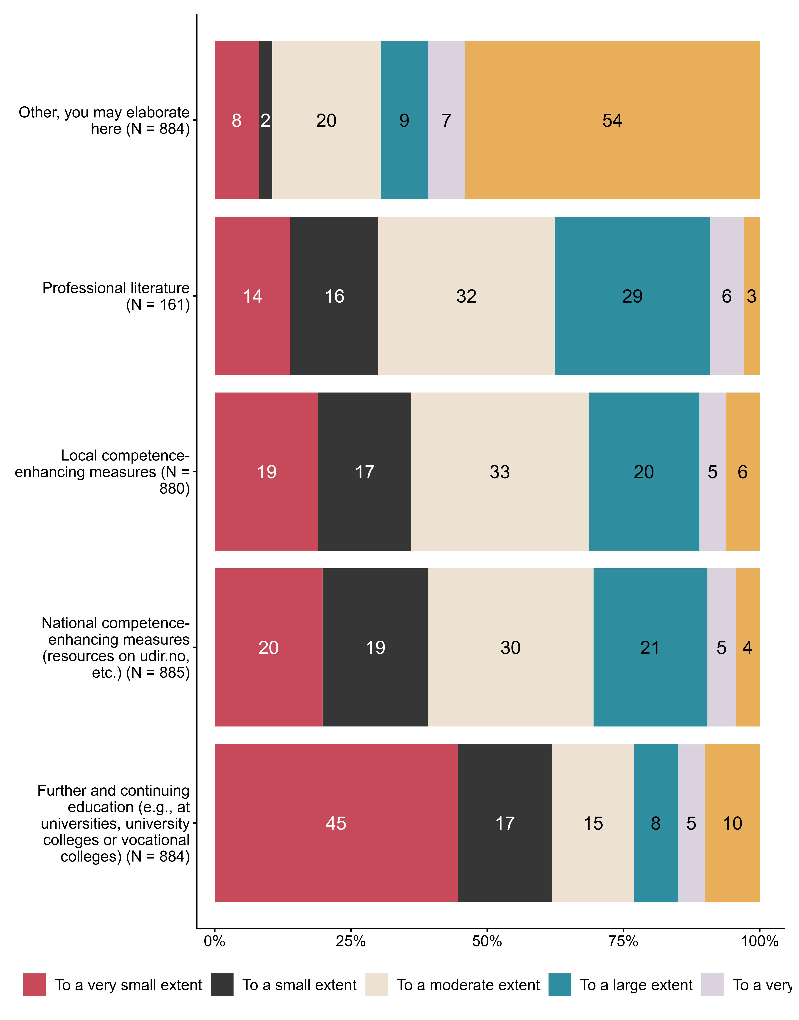
Figur 3.15. To what extent do you use the following competence-enhancing measures related to public health and life skills?. N = [161–885], Figurdata (XLSX), PNG. (Q_LS30_1,Q_LS30_2,Q_LS30_3,Q_LS30_4,Q_LS30_5)

3.16 How much do you disagree/agree with the following statements. Ensuring that all students experience belonging when working with public health and life skills
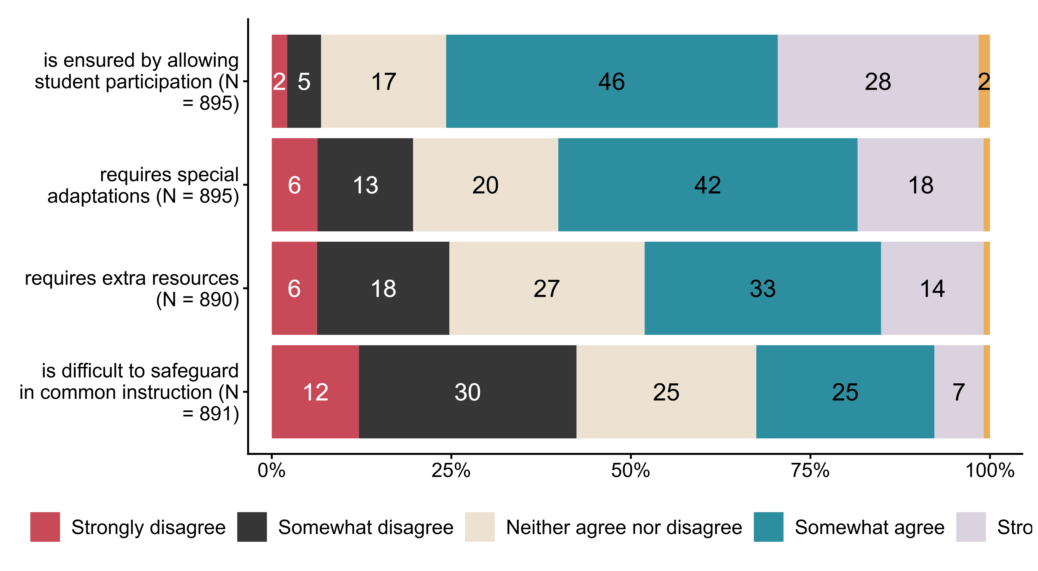
Figur 3.16. How much do you disagree/agree with the following statements. Ensuring that all students experience belonging when working with public health and life skills. N = [890–895], Figurdata (XLSX), PNG. (Q_LS32_1,Q_LS32_2,Q_LS32_3,Q_LS32_4)

3.17 How often do you adapt work with public health and life skills
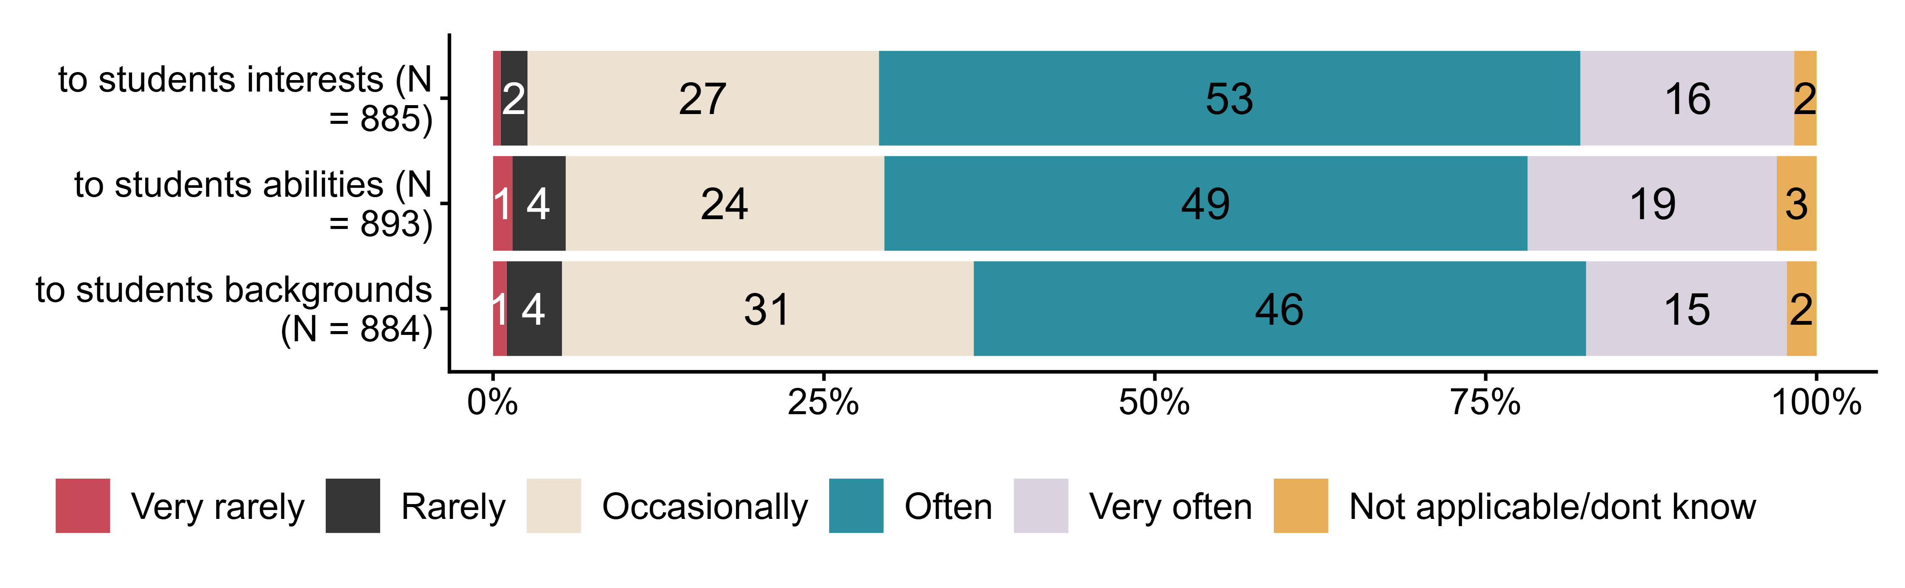
Figur 3.17. How often do you adapt work with public health and life skills. N = [884–893], Figurdata (XLSX), PNG. (Q_LS33_1,Q_LS33_2,Q_LS33_3)

3.18 Please indicate your agreement with the following statements about your school’s work with public health and life skills (FoL)
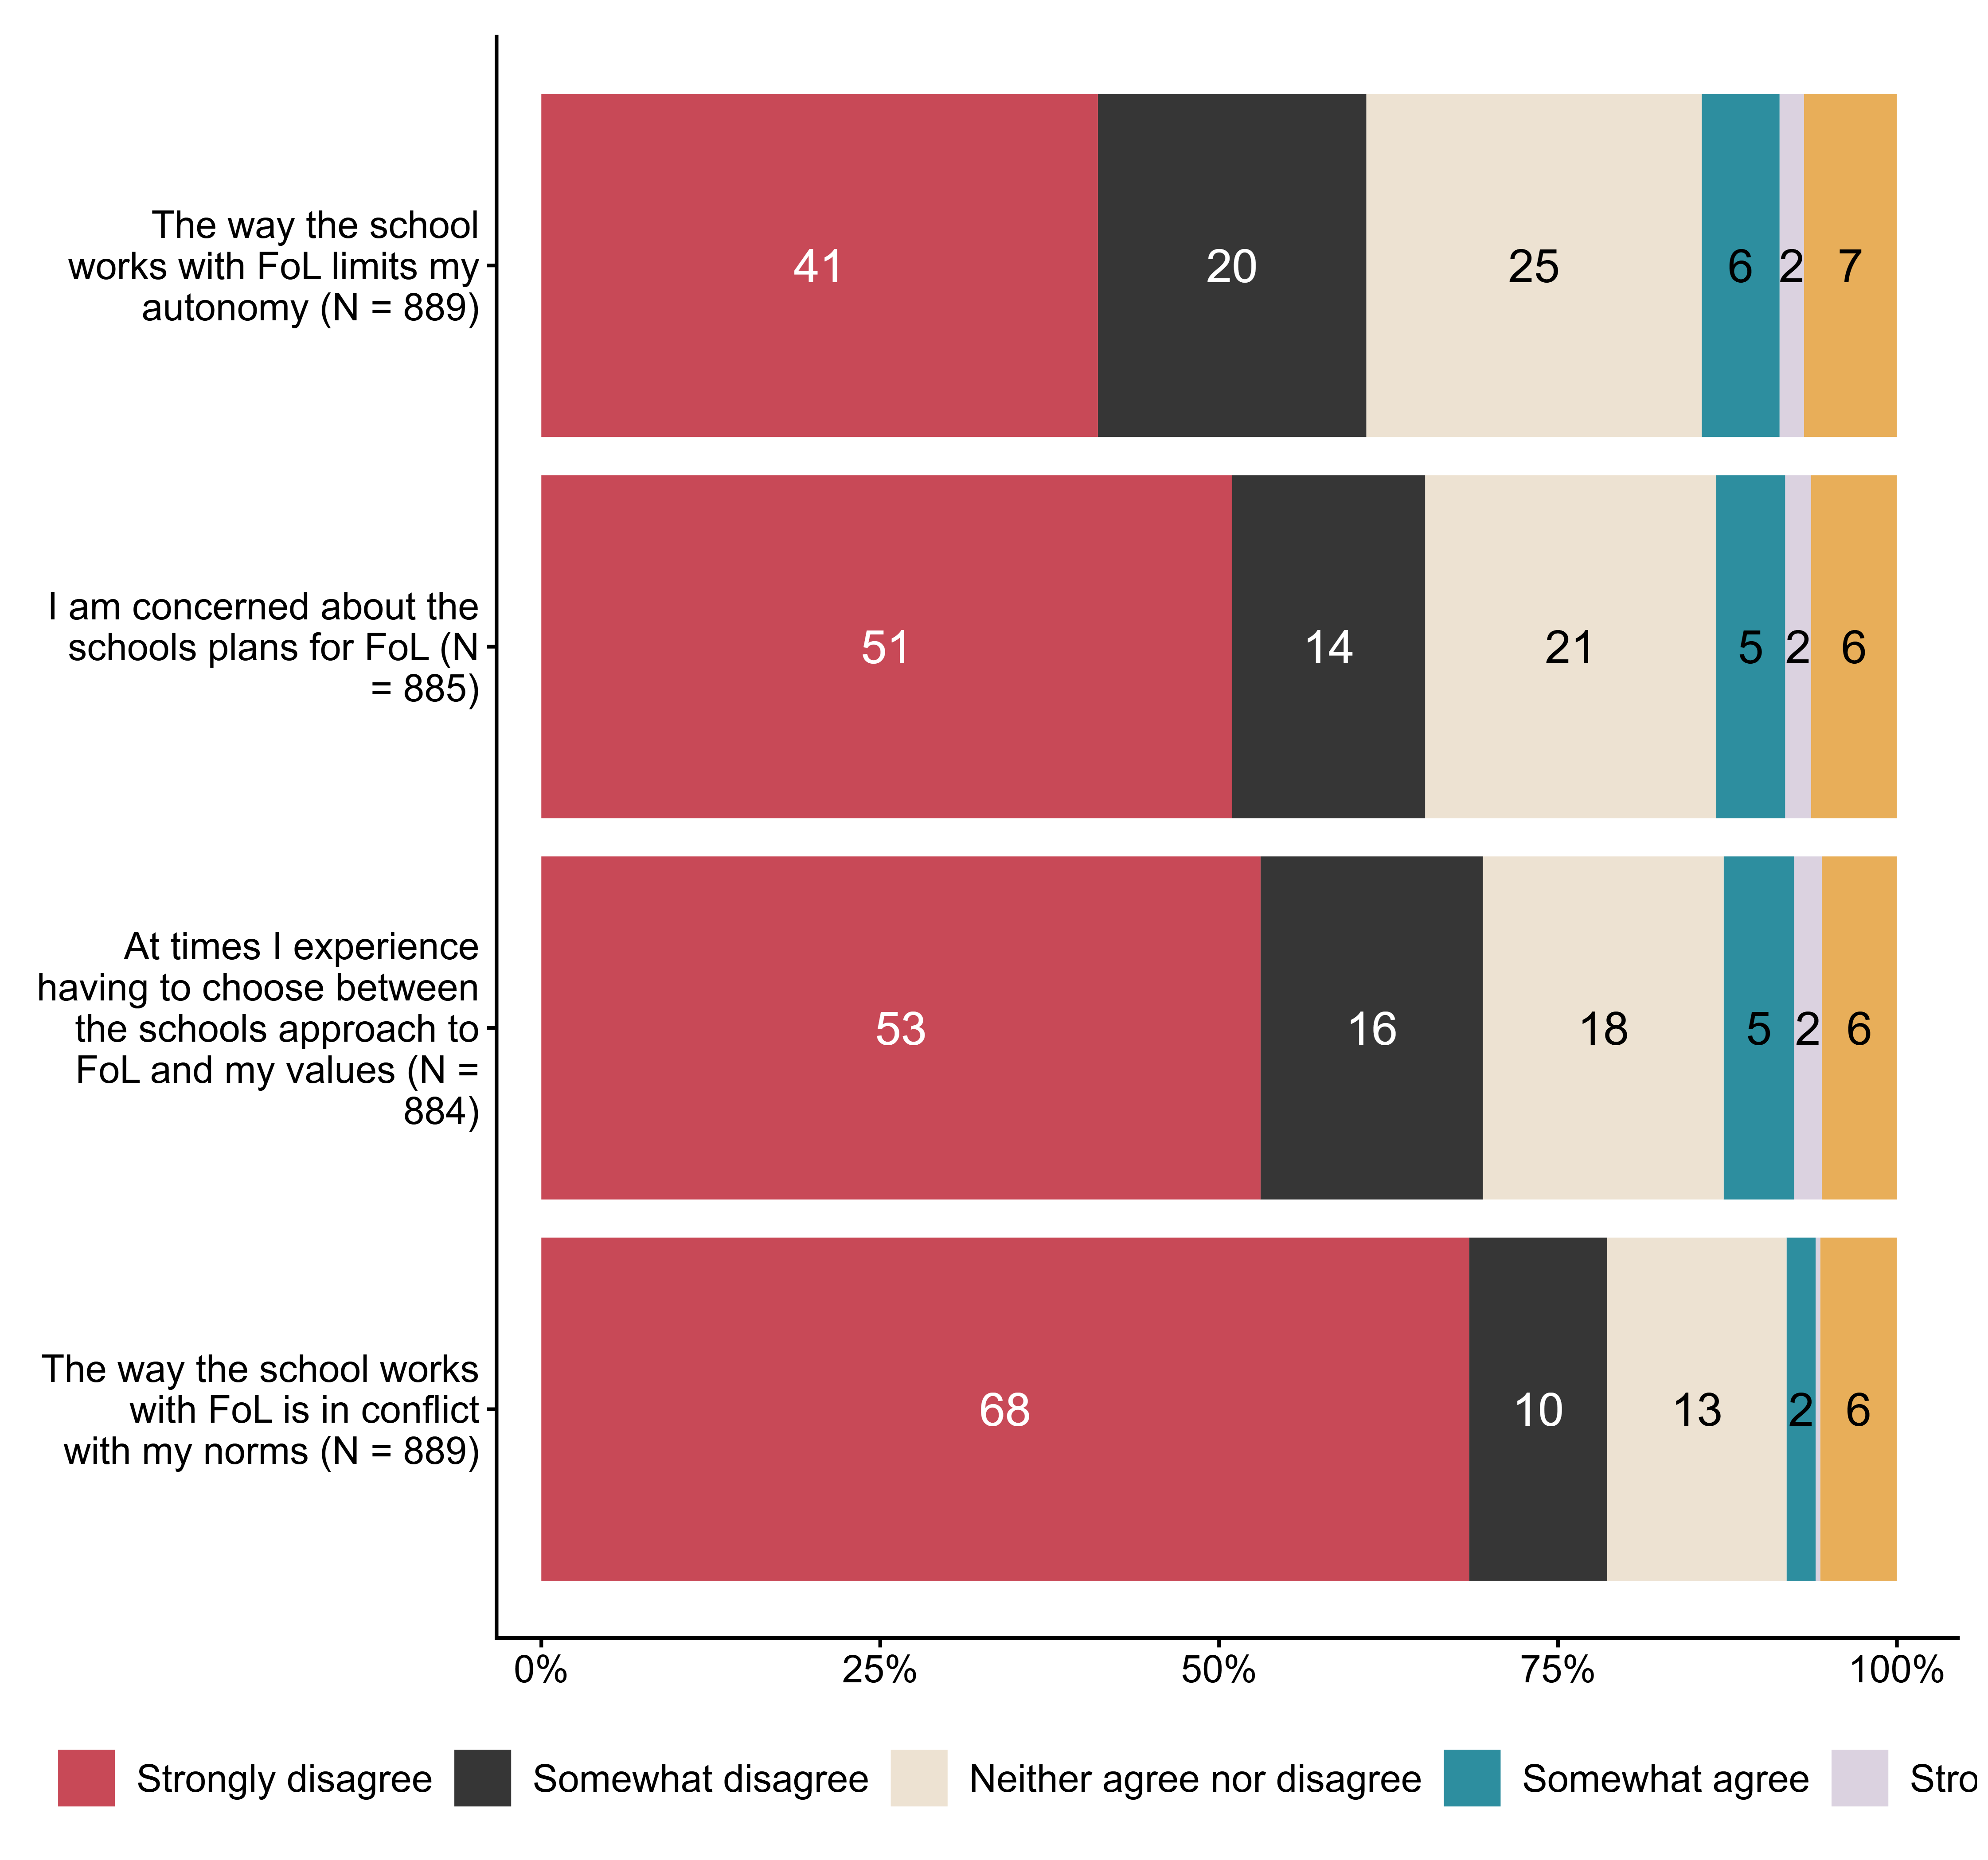
Figur 3.18. Please indicate your agreement with the following statements about your school’s work with public health and life skills (FoL). N = [884–889], Figurdata (XLSX), PNG. (Q_LS35_1,Q_LS35_2,Q_LS35_3,Q_LS35_4)

3.19 To what extent do you have sufficient access to the following for work with public health and life skills
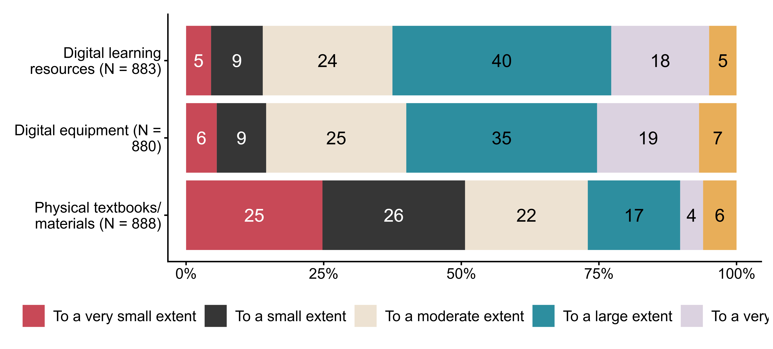
Figur 3.19. To what extent do you have sufficient access to the following for work with public health and life skills. N = [880–888], Figurdata (XLSX), PNG. (Q_LS36_1,Q_LS36_2,Q_LS36_3)

3.20 To what extent do you agree/disagree with the following statements about the school leadership’s work with public health and life skills (FoL)? The school leadership
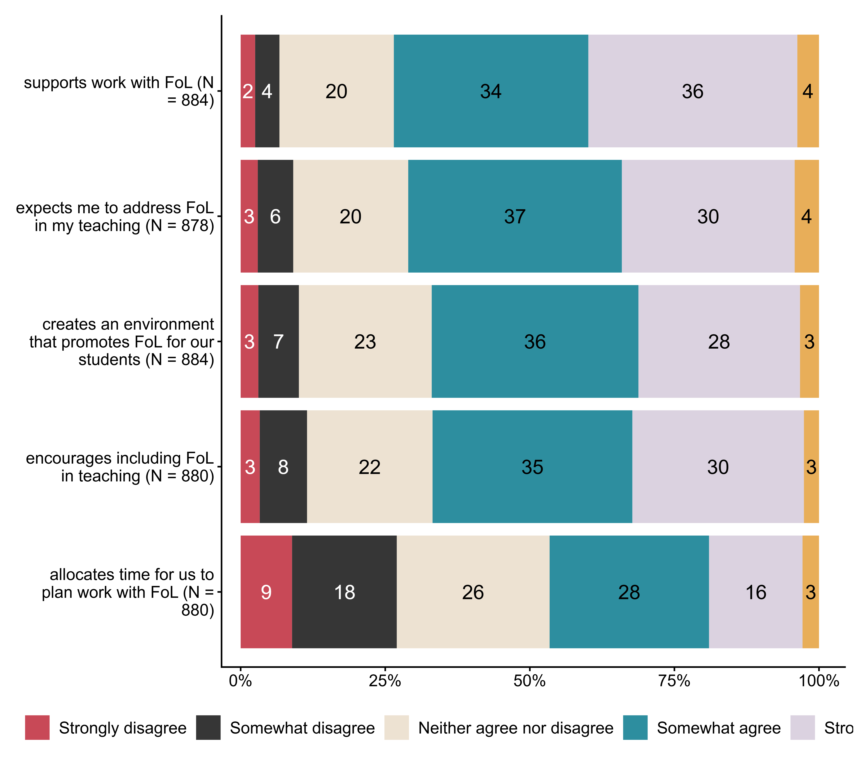
Figur 3.20. To what extent do you agree/disagree with the following statements about the school leadership’s work with public health and life skills (FoL)? The school leadership. N = [878–884], Figurdata (XLSX), PNG. (Q_LS37_1,Q_LS37_2,Q_LS37_3,Q_LS37_4,Q_LS37_5)

3.21 In collaboration on public health and life skills I find that teachers at my school
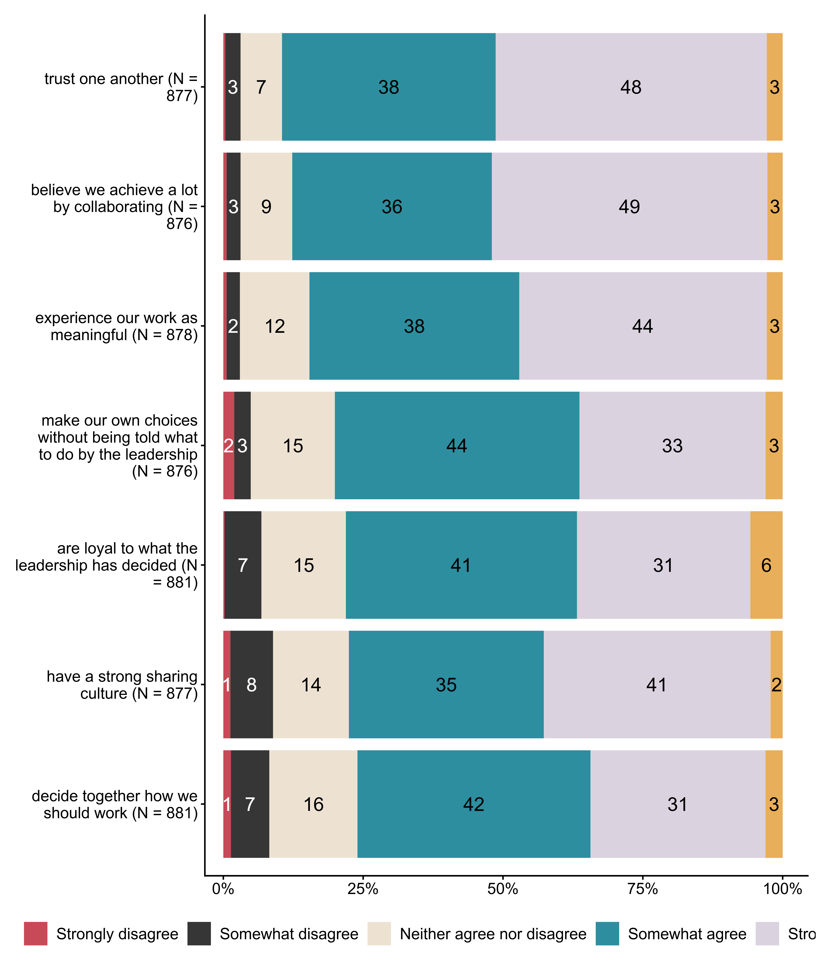
Figur 3.21. In collaboration on public health and life skills I find that teachers at my school. N = [876–881], Figurdata (XLSX), PNG. (Q_LS38_1,Q_LS38_2,Q_LS38_3,Q_LS38_4,Q_LS38_5,Q_LS38_6,Q_LS38_7)

3.22 Overall, to what extent do you feel that the introduction of public health and life skills in LK20 has improved the school’s work with students’
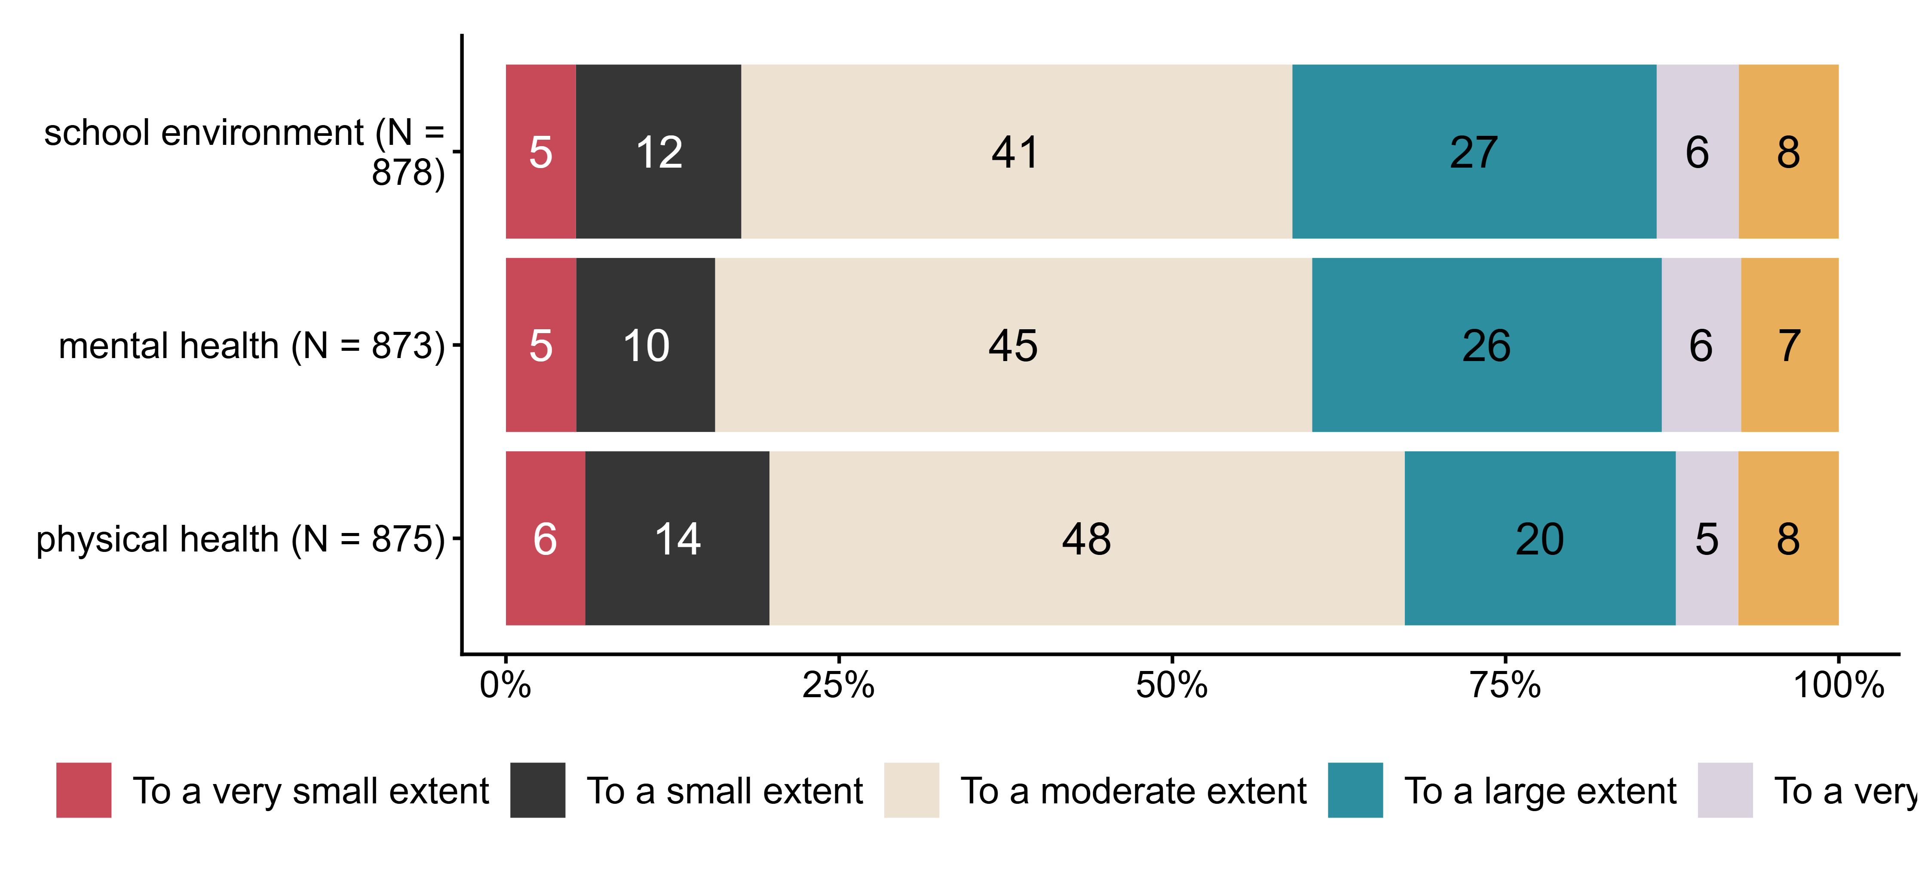
Figur 3.22. Overall, to what extent do you feel that the introduction of public health and life skills in LK20 has improved the school’s work with students’. N = [873–878], Figurdata (XLSX), PNG. (Q_LS39_1,Q_LS39_2,Q_LS39_3)

3.23 How well do you manage job-related stress at the moment?
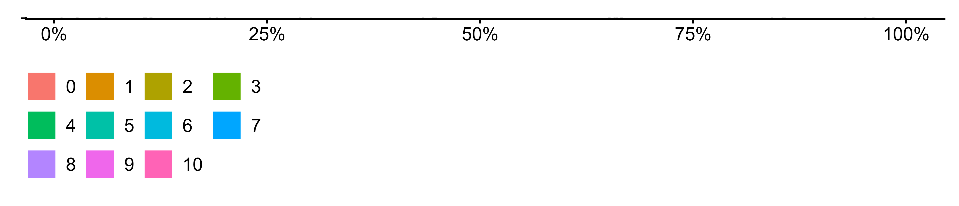
Figur 3.23. How well do you manage job-related stress at the moment?. N = 877, Figurdata (XLSX), PNG. (Q_LS40_1)

3.24 Approximately how many years of higher education do you have that are relevant to the teaching profession?
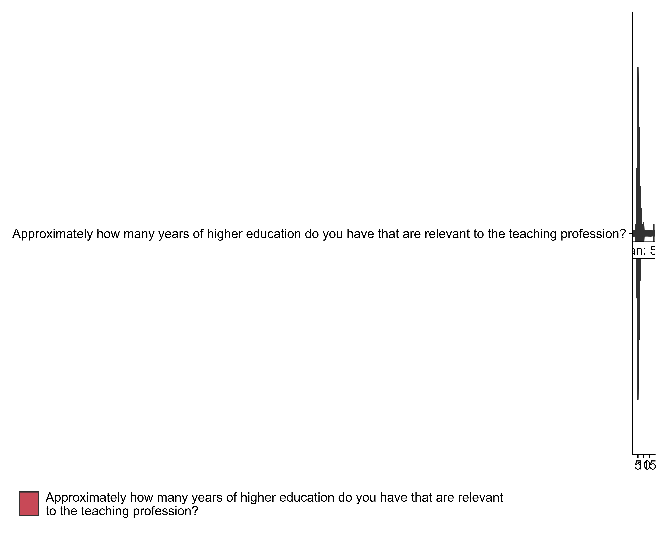
Figur 3.24. Approximately how many years of higher education do you have that are relevant to the teaching profession?. (Q_LS42)

3.25 Approximately how many years have you worked as a teacher?
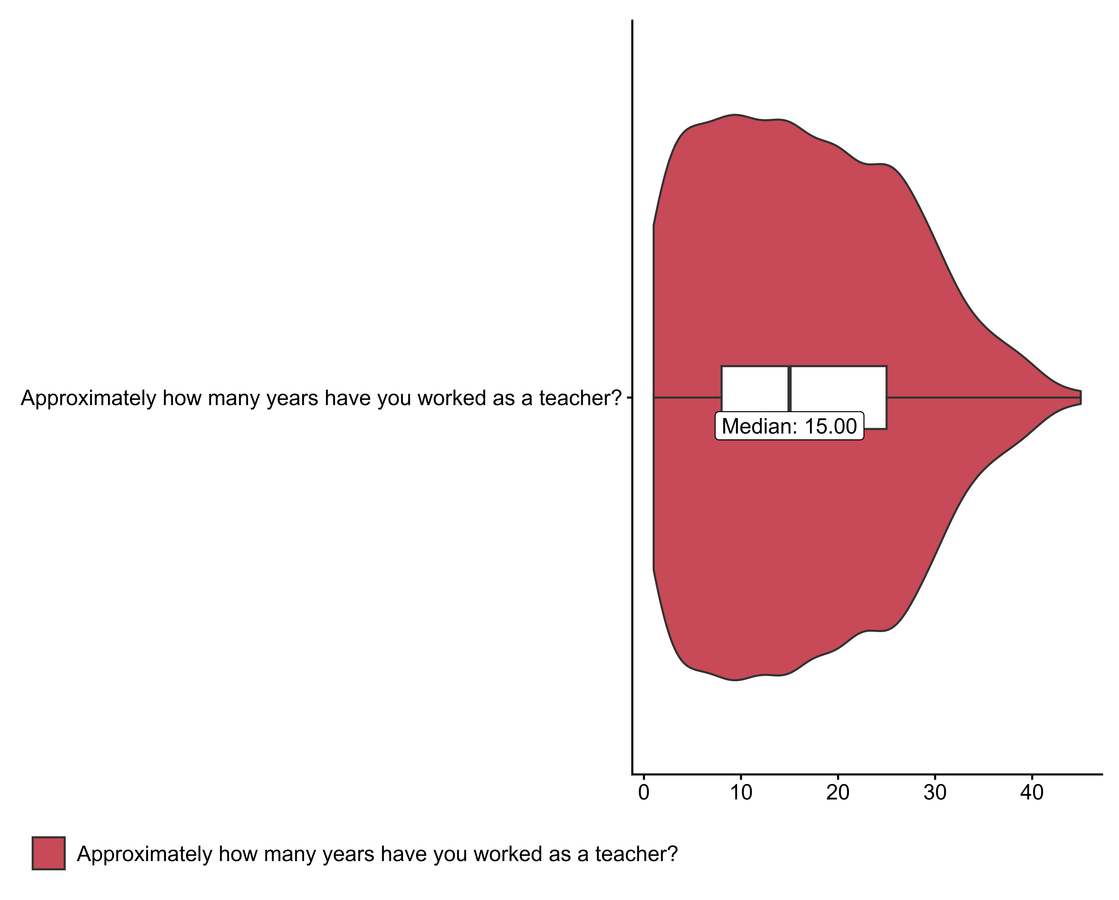
Figur 3.25. Approximately how many years have you worked as a teacher?. (Q_LS43)

3.26 Are you a homeroom/contact teacher in the 2024/25 school year?
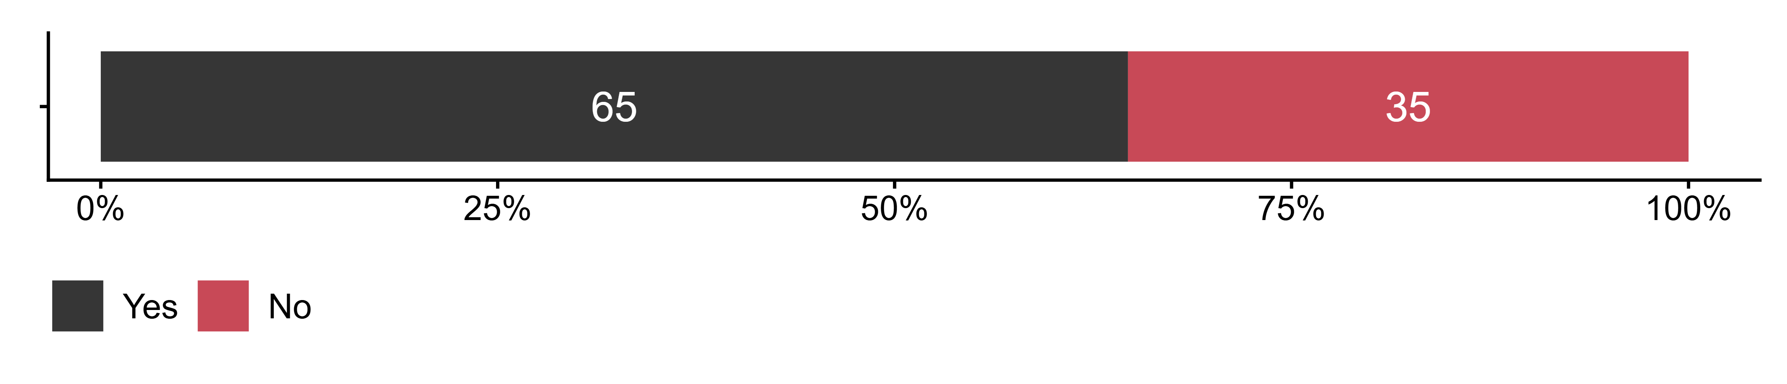
Figur 3.26. Are you a homeroom/contact teacher in the 2024/25 school year?. N = 878, Figurdata (XLSX), PNG. (Q_LS44)

3.27 Age
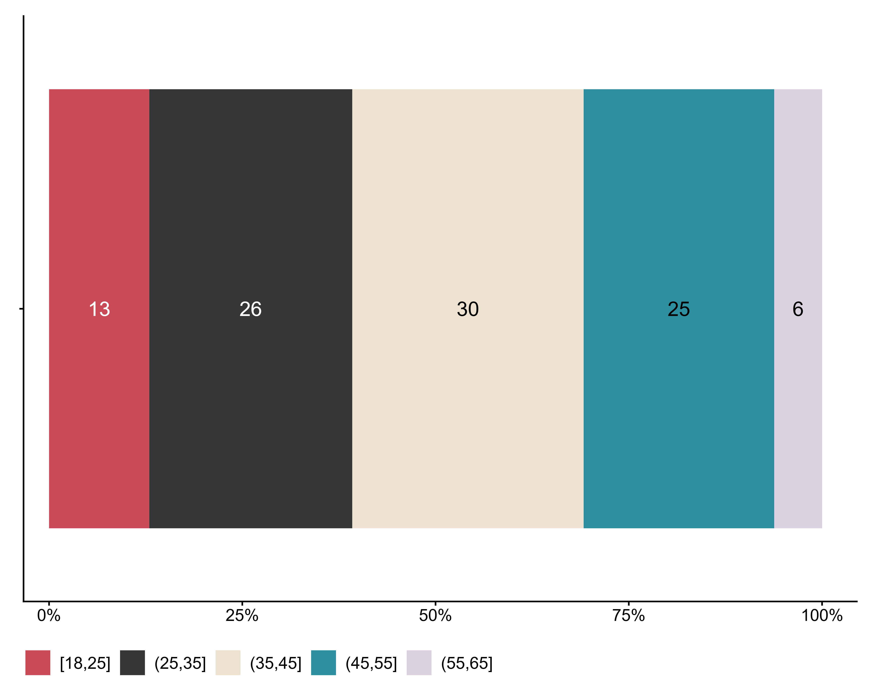
Figur 3.27. Age. N = 878, Figurdata (XLSX), PNG. (Q_LS45_DERIVED)

3.28 Gender
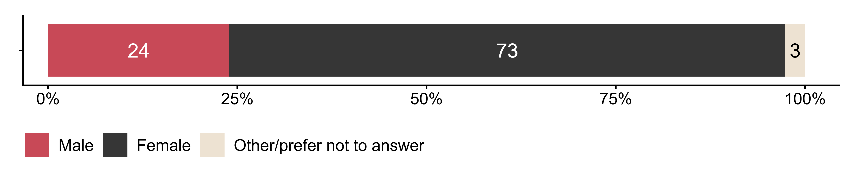
Figur 3.28. Gender. N = 878, Figurdata (XLSX), PNG. (Q_LS46)

3.29 Comments on the topic or the survey? Anything we should have asked?
Tabell 3.1. Comments on the topic or the survey? Anything we should have asked?. (Q_LS47)
[1] "Redacted"

