Compulsory school owners
Innholdsfortegnelse

Figurer

Tabeller

1. School owner of compulsory schools

1.1 I am responding on behalf of the (county) municipality and my role is
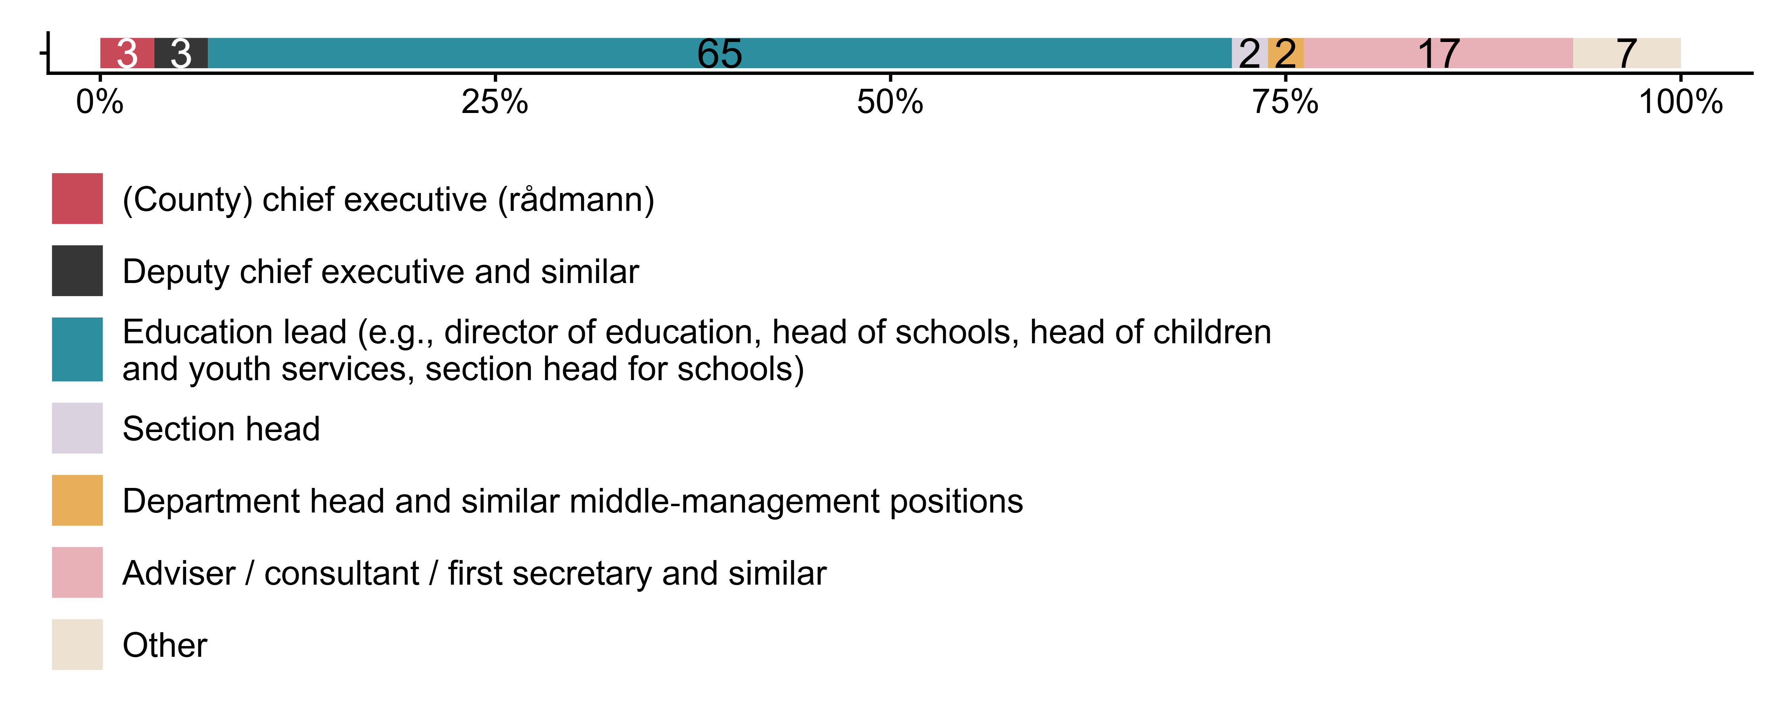
Figur 1.1. I am responding on behalf of the (county) municipality and my role is. N = 88, Figurdata (XLSX), PNG. (SEQ4)

1.2 Approximately how many years have you worked as/for the school owner (education authority)?
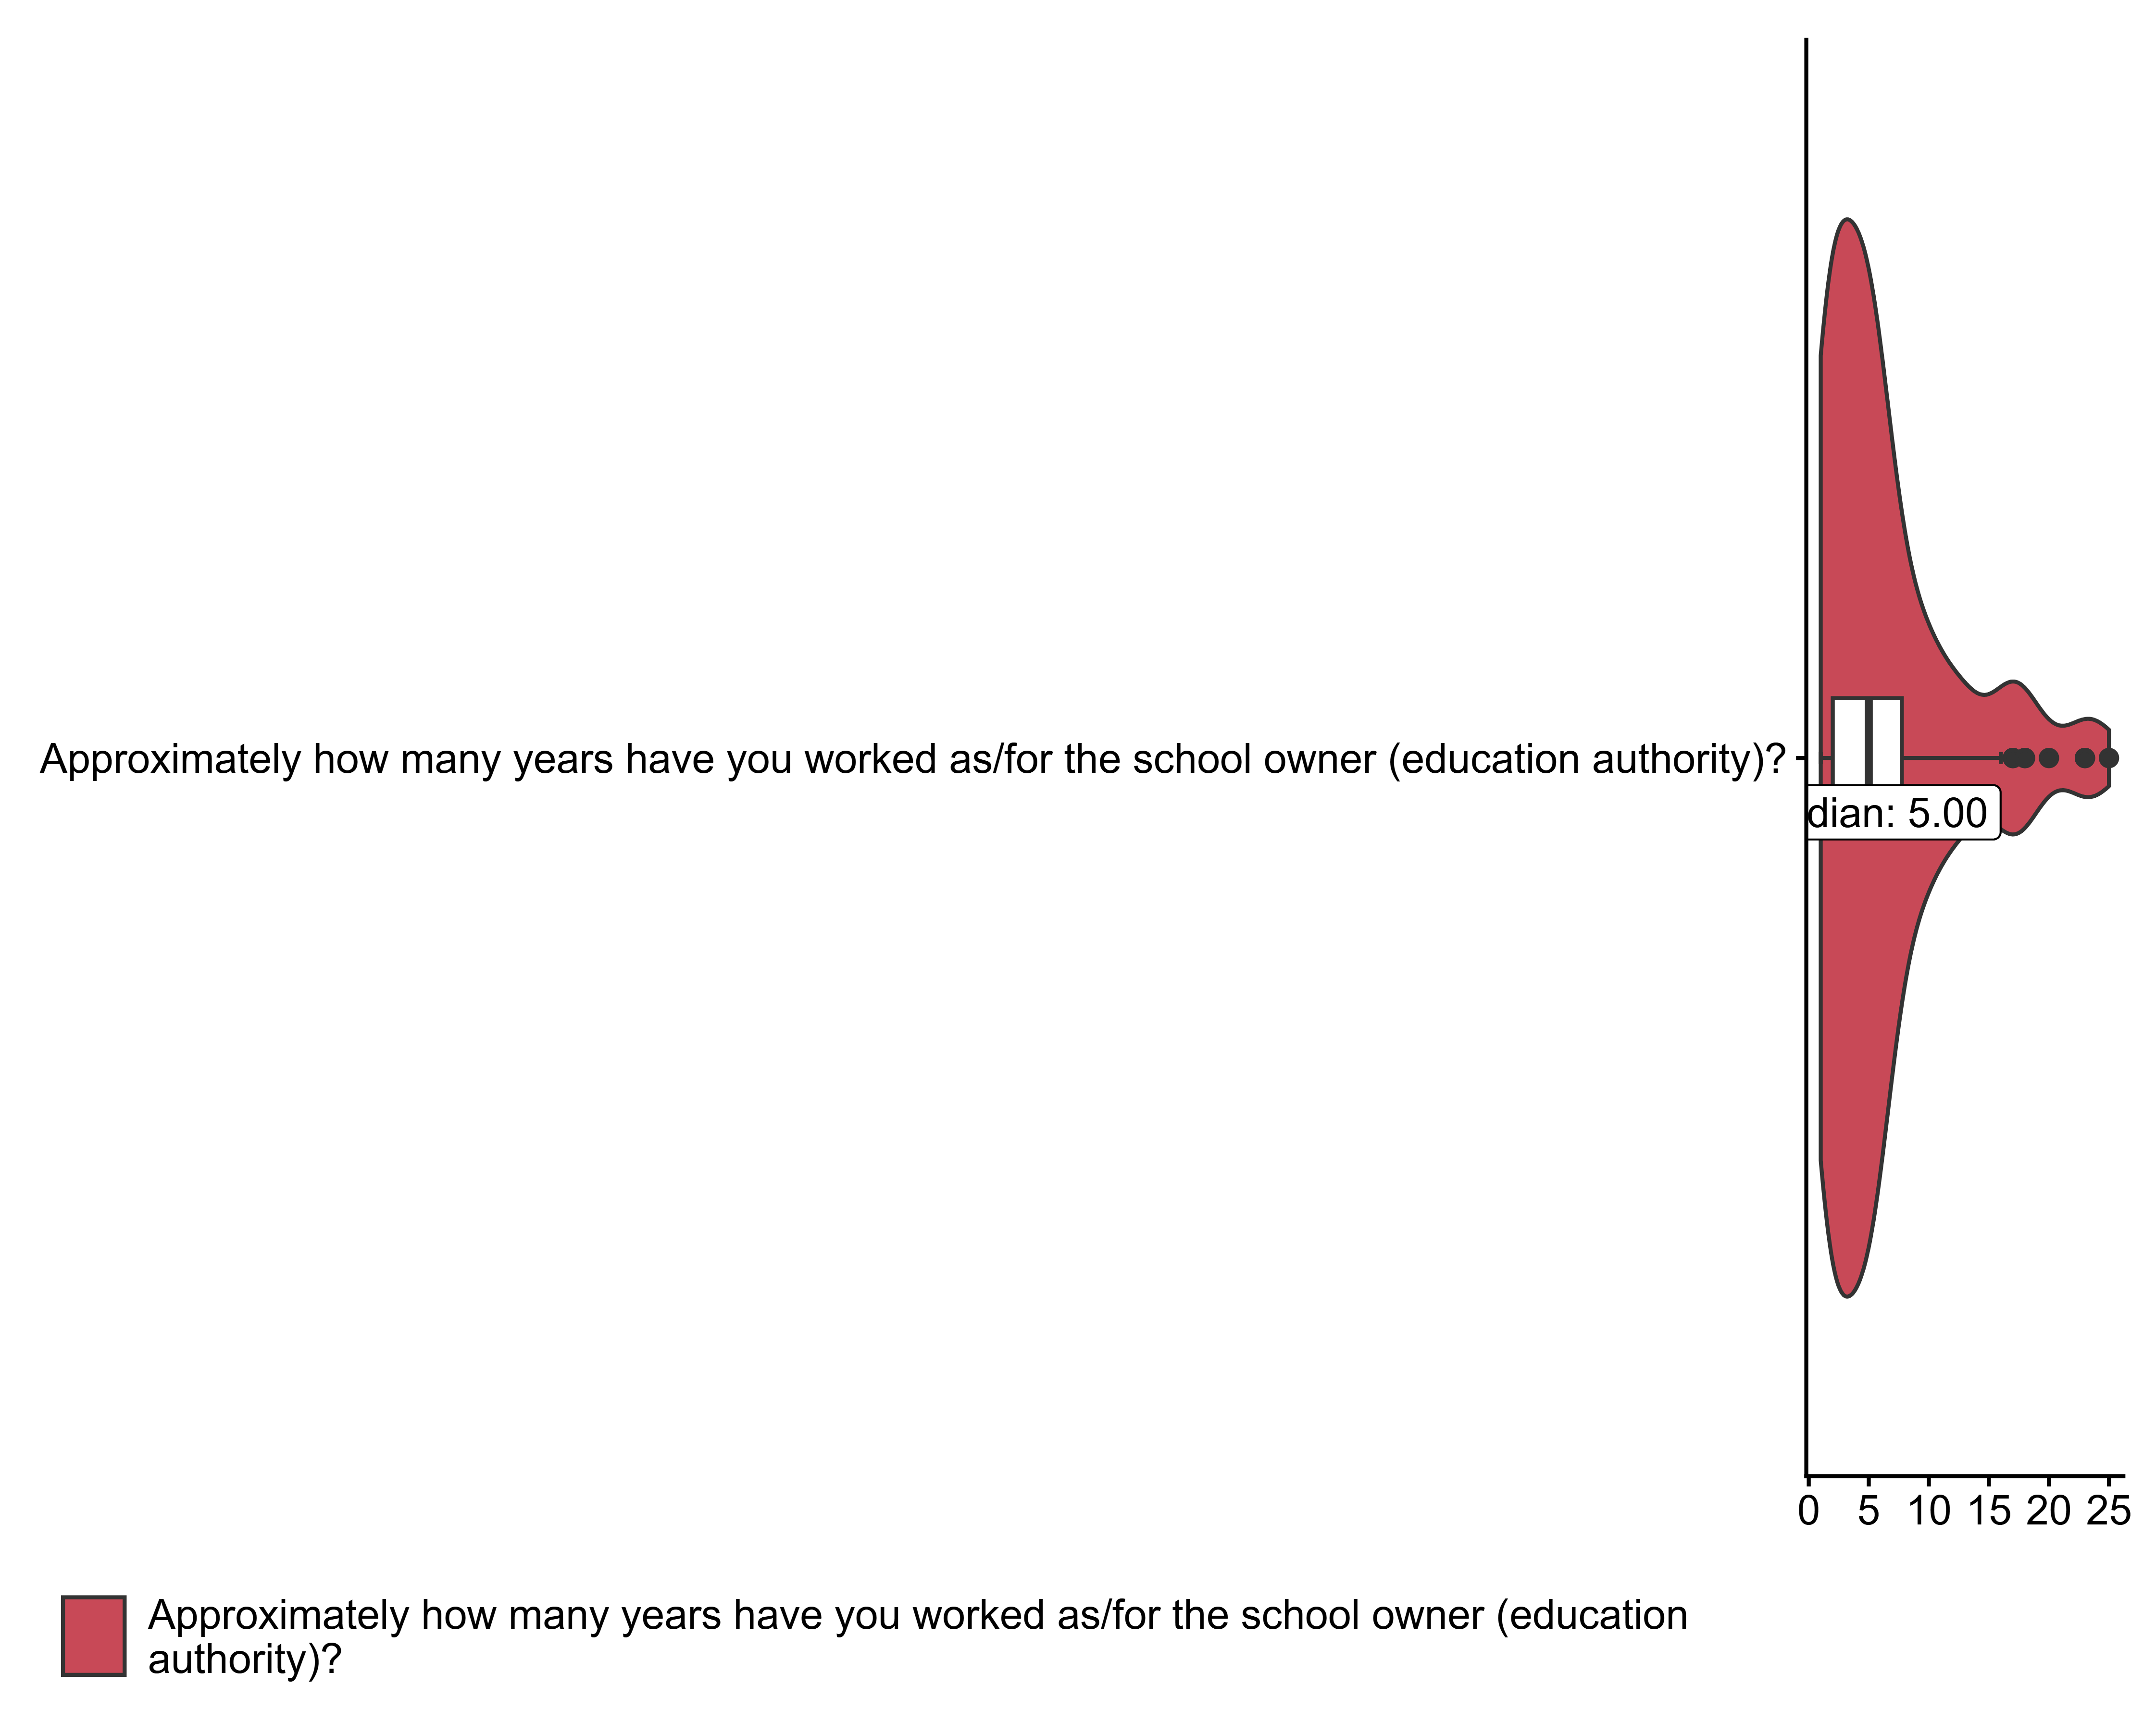
Figur 1.2. Approximately how many years have you worked as/for the school owner (education authority)?. (SEQ5)

1.3 How familiar are you with what is written about public health and life skills (FoL) in LK20?
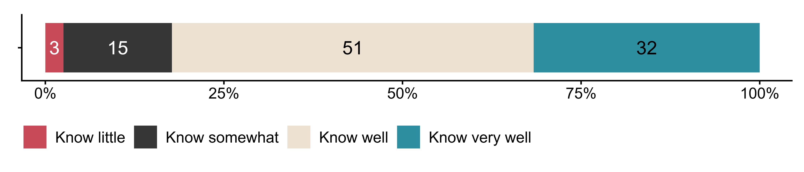
Figur 1.3. How familiar are you with what is written about public health and life skills (FoL) in LK20?. N = 79, Figurdata (XLSX), PNG. (SEQ8)

1.4 To what extent do you agree that the introduction of public health and life skills (FoL) in LK20
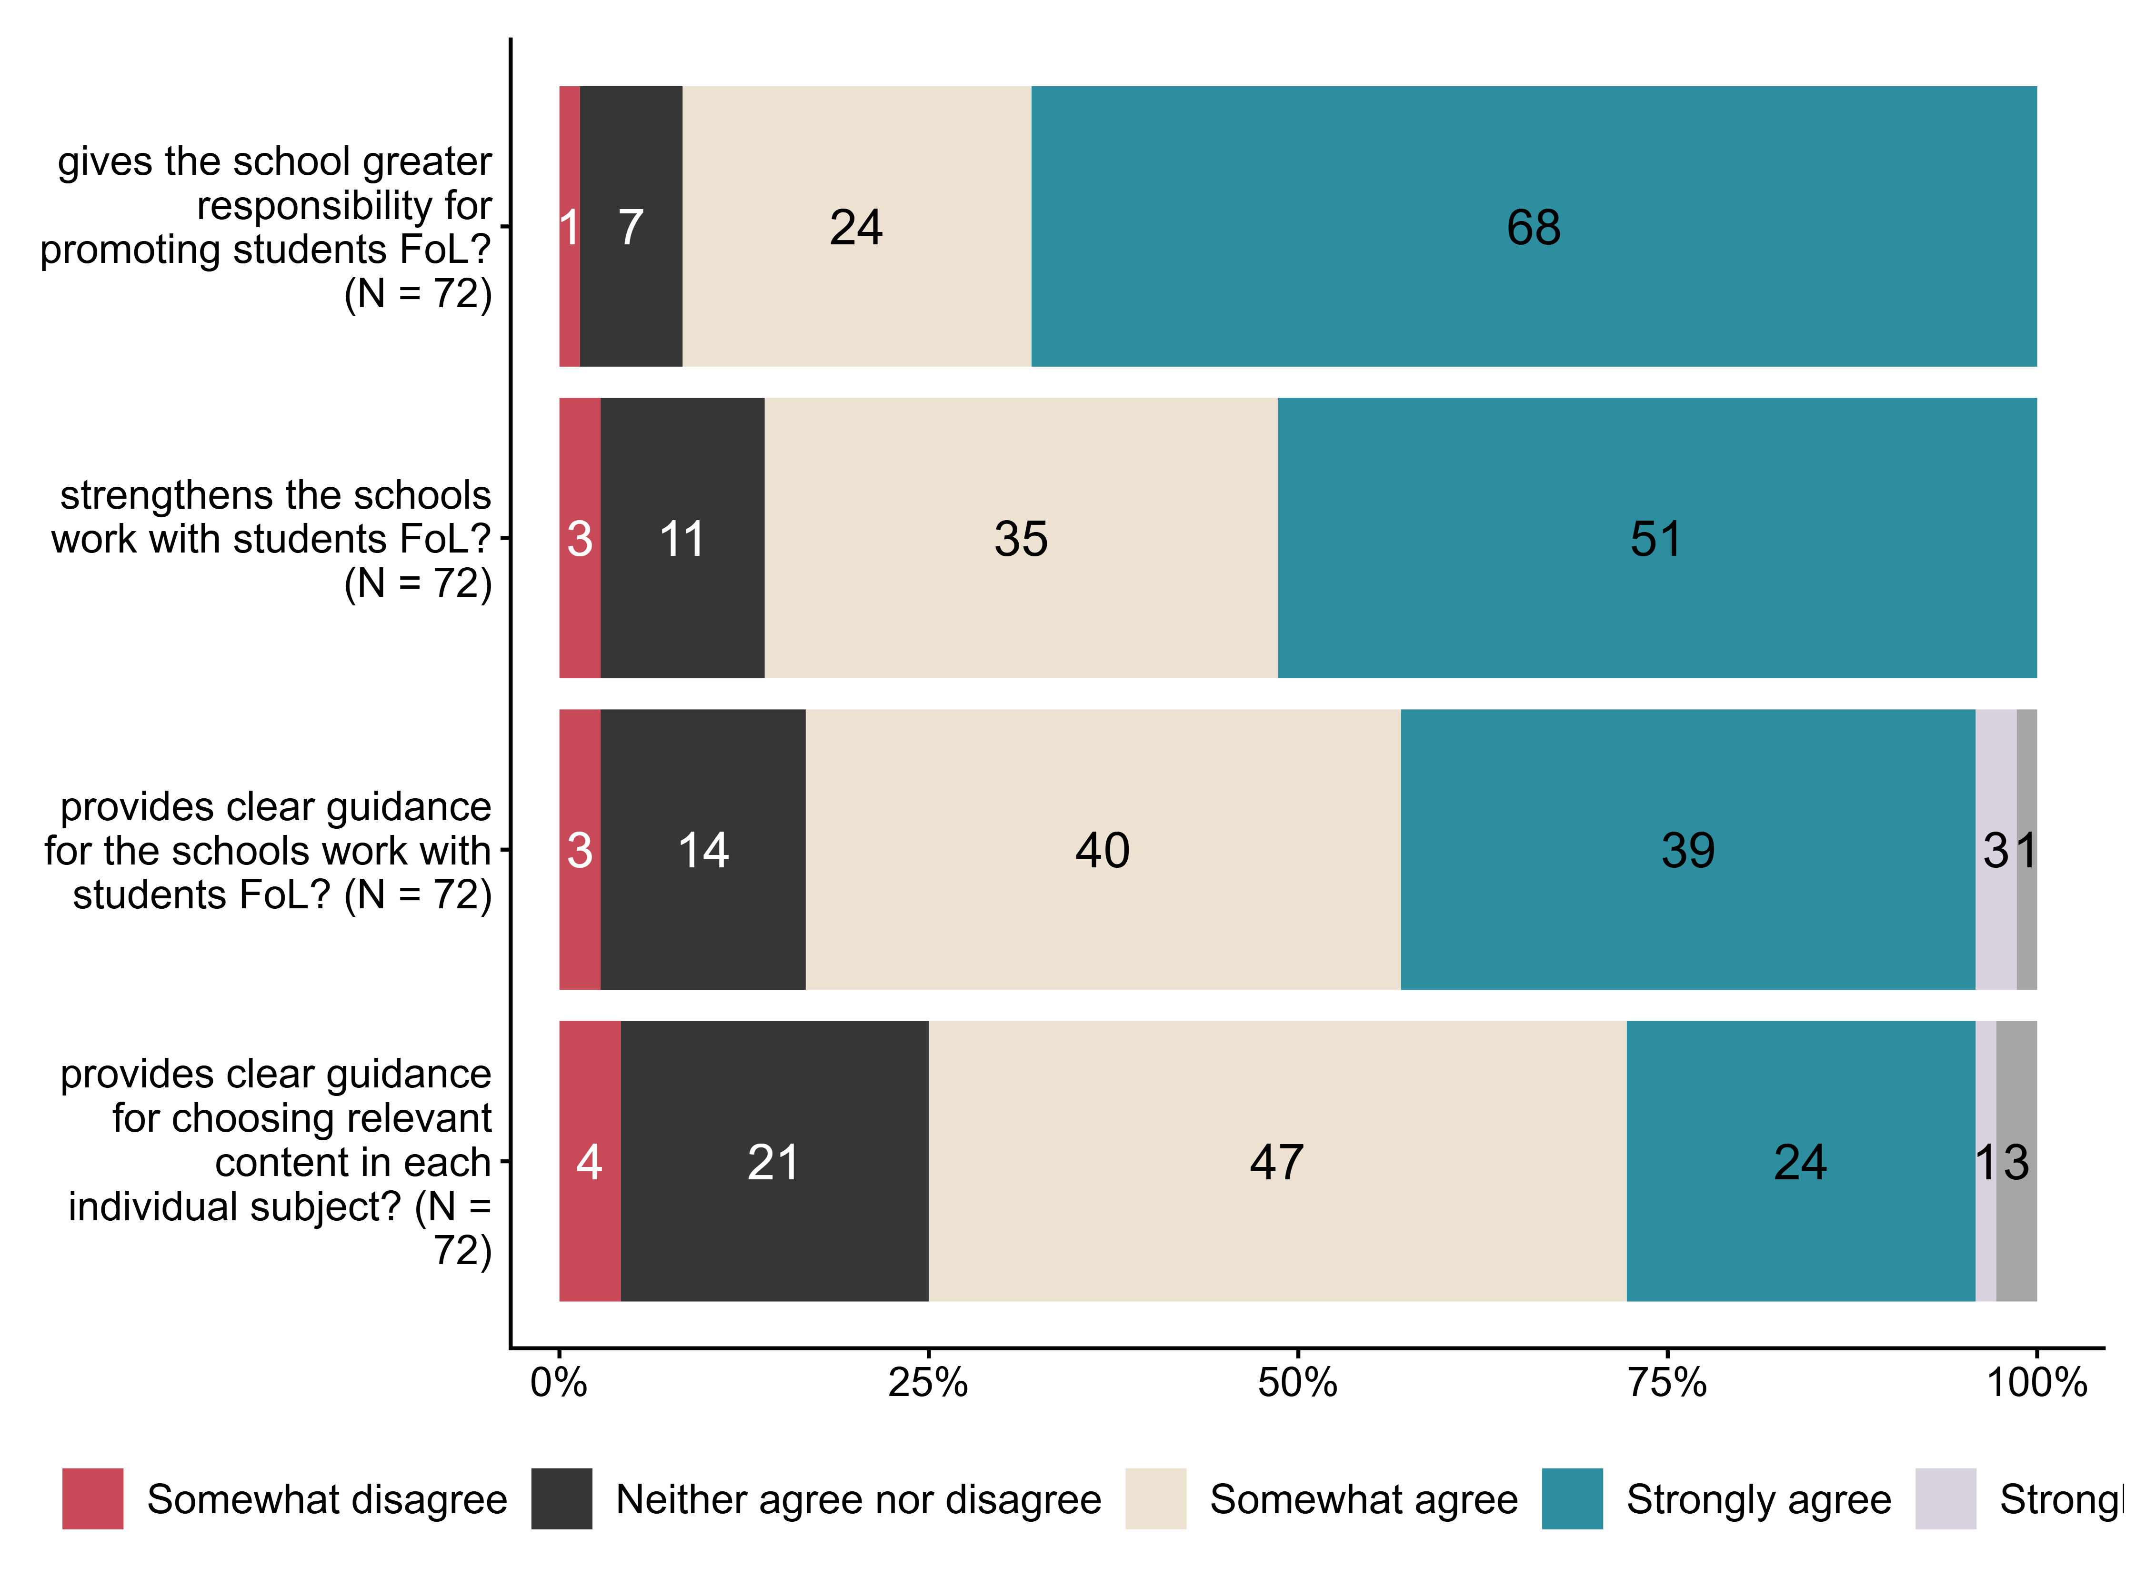
Figur 1.4. To what extent do you agree that the introduction of public health and life skills (FoL) in LK20. N = 72, Figurdata (XLSX), PNG. (SEQ9_1,SEQ9_2,SEQ9_3,SEQ9_4)

1.5 How do you view teachers’ work with public health and life skills (FoL) at the schools in your (county) municipality?
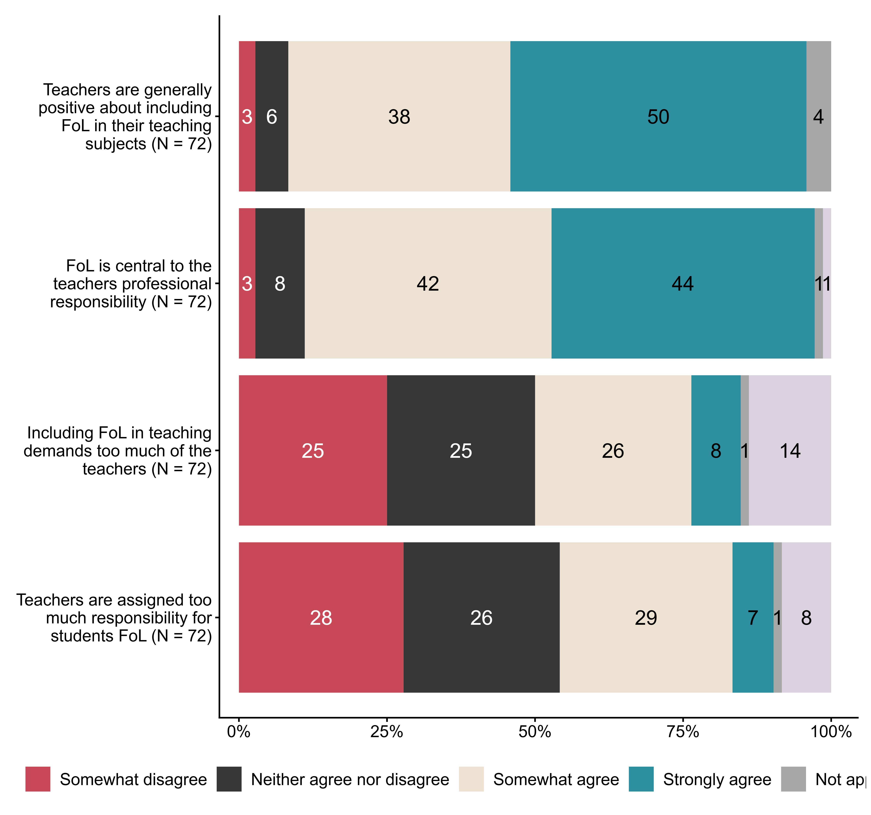
Figur 1.5. How do you view teachers’ work with public health and life skills (FoL) at the schools in your (county) municipality?. N = 72, Figurdata (XLSX), PNG. (SEQ10_1,SEQ10_2,SEQ10_3,SEQ10_4)

1.6 Below we have listed some statements about work with public health and life skills (FoL) carried out by the school owner. To what extent do they fit your (county) municipality?
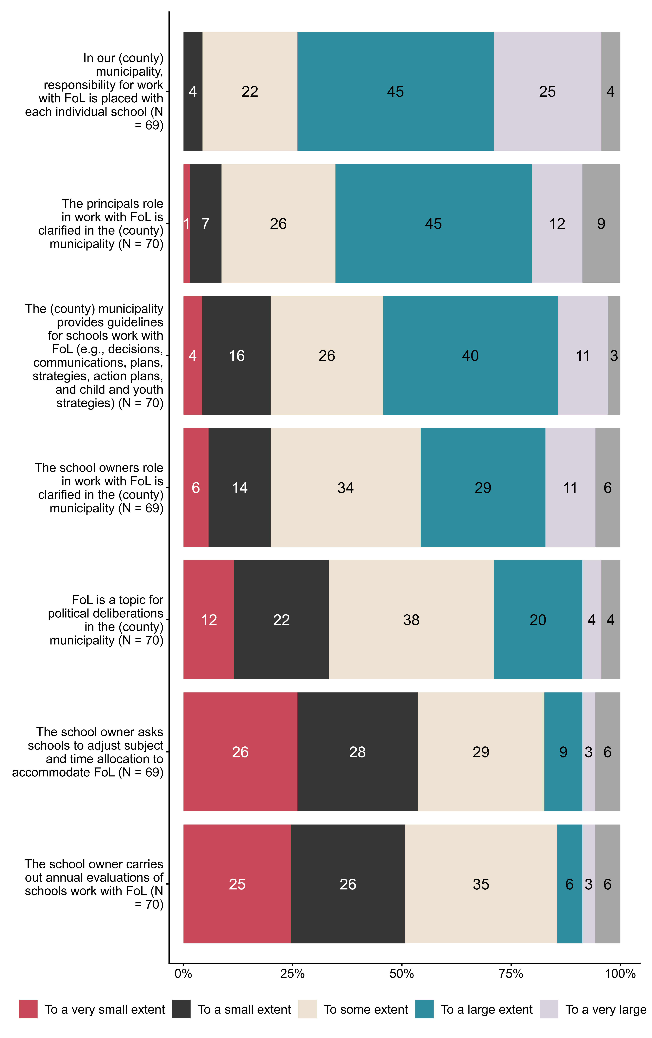
Figur 1.6. Below we have listed some statements about work with public health and life skills (FoL) carried out by the school owner. To what extent do they fit your (county) municipality?. N = [69–70], Figurdata (XLSX), PNG. (SEQ12_1,SEQ12_2,SEQ12_3,SEQ12_4,SEQ12_5,SEQ12_6,SEQ12_7)

1.7 To what extent do you agree with the following statements about competence development within public health and life skills (FoL)?
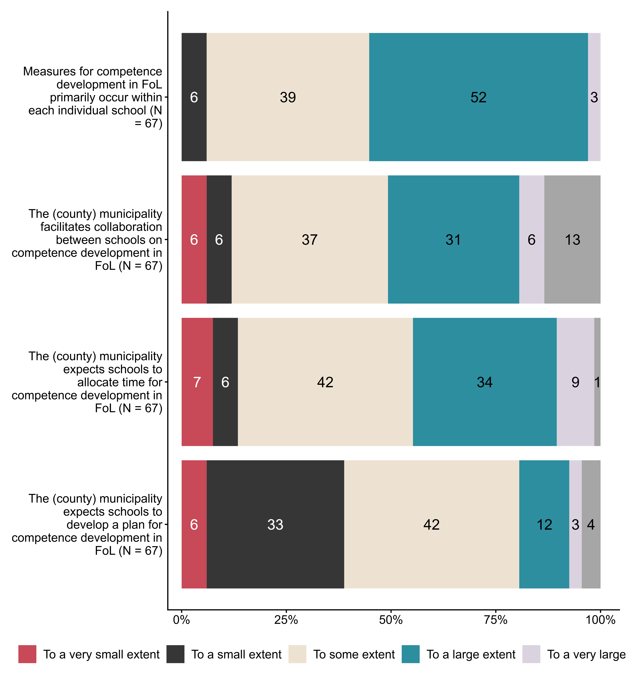
Figur 1.7. To what extent do you agree with the following statements about competence development within public health and life skills (FoL)?. N = 67, Figurdata (XLSX), PNG. (SEQ13_1,SEQ13_2,SEQ13_3,SEQ13_4)

1.8 To what extent have staff in schools in your (county) municipality been offered the following competence‑enhancing measures in public health and life skills?
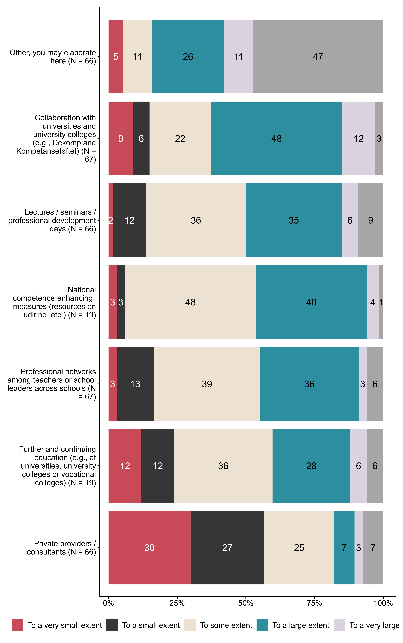
Figur 1.8. To what extent have staff in schools in your (county) municipality been offered the following competence‑enhancing measures in public health and life skills?. N = [19–67], Figurdata (XLSX), PNG. (SEQ14_1,SEQ14_2,SEQ14_3,SEQ14_4,SEQ14_5,SEQ14_6,SEQ14_7)

1.9 To what extent do you, as the school owner, expect schools to use resource persons beyond the school’s own staff in work with public health and life skills?
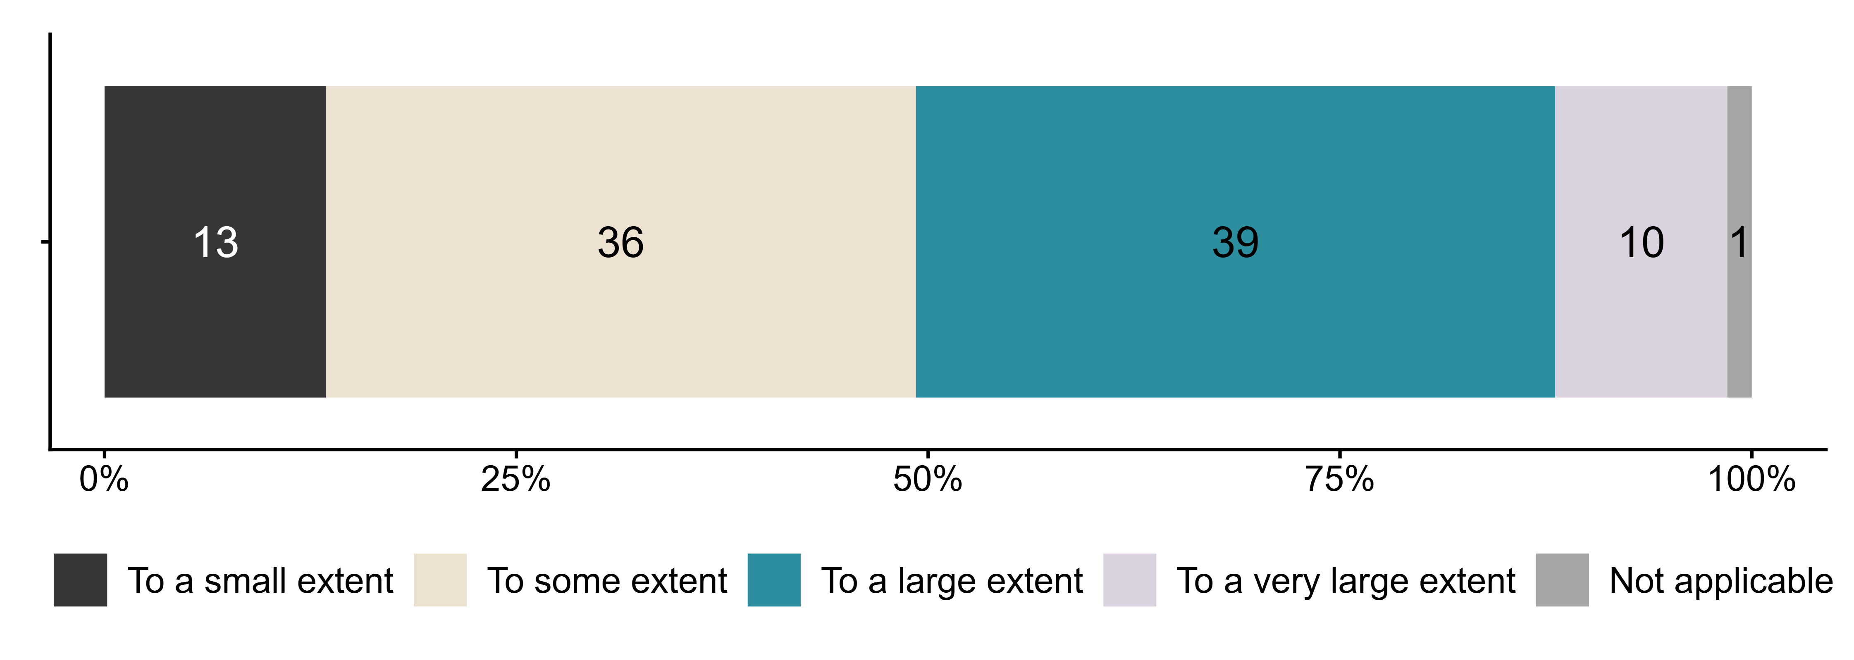
Figur 1.9. To what extent do you, as the school owner, expect schools to use resource persons beyond the school’s own staff in work with public health and life skills?. N = 67, Figurdata (XLSX), PNG. (SEQ15)

1.10 Have you provided recommendations regarding which resource persons should be used in work with public health and life skills?
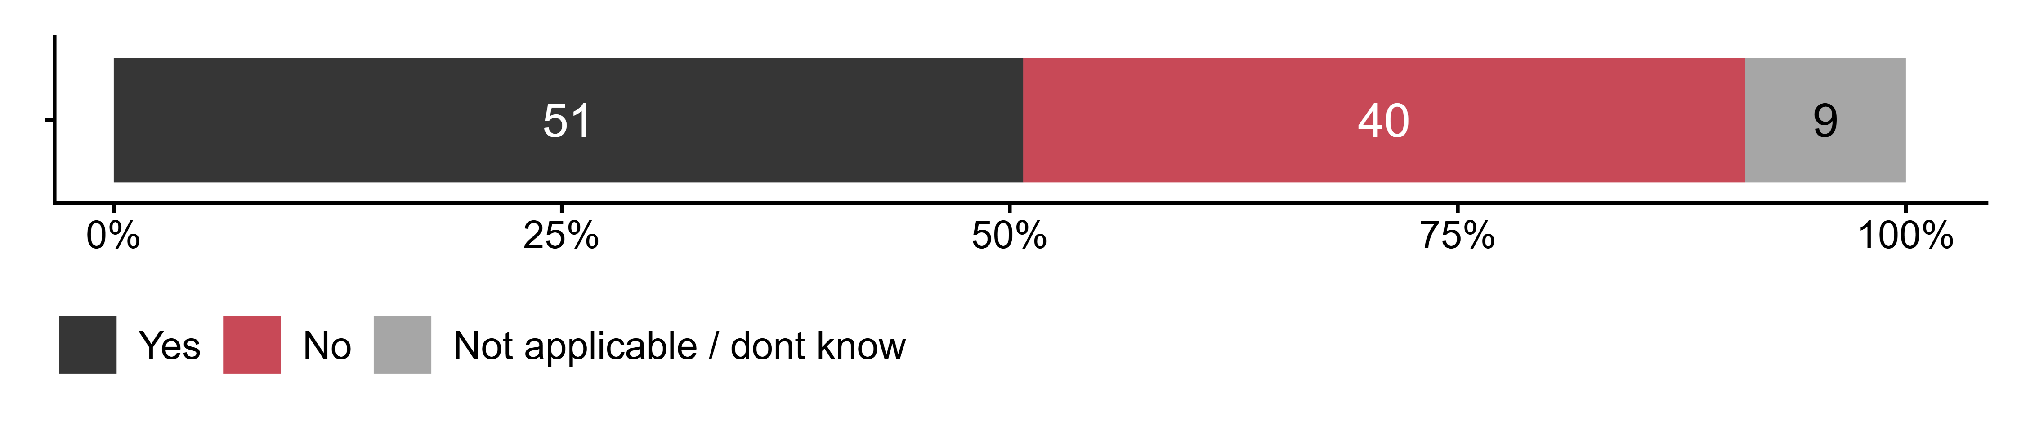
Figur 1.10. Have you provided recommendations regarding which resource persons should be used in work with public health and life skills?. N = 67, Figurdata (XLSX), PNG. (SEQ16)

1.11 Which resource persons outside the school’s own staff have you recommended using in work with public health and life skills?
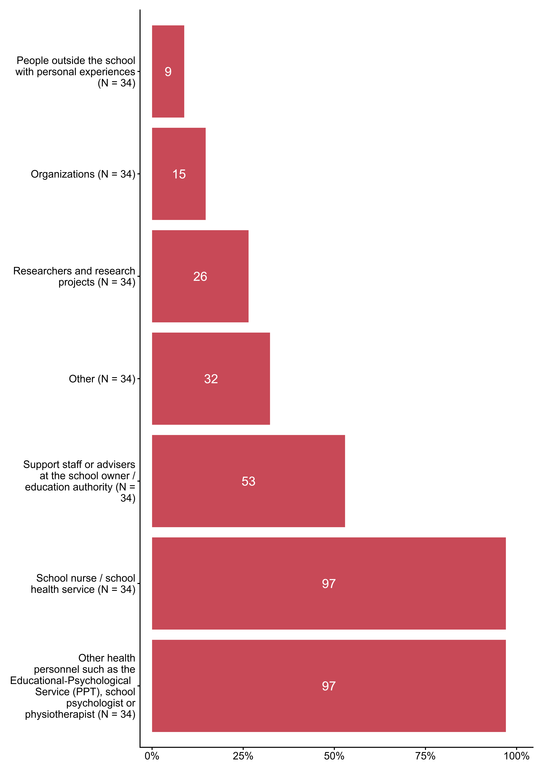
Figur 1.11. Which resource persons outside the school’s own staff have you recommended using in work with public health and life skills?. N = 34, Figurdata (XLSX), PNG. (SEQ17_1,SEQ17_2,SEQ17_3,SEQ17_4,SEQ17_5,SEQ17_6,SEQ17_7)

1.12 Does the (county) municipality offer professional development for school staff on any of the following topics?
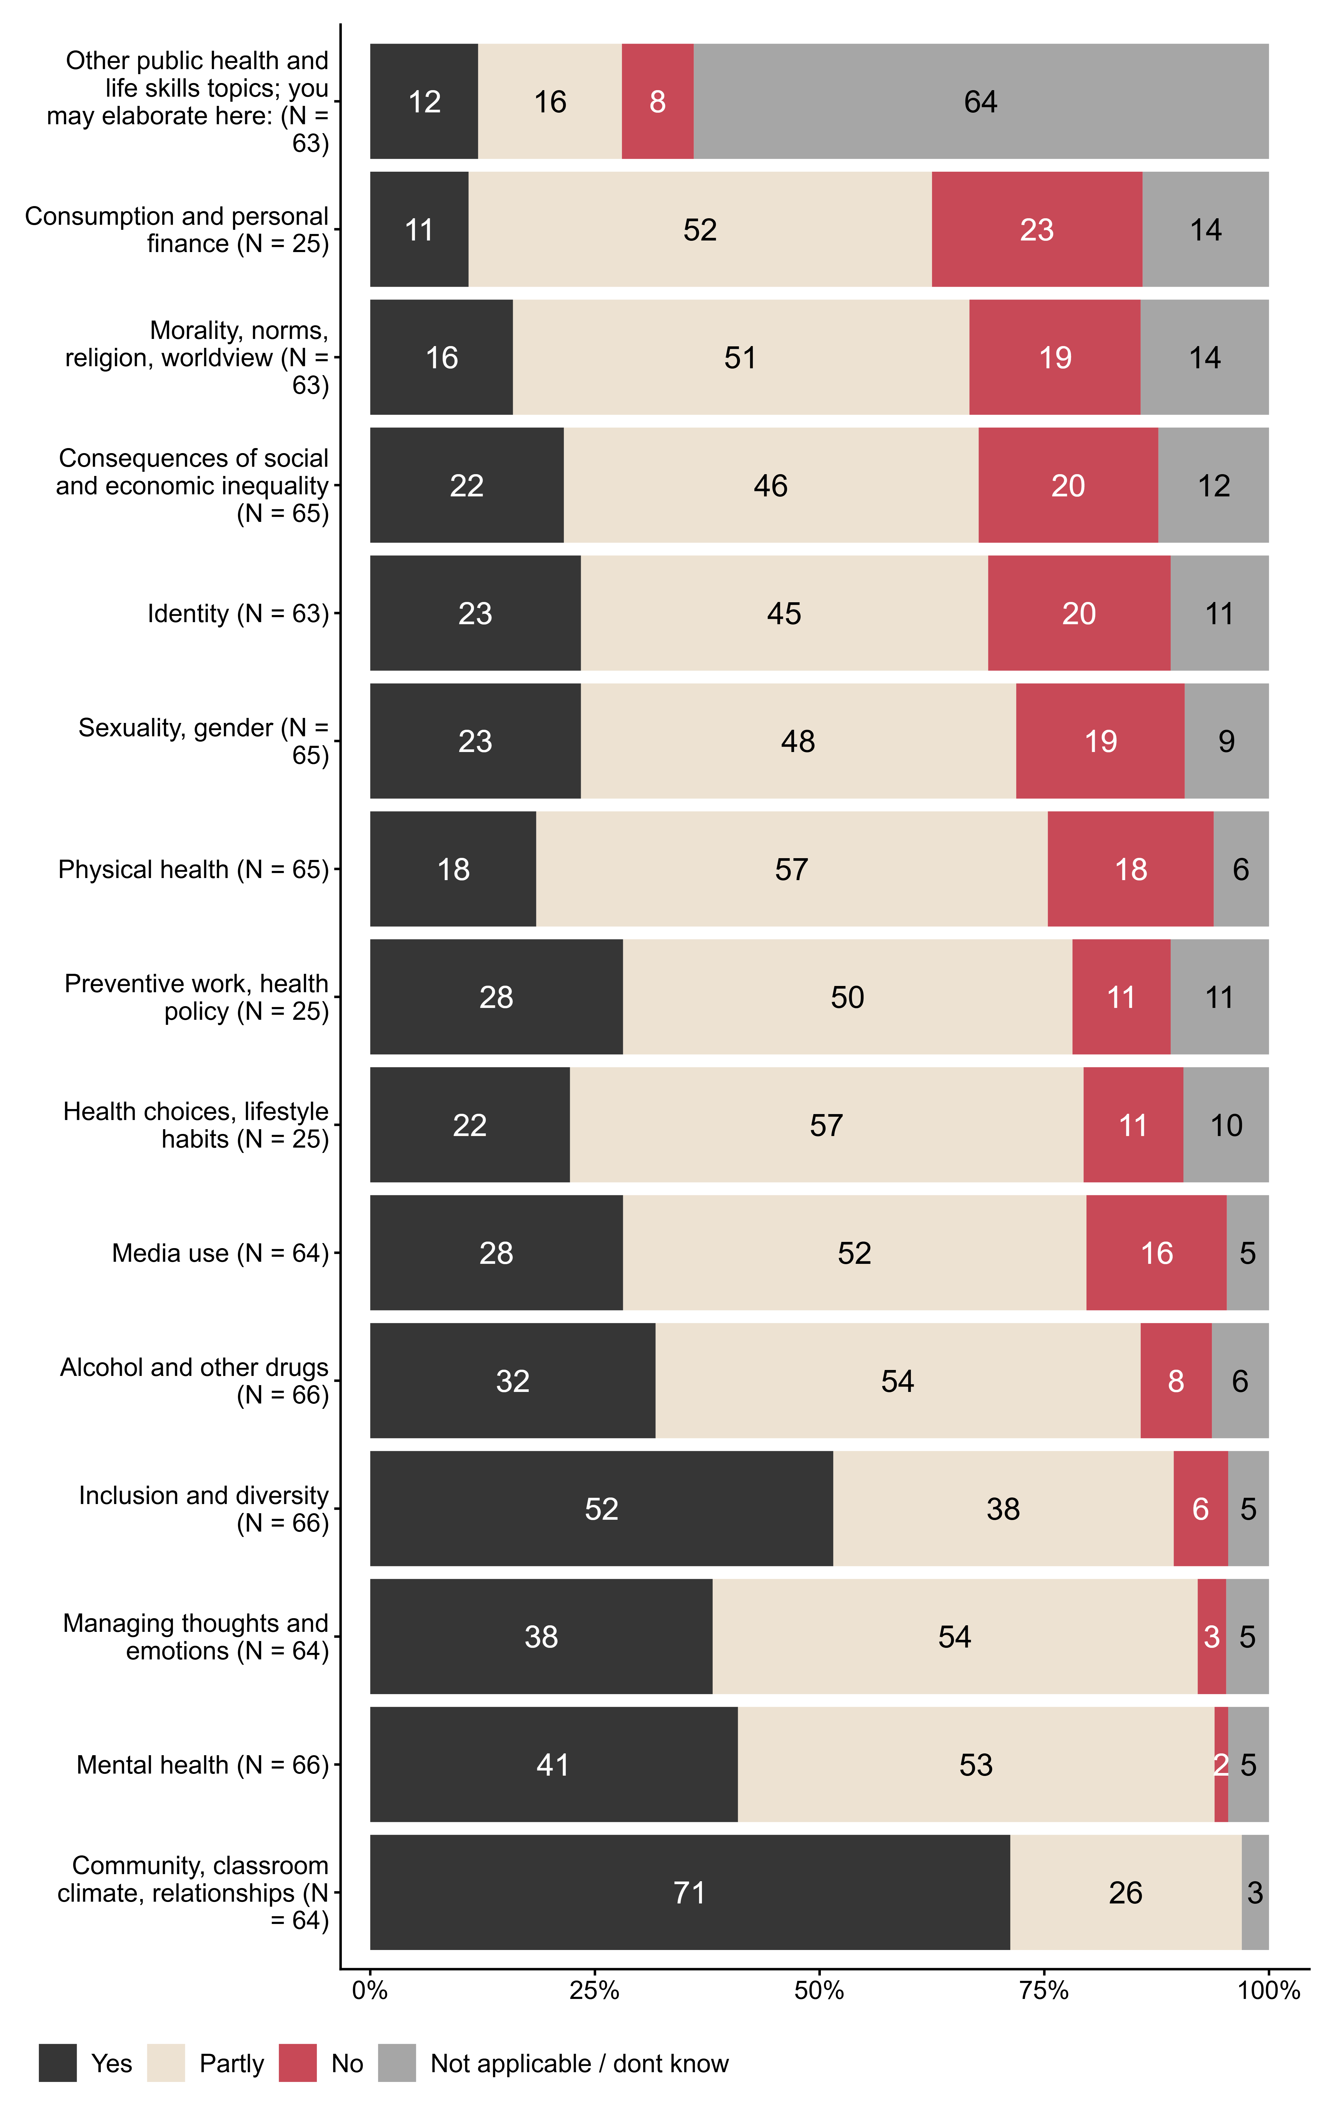
Figur 1.12. Does the (county) municipality offer professional development for school staff on any of the following topics?. N = [25–66], Figurdata (XLSX), PNG. (SEQ18_1,SEQ18_2,SEQ18_3,SEQ18_4,SEQ18_5,SEQ18_6,SEQ18_7,SEQ18_8,SEQ18_9,SEQ18_10,SEQ18_11,SEQ18_12,SEQ18_13,SEQ18_14,SEQ18_15)

1.13 To what extent do you agree with the following statements about resource use related to work with public health and life skills (FoL)? By resources we mean, for example, financial support or extra preparation time, reduced teaching time for homeroom/contact teachers to follow up individual students, hiring professionals such as school support workers or milieu therapists to support work with relationships, conflict management and social initiatives.
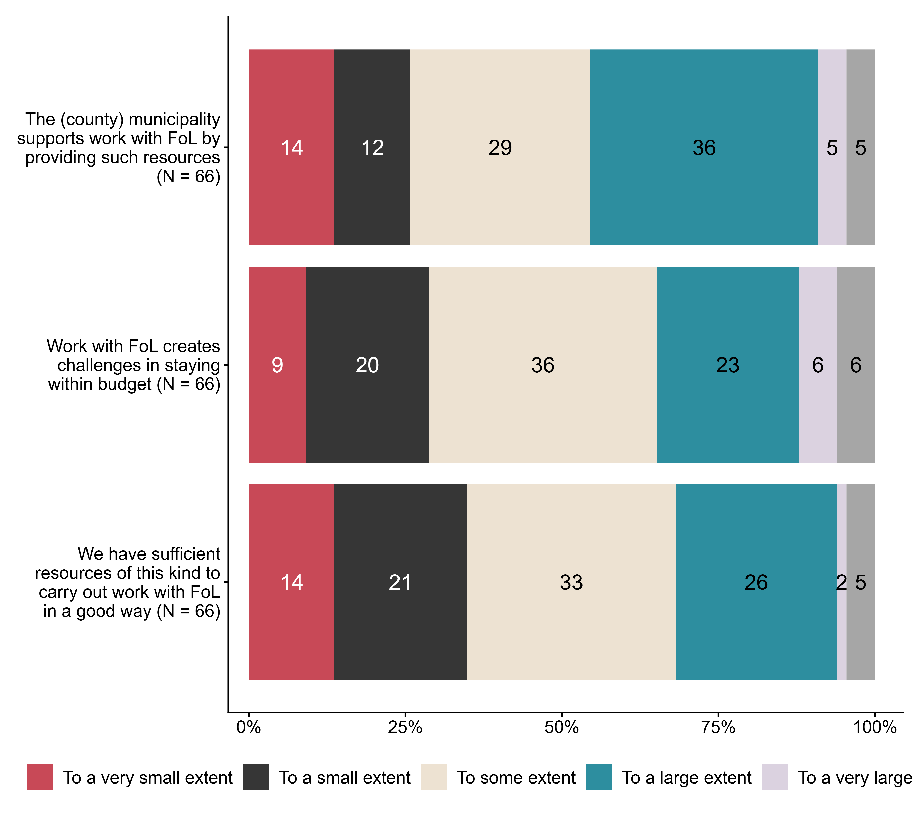
Figur 1.13. To what extent do you agree with the following statements about resource use related to work with public health and life skills (FoL)? By resources we mean, for example, financial support or extra preparation time, reduced teaching time for homeroom/contact teachers to follow up individual students, hiring professionals such as school support workers or milieu therapists to support work with relationships, conflict management and social initiatives.. N = 66, Figurdata (XLSX), PNG. (SEQ19_1,SEQ19_2,SEQ19_3)

1.14 Overall, to what extent do you feel that the introduction of public health and life skills in LK20 has improved the school’s work with students’
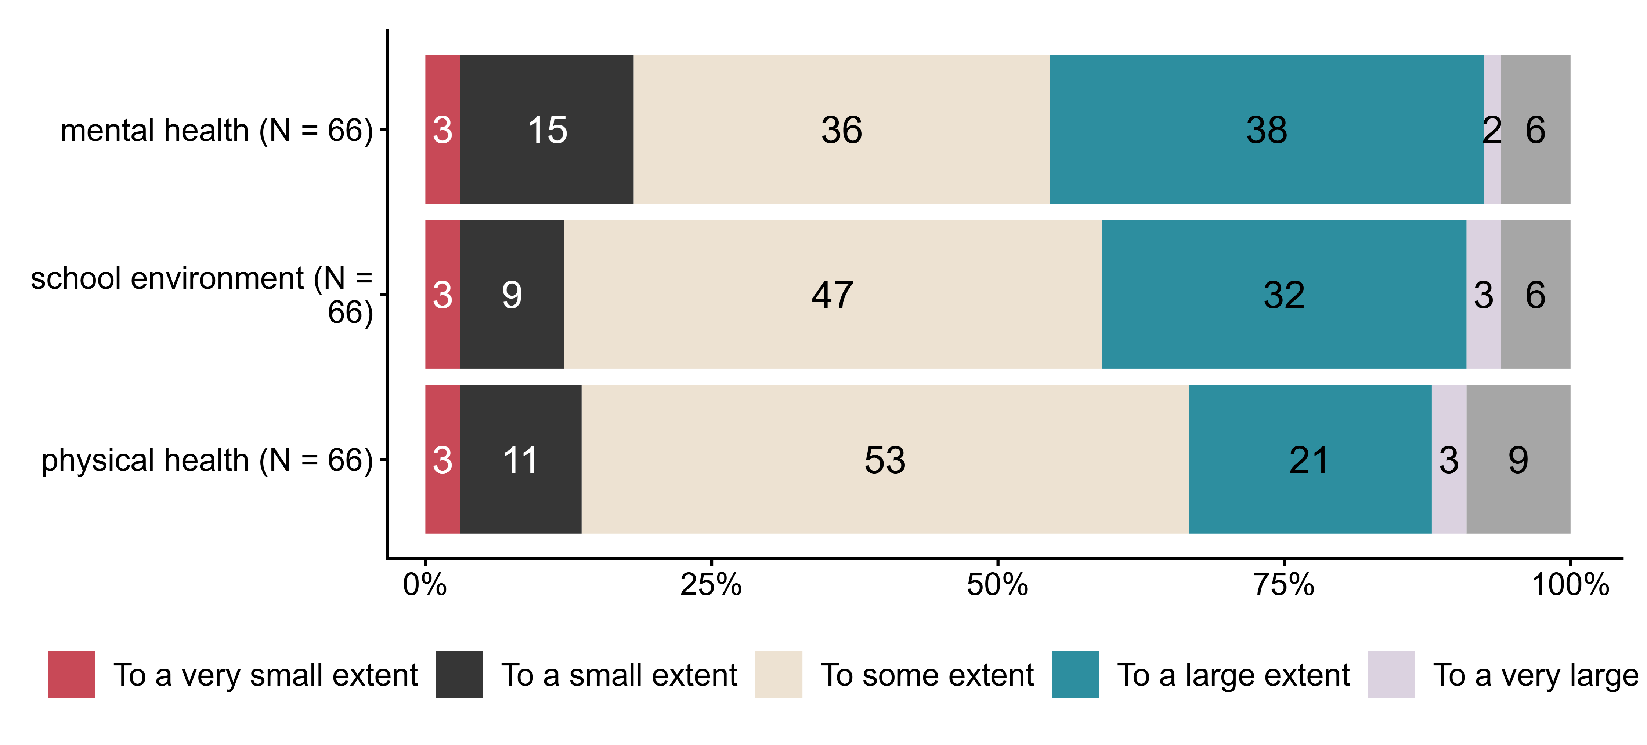
Figur 1.14. Overall, to what extent do you feel that the introduction of public health and life skills in LK20 has improved the school’s work with students’. N = 66, Figurdata (XLSX), PNG. (SEQ20_1,SEQ20_2,SEQ20_3)

